IDEE

INDICATORS OF DISABILITY EQUALITY IN EUROPE

ANED 2011 Task 4

Update and extend the piloting of quantitative implementation indicators

Comparative data on a selection of quantitative implementation indicators

By

Stefanos Grammenos
CESEP ASBL

October 2011
Contents

INTRODUCTION 2
0.1 Objectives of the study 2
0.2 Europe 2020 2
0.3 The European Disability Strategy 2010-2020 3
0.4 Presentation of the report 4
1 DEMOGRAPHICS 6
1.1 POPULATION OF DISABLED WOMEN AND MEN 6
2 LABOUR MARKET 14
2.1 EMPLOYMENT RATE 14
2.2 UNEMPLOYMENT RATE 21
2.3 ACTIVITY RATE 31
3 EDUCATION 41
3.1 EARLY LEAVERS FROM EDUCATION AND TRAINING 41
3.2 COMPLETION OF TERTIARY OR EQUIVALENT EDUCATION 49
4 POVERTY 58
4.1 LOW WORK INTENSITY 58
4.2 PEOPLE AT RISK OF POVERTY AFTER SOCIAL TRANSFERS 66
4.3 SEVERELY MATERIALLY DEPRIVED PEOPLE 75
4.4 PEOPLE AT RISK OF POVERTY OR SOCIAL EXCLUSION 84
5 ACCESSIBILITY 92
5.1 ACCESSIBILITY OF PUBLIC TRANSPORT 92
5.2 ACCESSIBILITY OF POSTAL OR BANKING SERVICES 98
6 Summary of findings and recommendations 105
6.1 Demographics 105
6.2 Employment 105
6.3 Unemployment 105
6.4 Activity rate 106
6.5 Early leavers from education and training 106
6.6 Completion of tertiary or equivalent education 107
6.7 Households with very low work intensity 107
6.8 Risk of poverty after social transfers 108
6.9 Severe material deprivation 108
6.10 Overall risk of poverty or social exclusion 109
6.11 Accessibility of public transport 109
6.12 Accessibility of postal or banking services 109
ANNEX 111

INTRODUCTION

In 2008 and 2009 ANED produced a mapping of available data on disability, proposed a range of possible qualitative and quantitative indicators, and examined the initial feasibility of proposals brought forward from the ANED working group on Indicators of Disability Equality in Europe (IDEE). In 2010, this work was extended by piloting a selection of quantitative items from the list.

In the final year of the first ANED work programme, this work is concluding by updating selected quantitative items and by adding new items of policy relevance. The selection for the indicator set prioritises those items that are most relevant to monitoring progress against the EU2020 Strategy objectives and within the themes of the actions and implementations contained in the EU Disability Strategy 2010-2020.

Objectives of the study

The objectives of this study were:

- To access and prepare the required datasets for analysis
- To provide comparative data against a selection of quantitative indicators.

The key priorities were to populate and update selected items of direct relevance to EU2020 indicators, from a disability perspective, and to present selected items of direct relevance to actions in the EU Disability Strategy (e.g. those relevant to Accessibility).

Europe 2020

As discussed in ANED’s policy reviews, Europe 2020 provides an important overarching framework for policy development and evaluation - a new strategy for the EU to develop as a smarter, knowledge based, greener economy, delivering high levels of employment, productivity and social cohesion. It is designed as the successor to the Lisbon Strategy.

Monitoring achievements through statistics is an integral part of the Europe 2020 strategy. Its headline indicators measure the progress made by the EU and the Member States towards achieving the targets of the strategy. Some of these targets and indicators are of particular relevance also to the social inclusion of disabled women and men in Europe, and align closely with key themes and actions identified in the European Disability Strategy. In this context, the socio-economic targets for EU2020 (those relating to employment, tertiary education and poverty reduction) have been selected as most relevant to the development of parallel indicators of disability equality.

The socio-economic targets are:

Table 1: EU 2020 targets

 | Headline targets |  | Indicators
1. | 75% of the population aged 20-64 should be employed | 1. | Employment rate by gender, age group 20-64
2. | The share of early school leavers should be under 10% and at least 40% of 30-34 years old should have completed a tertiary or equivalent education | 2.1 | Early leavers from education and training by gender
2. |  | 2.2 | Tertiary educational attainment by gender, age group 30-34
3. | Reduction of poverty by aiming to lift at least 20 million people out of the risk of poverty or exclusion | 3.1 | People at-risk-of-poverty or social exclusion (union of the three sub-indicators below)
3. |  | 3.2 | People living in households with very low work intensity
3. |  | 3.3 | People at-risk-of-poverty after social transfers
3. |  | 3.4 | Severely materially deprived people
Source: Eurostat

The European Disability Strategy 2010-2020

The European Disability Strategy 2010-2020 was adopted on 15 November 2010 and asserts that persons with disabilities have the right to participate fully and equally in society and the economy. Denial of equal opportunities is a breach of human rights.

By committing to conclusion of the United Nations Convention on the Rights of Persons with Disabilities (UNCRPD), the EU and its Member States have committed themselves to create a barrier-free Europe. The Member States retain the principle responsibilities for implementation of their national responsibilities, following ratification, but EU action is needed to complement these national efforts.

The Strategy for the period 2010-2020 offers a comprehensive framework committing the Commission to a greater empowerment of people with disabilities to enjoy their full rights, and removing barriers to full participation and equality in key areas of everyday life. The Strategy builds on the UNCRPD, within the scope of EU competences, and takes into account the experience of implementing the preceding Disability Action Plan (2004-2010). Its objectives are pursued by actions in eight priority areas:

- Accessibility: make goods and services accessible to people with disabilities and promote the market of assistive devices.
- Participation: ensure that people with disabilities enjoy all benefits of EU citizenship; remove barriers to equal participation in public life and leisure activities; promote the provision of quality community-based services.
- Equality: combat discrimination based on disability and promote equal opportunities.
- Employment: raise significantly the share of persons with disabilities working in the open labour market.
- Education and training: promote inclusive education and lifelong learning for students and pupils with disabilities.
- Social protection: promote decent living conditions, combat poverty and social exclusion.
- Health: promote equal access to health services and related facilities.
- External action: promote the rights of people with disabilities in the EU enlargement and international development programmes

Presentation of the report

The report includes presentation and discussion of 12 selected indicators, each of which is further elaborated or disaggregated as appropriate (e.g. in relation to gender or relevant age bands etc). The main themes addressed are those of employment, post-compulsory education and household poverty or deprivation. These include items that have been further elaborated since the previous report in 2010, including updated items illustrating the effects of change over time (the most recent available data is generally from 2009). Two newly populated indicators are included on the theme of accessibility. Tables and figures present results derived from secondary analysis of EU-SILC survey data for 2008 and 2009. In some cases, we have also drawn statistics from Eurostat’s internet database.
Since 2006, the survey includes all EU27 Member States. It covers all individuals aged 16 years old and over living in private households (persons living in collective households and in institutions are generally excluded from the target population). The general rule for the cross sectional part of the survey is to attain a minimum effective sample size, for all EU countries, of 272,900 interviewed persons aged 16 or over. The national sample ranges from 6,500 persons in Luxembourg to 16,000 in Spain.

The information included in the SILC project may be extracted either from registers or collected from interviews. In case of interviews, five modes of data collection are possible: Face-to-face personal interview (PAPI); Face-to-face personal interview (CAPI); Telephone interview (CATI); Self-administered by respondent; Proxy interview. In the EU-SILC legal basis, priority is given to face-to-face personal interviews (PAPI or CAPI) over the other modes of data collection.

We have used ’age at the date of interview‘ for indicators concerning the labour market, education and accessibility issues. We have used ’age at the end of the income reference‘ period for income related indicators as well as for labour intensity.

The presentation for each indicator includes:

- its relevance to EU policy/strategy,
- headline findings;
- relevant charts and/or data tables;
- notes on the data source (with web links where applicable);
- notes describing the methodology applied;
- any statistical or exception notes that are required for clarity.

In each case, the data is presented by:

- Member State,
- Year (for 2008 and 2009, except for the new accessibility items),
- Gender,
- Age group (below and above 65, or specific age bands relevant to policy on employment or tertiary education).

DEMOGRAPHICS

POPULATION OF DISABLED WOMEN AND MEN

Relevance to EU strategy

The EU strategy for the period 2010-2020 provides a comprehensive framework committing the Commission to empowerment of people with disabilities to enjoy their full rights, and to removing everyday barriers in life. The Strategy builds on the UNCRPD and takes into account the experience of the Disability Action Plan (2004-2010).

The Commission notes that EU action will supplement the collection of periodic disability-related statistics with a view to monitoring the situation of persons with disabilities. The indicator aims to provide an estimation of the target group for the Strategy.

Headline findings

The prevalence of impairment varies sharply between Member States but remained relatively stable through 2008 and 2009 (with around 25% of people aged 16+reporting some kind of sustained limitation in daily activities). This prevalence is higher among women than men, mainly due to the population age composition.

Concerning the degree of limitation/impairment, the variability in prevalence of reported severe limitaton is smaller than the variation in moderate limitation between the Member States.

The prevalence of disability/impairment increases with age. Among people aged 65 or more it is much higher than for younger adults.

Limitation/impairment prevalence increases in a similar way for men and women until the age of about 40 but then begins to diverge. The higher overall prevalence for women is not only an age composition effect (due to a higher life expectancy of women). Limitation/impairment prevalence for men is lower compared to women at each age after approximately 40 years old.

Different factors may affect the prevalence of self-reported impairment (personal characteristics, education, occupation, income, etc). Some authors argue that self-assessed status may be distorted by what is called justification bias. For example, due to social pressures, people who are unemployed or inactive may be incentivised to misreport the extent of their activity limitations in order to justify their social condition. The evolution between 2008 and 2009 indicates no relation between changes in national unemployment rate and changes in reported activity limitation for the age group 16-64 (correlations observed for certain countries and for certain periods, e.g. Spain for 2004-2009, can be considered spurious). Impairment prevalence and unemployment rate follow similar paths but this does not imply a direct link between the two.

Figure 1: People reporting activity limitations by Member State; 2008 and 2009

As a % of the general population; age 16+
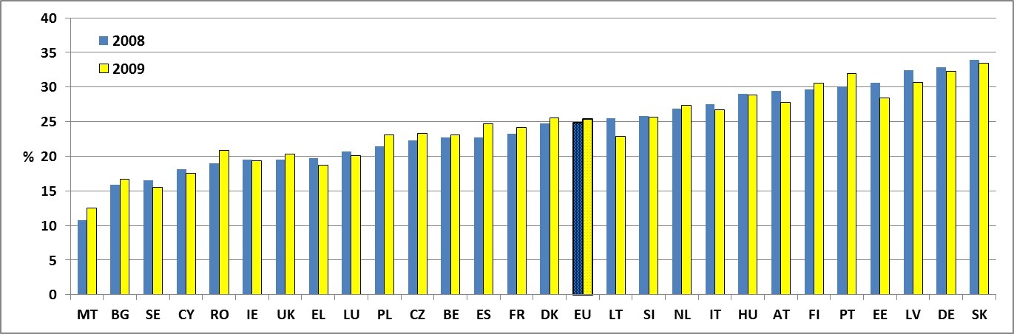
Data source: EU-SILC 2008 ; EU-SILC 2009
Figure 2: People reporting activity limitations by Member State and gender; 2009

As a % of the general population; age 16+
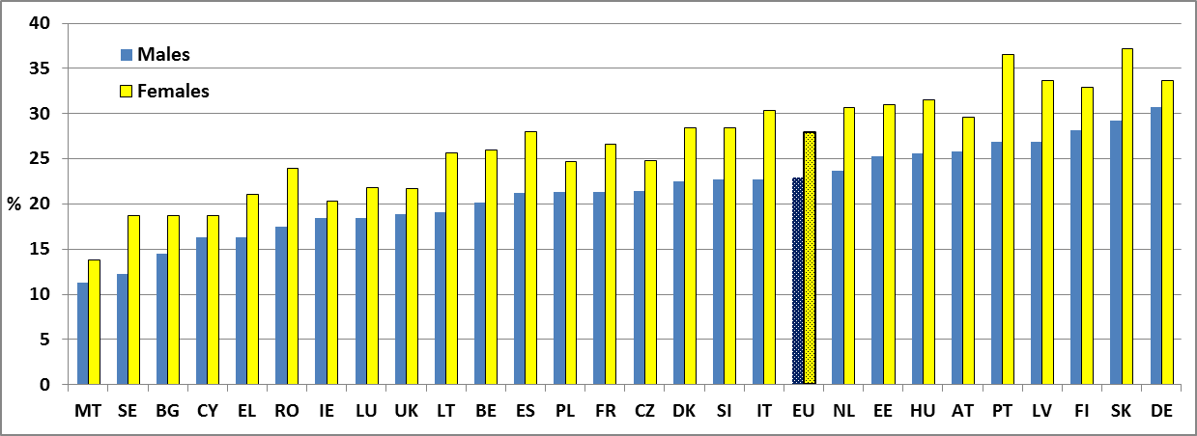
Data source: EU-SILC 2009

Figure 3: People reporting activity limitations by Member State and degree of limitation; 2009

As a % of the general population; age 16+
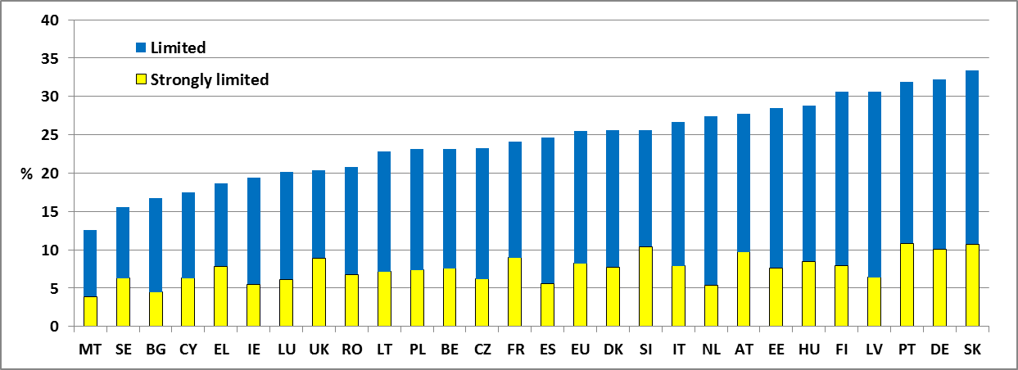
Data source: EU-SILC 2009

Figure 4: People reporting activity limitations by age group, 2009

As a % of the general population in same age group
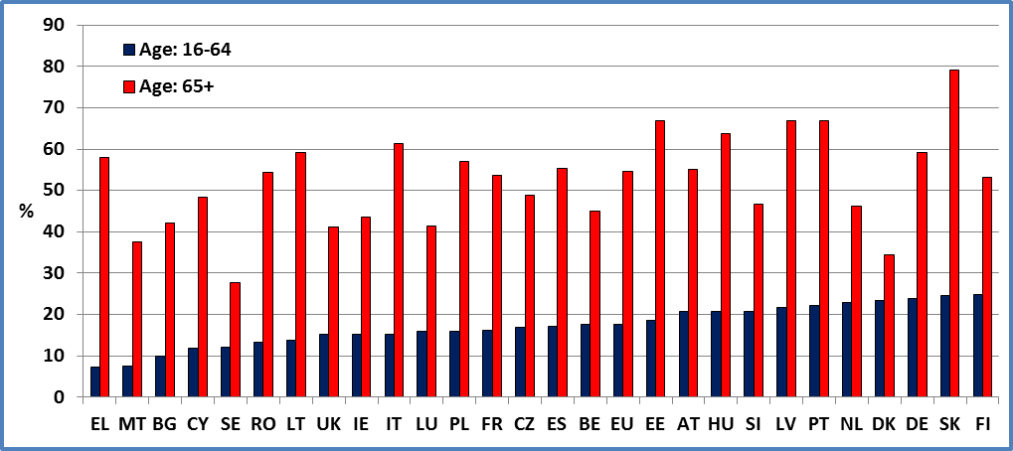
Data source: EU-SILC 2009

Figure 5: Per cent of persons reporting activity limitations by age and gender, EU 2009

As a % of the general population at same age
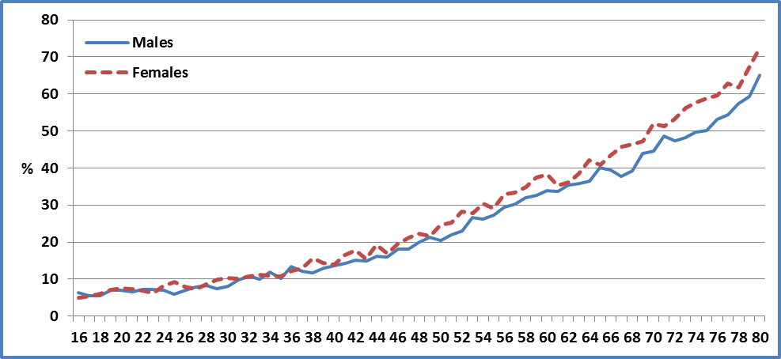
Data source: EU-SILC 2009

Data

Table 2: People reporting activity limitations by Member State and gender

As a % of the general population; age 16+
 | 2008 |  |  | 2009
 | All | Females | Males | All | Females | Males
AT | 29.5 | 31.0 | 27.8 | 27.8 | 29.6 | 25.8
BE | 22.7 | 25.1 | 20.3 | 23.1 | 26.0 | 20.2
BG | 15.9 | 17.6 | 14.0 | 16.7 | 18.8 | 14.5
CY | 18.1 | 19.1 | 17.1 | 17.5 | 18.7 | 16.3
CZ | 22.2 | 23.7 | 20.5 | 23.3 | 24.8 | 21.4
DE | 32.9 | 34.3 | 31.3 | 32.2 | 33.7 | 30.7
DK | 24.8 | 27.8 | 21.5 | 25.6 | 28.4 | 22.6
EE | 30.6 | 33.1 | 27.7 | 28.4 | 31.0 | 25.3
EL | 19.7 | 22.1 | 17.1 | 18.7 | 21.0 | 16.3
ES | 22.7 | 26.0 | 19.4 | 24.7 | 28.0 | 21.2
FI | 29.7 | 32.0 | 27.2 | 30.6 | 32.9 | 28.1
FR | 23.3 | 25.1 | 21.2 | 24.1 | 26.6 | 21.4
HU | 29.0 | 31.2 | 26.6 | 28.8 | 31.6 | 25.6
IE | 19.5 | 20.4 | 18.6 | 19.4 | 20.3 | 18.4
IT | 27.5 | 31.2 | 23.5 | 26.7 | 30.4 | 22.8
LT | 25.5 | 28.0 | 22.2 | 22.8 | 25.7 | 19.1
LU | 20.7 | 23.0 | 18.2 | 20.1 | 21.8 | 18.5
LV | 32.4 | 36.2 | 27.8 | 30.6 | 33.7 | 26.9
MT | 10.8 | 11.6 | 10.0 | 12.6 | 13.8 | 11.3
NL | 26.9 | 30.9 | 22.4 | 27.4 | 30.7 | 23.7
PL | 21.5 | 22.9 | 19.8 | 23.1 | 24.7 | 21.4
PT | 30.1 | 34.3 | 25.4 | 31.9 | 36.6 | 26.9
RO | 18.9 | 21.5 | 16.2 | 20.8 | 23.9 | 17.5
SE | 16.5 | 19.3 | 13.6 | 15.6 | 18.7 | 12.3
SI | 25.8 | 27.9 | 23.6 | 25.7 | 28.4 | 22.7
SK | 33.9 | 37.8 | 29.3 | 33.4 | 37.2 | 29.2
UK | 19.5 | 20.7 | 18.2 | 20.3 | 21.7 | 18.9
EU | 24.9 | 27.2 | 22.4 | 25.5 | 27.9 | 22.8
Data source: EU-SILC 2008 ; EU-SILC 2009
Data for 2008: We have used data from the Eurostat webpage for FR, MT and EU as the EU-SILC UDB (User Data Base) did not include France and Malta for 2008.

Table 3: People reporting activity limitation by Member State and degree

As a % of the general population; age 16+
 | 2008 |  |  | 2009
 | Strongly limited | Limited | Not limited | Strongly limited | Limited | Not limited
AT | 10.5 | 18.9 | 70.6 | 9.7 | 18.1 | 72.2
BE | 6.9 | 15.9 | 77.3 | 7.6 | 15.6 | 76.9
BG | 4.6 | 11.3 | 84.1 | 4.5 | 12.2 | 83.3
CY | 6.4 | 11.7 | 81.9 | 6.3 | 11.2 | 82.5
CZ | 5.6 | 16.7 | 77.8 | 6.2 | 17.1 | 76.7
DE | 10.5 | 22.4 | 67.1 | 10.1 | 22.1 | 67.8
DK | 7.5 | 17.3 | 75.3 | 7.8 | 17.9 | 74.4
EE | 9.9 | 20.8 | 69.4 | 7.7 | 20.8 | 71.6
EL | 8.2 | 11.5 | 80.3 | 7.9 | 10.8 | 81.3
ES | 5.4 | 17.3 | 77.3 | 5.6 | 19.0 | 75.3
FI | 7.8 | 21.9 | 70.3 | 8.0 | 22.7 | 69.4
FR | 8.6 | 14.7 | 76.8 | 9.0 | 15.1 | 75.9
HU | 10.3 | 18.8 | 71.0 | 8.5 | 20.3 | 71.2
IE | 5.4 | 14.1 | 80.5 | 5.5 | 13.9 | 80.6
IT | 8.2 | 19.3 | 72.5 | 7.9 | 18.8 | 73.3
LT | 7.5 | 18.0 | 74.5 | 7.2 | 15.7 | 77.2
LU | 6.9 | 13.7 | 79.3 | 6.2 | 14.0 | 79.9
LV | 7.8 | 24.6 | 67.6 | 6.4 | 24.2 | 69.4
MT | 2.6 | 8.2 | 89.2 | 3.9 | 8.7 | 87.4
NL | 5.8 | 21.1 | 73.1 | 5.4 | 22.0 | 72.6
PL | 6.5 | 14.9 | 78.6 | 7.4 | 15.8 | 76.9
PT | 11.9 | 18.2 | 70.0 | 10.8 | 21.1 | 68.1
RO | 6.7 | 12.2 | 81.1 | 6.8 | 14.1 | 79.2
SE | 7.0 | 9.5 | 83.5 | 6.3 | 9.2 | 84.5
SI | 9.7 | 16.1 | 74.2 | 10.4 | 15.3 | 74.4
SK | 11.1 | 22.8 | 66.1 | 10.7 | 22.7 | 66.6
UK | 8.5 | 11.0 | 80.5 | 8.9 | 11.4 | 79.7
EU | 8.1 | 16.8 | 75.1 | 8.2 | 17.2 | 74.6
Data for 2008: We have used Eurostat webpage for FR, MT and EU as the EU-SILC UDB did not include France and Malta for 2008.
Data source: EU-SILC 2008 ; EU-SILC 2009
Table 4: People reporting activity limitation by Member State and age group

As a % of the general population in same age group
 | 2008 |  | 2009
 | Age : 16-64 | Age : 65+ | Age : 16-64 | Age : 65+
AT | 21.8 | 58.9 | 20.6 | 55.1
BE | 17.1 | 44.8 | 17.5 | 45.0
BG | 9.5 | 39.3 | 10.0 | 42.1
CY | 11.8 | 52.7 | 11.8 | 48.4
CZ | 15.3 | 51.5 | 16.8 | 48.9
DE | 24.7 | 60.0 | 23.9 | 59.2
DK | 23.1 | 31.4 | 23.3 | 34.5
EE | 19.2 | 74.1 | 18.5 | 67.0
EL | 10.5 | 52.3 | 7.4 | 57.9
ES | 15.4 | 52.5 | 17.0 | 55.2
FI | 23.5 | 53.8 | 24.8 | 53.1
FR |  |  | 16.2 | 53.6
HU | 21.8 | 62.0 | 20.7 | 63.6
IE | 15.3 | 45.4 | 15.3 | 43.7
IT | 16.2 | 62.0 | 15.3 | 61.4
LT | 16.4 | 61.2 | 13.8 | 59.2
LU | 16.6 | 40.0 | 15.9 | 41.4
LV | 23.6 | 68.3 | 21.6 | 66.8
MT |  |  | 7.5 | 37.5
NL | 22.4 | 46.7 | 22.9 | 46.2
PL | 14.7 | 55.7 | 16.0 | 56.9
PT | 20.0 | 66.6 | 22.2 | 66.9
RO | 12.2 | 49.5 | 13.3 | 54.4
SE | 12.8 | 30.0 | 12.0 | 27.8
SI | 20.9 | 47.8 | 20.8 | 46.6
SK | 24.4 | 81.7 | 24.6 | 79.1
UK | 14.6 | 39.7 | 15.2 | 41.2
EU | 17.6 | 54.3 | 17.6 | 54.6
Data source: EU-SILC 2008 ; EU-SILC 2009

Methodology

The European Statistics on Income and Living Condition (EU-SILC) survey contains a small module on health, including three questions on general health status.

The questions on general health status represent the so-called Minimum European Health Module (MEHM) and are proposed to be used in all EU health surveys or survey modules, in order to link results among surveys. These three questions relate to: self-perceived health, chronic (longstanding) illnesses or conditions; limitation in activities due to health problems. The third question comes closest to the identification of ‘people with disabilities’.

The data on limitation in activities due to health problems refer to self-evaluation by the respondents of the extent of which they have been limited, for at least six months, in everyday activities, due to ‘health problems’ (the question refers to ’Limitation in activities people usually do because of health problems for at least the last 6 months‘), and the possible answers are:

- yes, strongly limited
- yes, limited
- no, not limited

For data distinguishing ‘limited’ from ‘not limited’ in Denmark, Finland, Netherlands, Sweden and Slovenia, we have used personal cross sectional weights for selected persons (pb060). Otherwise, we have used personal cross sectional weights (pb040).

Notes

EU-SILC may underestimate the number of people with impairments/disabilities in the target population, especially as those living in collective households and in institutions are generally excluded from the sample.

LABOUR MARKET

EMPLOYMENT RATE

Relevance to EU strategy

The Lisbon European Council (March 2000) noted that the overall aim of employment policy should be to raise the employment rate from an average of 61% in 2000 to as close as possible to 70% by 2010, and to increase the number of women in employment from an average of 51% to more than 60% by 2010.

Europe 2020 is the successor to the Lisbon strategy and the employment rate is one of its headline indicators. The Europe 2020 objective is that 75% of the total population aged 20-64 should be employed (this population includes all people, disabled and non-disabled).

The employment rights of disabled people are addressed in Article 27 of the UNCRPD. Employment is also one of the eight priority areas for action in the European Disability Strategy 2010-2020 adopted in 2010. The aim is to raise significantly the share of persons with disabilities working in the open labour market.

The Commission considers that quality jobs ensure economic independence, foster personal achievement, and offer the best protection against poverty.

The European Disability Strategy 2010-2020 aims to exploit the full potential of the Europe 2020 Strategy and its Agenda for new skills and jobs by providing Member States with analysis, political guidance, information exchange and other support.

Headline findings

A number of Member States exhibit an average employment rate close to, or higher than, 70% (for the total population) but there is a significant disability employment gap in all Member States.

The average EU employment rate of people with disabilities (i.e. people reporting activity limitations in the EU-SILC data) remained static between 2008 and 2009 in a generally difficult environment following the onset of the economic crisis (at 45.7% compared to 45.8%).

The employment rate of women (both with and without disabilities) is relatively low compared to that for men. In 2009 the employment rate for disabled women was 41.4% (compared to 50.7% for disabled men an d65.2% for non-disabled women).

There is a significant employment gap across the EU, with the average European employment rate of people with disabilities about 27 percentage points lower than that for people without disabilities. In the majority of Member States the employment rate for people without disabilities is higher than 70%; in the majority of Member States the employment rate of people with disabilities is less than 50%.

There is an employment gap in every Member State but the national situation varies considerably. The employment rate of people with disabilities (for both women and men) is very low in Ireland, Romania and Greece. Conversely, it is relatively high in Finland, Luxembourg and Denmark.

Countries with similar employment rates for non-disabled people present large differences for people with disabilities. This suggests that national interventions and policies make a difference and that there is potential to increase the employment rate of people with disabilities.

Table 6: Employment rate by disability status and Member State (age 20-64), 2009

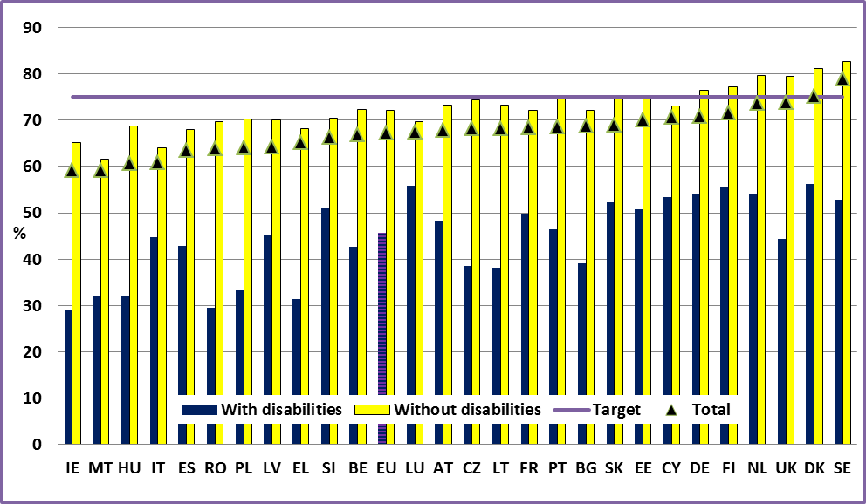
Data source: EU-SILC 2009

Figure 7: Employment rate of people with disabilities in 2008 and 2009(age 20-64)

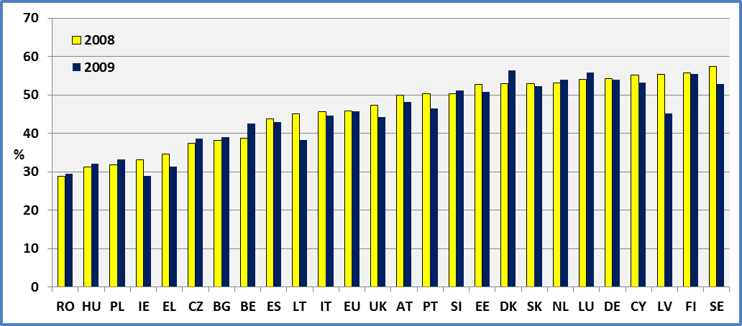
Data source: EU-SILC 2008 ; EU-SILC 2009

Figure 8: Female employment rate by disability status and Member State (age 20-64), 2008

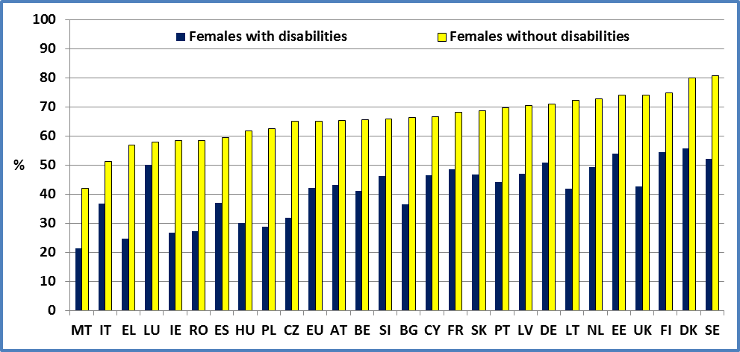
Data source: EU-SILC 2009

Figure 9: Male employment rate by disability status and Member State (age 20-64), 2008

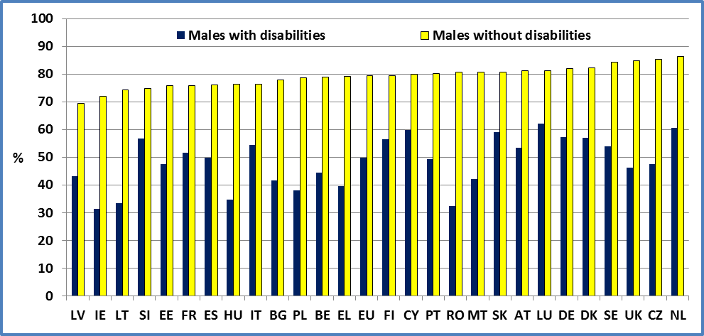
Data source: EU-SILC 2009

Data

Table 5: Employment rate by disability status and Member State (age 20-64)

 | 2008 |  |  |  |  | 2009
 | Men + Women |  |  |  |  | Men + Women
 | Disability |  |  | All | LFS | Disability |  |  | All | LFS
 | Yes | No | Total |  |  | Yes | No | Total
AT | 49.9 | 74.1 | 68.5 | 68.5 | 75.1 | 48.2 | 73.3 | 67.8 | 67.8 | 74.7
BE | 38.8 | 73.3 | 67.2 | 67.2 | 68.0 | 42.6 | 72.4 | 66.9 | 66.9 | 67.1
BG | 38.2 | 73.3 | 69.7 | 69.8 | 70.7 | 39.0 | 72.1 | 68.7 | 68.7 | 68.8
CY | 55.1 | 74.7 | 72.3 | 72.3 | 76.5 | 53.3 | 73.1 | 70.6 | 70.7 | 75.7
CZ | 37.5 | 74.6 | 68.7 | 69.1 | 72.4 | 38.6 | 74.3 | 68.1 | 68.9 | 70.9
DE | 54.2 | 76.8 | 70.9 | 70.6 | 74.6 | 53.9 | 76.4 | 70.8 | 70.5 | 74.8
DK | 52.9 | 81.3 | 74.6 | 73.9 | 79.8 | 56.3 | 81.1 | 75.2 | 74.9 | 77.8
EE | 52.8 | 81.7 | 75.7 | 75.7 | 77.0 | 50.7 | 74.8 | 70.1 | 70.1 | 69.9
EL | 34.7 | 69.8 | 65.9 | 65.9 | 66.5 | 31.4 | 68.1 | 65.2 | 65.2 | 65.8
ES | 43.7 | 72.9 | 68.2 | 68.2 | 68.3 | 42.9 | 67.9 | 63.5 | 63.5 | 63.7
FI | 55.8 | 78.5 | 72.9 | 72.0 | 75.8 | 55.5 | 77.2 | 71.6 | 70.8 | 73.5
FR |  |  |  |  | 70.4 | 49.8 | 72.1 | 68.3 | 68.3 | 69.5
HU | 31.3 | 68.5 | 60.0 | 60.0 | 61.9 | 32.1 | 68.8 | 60.7 | 61.0 | 60.5
IE | 33.1 | 70.9 | 64.6 | 64.6 | 72.3 | 29.0 | 65.1 | 59.2 | 59.2 | 66.7
IT | 45.7 | 65.9 | 62.5 | 62.5 | 63.0 | 44.7 | 64.0 | 60.9 | 60.9 | 61.7
LT | 45.1 | 80.0 | 73.9 | 73.6 | 72.0 | 38.2 | 73.2 | 68.1 | 68.0 | 67.2
LU | 54.1 | 72.6 | 69.5 | 69.5 | 68.8 | 55.8 | 69.7 | 67.4 | 67.6 | 70.4
LV | 55.4 | 78.9 | 73.1 | 73.1 | 75.8 | 45.1 | 70.0 | 64.3 | 64.3 | 67.1
MT |  |  |  |  | 59.1 | 32.0 | 61.6 | 59.2 | 59.2 | 58.7
NL | 53.1 | 79.3 | 73.3 | 73.9 | 78.9 | 54.0 | 79.6 | 73.6 | 74.1 | 78.8
PL | 31.9 | 69.3 | 63.5 | 63.5 | 65.0 | 33.3 | 70.3 | 64.1 | 64.1 | 64.9
PT | 50.4 | 77.7 | 72.0 | 72.0 | 73.1 | 46.4 | 75.1 | 68.5 | 68.5 | 71.2
RO | 28.9 | 69.3 | 64.0 | 64.0 | 64.4 | 29.4 | 69.6 | 63.9 | 63.9 | 63.5
SE | 57.5 | 84.5 | 80.9 | 80.3 | 80.4 | 52.8 | 82.6 | 78.9 | 79.1 | 78.3
SI | 50.4 | 70.8 | 66.4 | 65.8 | 73.0 | 51.2 | 70.5 | 66.3 | 65.3 | 71.9
SK | 53.0 | 78.2 | 71.7 | 71.6 | 68.8 | 52.2 | 74.8 | 68.9 | 68.9 | 66.4
UK | 47.3 | 81.3 | 75.9 | 75.9 | 75.2 | 44.3 | 79.5 | 73.8 | 73.7 | 73.9
EU | 45.8 | 73.6 | 68.4 | 68.7 | 70.4 | 45.7 | 72.2 | 67.3 | 67.6 | 69.1
Data source: EU-SILC 2008; EU-SILC 2009
LFS data:
http://epp.eurostat.ec.europa.eu/portal/page/portal/europe_2020_indicators/headline_indicators
All: includes observations for which we do not dispose information on disability status.
FR and MT: EU-SILC UDB for 2008 does not include France and Malta..
Table 6: Employment rate by disability status, gender and Member State (age 20-64)

 | 2008 |  |  |  |  |  |  | 2009
 | Females |  |  |  | Males |  |  | Females |  |  | Males
 | Disability |  |  |  | Disability |  |  | Disability |  |  | Disability
 | Yes | No | Total |  | Yes | No | Total | Yes | No | Total | Yes | No | Total
AT | 43.9 | 64.0 | 59.5 | 55.8 |  | 84.1 | 77.6 | 43.1 | 65.4 | 60.5 | 53.5 | 81.1 | 75.2
BE | 33.8 | 66.7 | 60.5 | 44.3 |  | 79.8 | 73.8 | 41.0 | 65.6 | 60.7 | 44.4 | 78.9 | 73.0
BG | 34.2 | 66.6 | 63.2 | 42.4 |  | 80.2 | 76.3 | 36.6 | 66.4 | 63.1 | 41.7 | 77.8 | 74.3
CY | 44.5 | 67.5 | 64.7 | 65.2 |  | 82.2 | 80.0 | 46.5 | 66.5 | 64.1 | 59.9 | 79.9 | 77.3
CZ | 32.5 | 64.4 | 59.1 | 43.8 |  | 86.1 | 79.6 | 31.9 | 65.0 | 59.0 | 47.5 | 85.3 | 79.0
DE | 50.0 | 70.8 | 65.3 | 58.4 |  | 82.7 | 76.4 | 50.8 | 70.9 | 65.8 | 57.3 | 82.0 | 75.9
DK | 47.0 | 78.0 | 69.9 | 60.7 |  | 84.5 | 79.6 | 55.6 | 80.0 | 73.6 | 57.1 | 82.2 | 76.9
EE | 53.2 | 77.5 | 72.7 | 52.4 |  | 86.4 | 79.2 | 53.9 | 73.9 | 70.1 | 47.4 | 75.9 | 70.1
EL | 27.2 | 57.3 | 53.6 | 43.8 |  | 82.1 | 78.2 | 24.7 | 56.9 | 54.1 | 39.6 | 79.1 | 76.4
ES | 38.3 | 62.9 | 58.6 | 49.8 |  | 82.3 | 77.5 | 37.0 | 59.4 | 55.1 | 49.8 | 76.0 | 71.8
FI | 56.7 | 74.7 | 70.1 | 54.9 |  | 82.1 | 75.8 | 54.5 | 74.8 | 69.4 | 56.5 | 79.5 | 73.9
FR |  |  |  |  |  |  |  | 48.4 | 68.2 | 64.6 | 51.5 | 75.9 | 72.1
HU | 28.7 | 61.2 | 53.6 | 34.2 |  | 76.1 | 66.6 | 30.0 | 61.6 | 54.3 | 34.6 | 76.2 | 67.4
IE | 28.6 | 64.2 | 58.2 | 37.8 |  | 77.7 | 71.1 | 26.7 | 58.4 | 53.2 | 31.4 | 71.9 | 65.2
IT | 37.3 | 52.8 | 49.9 | 56.0 |  | 78.5 | 75.1 | 36.7 | 51.2 | 48.7 | 54.5 | 76.4 | 73.3
LT | 44.2 | 76.8 | 70.9 | 46.3 |  | 83.6 | 77.2 | 41.8 | 72.3 | 67.5 | 33.4 | 74.3 | 68.9
LU | 47.1 | 62.4 | 59.6 | 62.4 |  | 82.4 | 79.3 | 50.1 | 57.9 | 56.5 | 62.1 | 81.1 | 78.2
LV | 54.3 | 74.2 | 69.0 | 56.8 |  | 84.0 | 77.5 | 46.9 | 70.4 | 64.8 | 43.1 | 69.5 | 63.7
MT |  |  |  |  |  |  |  | 21.4 | 42.0 | 40.4 | 42.1 | 80.7 | 77.5
NL | 49.2 | 71.2 | 65.4 | 58.8 |  | 87.2 | 81.8 | 49.3 | 72.7 | 66.5 | 60.5 | 86.2 | 81.1
PL | 27.6 | 59.9 | 55.0 | 36.0 |  | 78.9 | 72.1 | 28.8 | 62.6 | 57.0 | 38.1 | 78.7 | 71.7
PT | 47.3 | 71.5 | 65.9 | 54.3 |  | 83.8 | 78.3 | 44.2 | 69.7 | 63.0 | 49.4 | 80.2 | 74.1
RO | 26.5 | 58.7 | 54.1 | 31.8 |  | 79.7 | 74.1 | 27.2 | 58.5 | 53.6 | 32.3 | 80.6 | 74.5
SE | 55.5 | 82.1 | 77.9 | 60.4 |  | 86.5 | 83.7 | 52.2 | 80.8 | 76.4 | 53.8 | 84.2 | 81.3
SI | 46.5 | 64.8 | 60.9 | 54.3 |  | 76.8 | 72.0 | 46.1 | 65.8 | 61.2 | 56.8 | 74.8 | 71.2
SK | 47.8 | 71.9 | 65.1 | 60.0 |  | 84.6 | 78.9 | 46.8 | 68.7 | 62.5 | 59.0 | 80.7 | 75.6
UK | 46.0 | 75.8 | 70.9 | 48.8 |  | 87.5 | 81.6 | 42.6 | 74.0 | 68.8 | 46.2 | 84.9 | 78.9
EU | 41.4 | 65.2 | 60.6 | 50.7 |  | 82.0 | 76.4 | 42.0 | 65.0 | 60.5 | 49.9 | 79.3 | 74.2
Data source: EU-SILC 2008 ; EU-SILC 2009

Data source

- EUSILC UDB 2008 – version 3 of March 2011
- EUSILC UDB 2009 – version 1 of March 2011
- http://epp.eurostat.ec.europa.eu/portal/page/portal/europe_2020_indicators/headline_indicators

Methodology

EU-SILC 2008 includes a question (PL030) on ‘Self-defined current economic status’. The possible answers are:

- Working full time
- Working part-time
- Unemployed
- Pupil, student, further training, unpaid work experience
- In retirement or in early retirement or has given up business
- Permanently disabled or/and unfit to work
- In compulsory military community or service
- Fulfilling domestic tasks and care responsibilities
- Other inactive person

Employment includes both people ‘Working full time’ and people ‘Working part-time’.

The EU average for 2008 covers all Member States except France and Malta.

In 2009, a new classification was introduced, which distinguishes:

- Employee working full-time
- Employee working part-time
- Self-employed working full-time (including family worker)
- Self-employed working part-time (including family worker)
- Unemployed
- Pupil, student, further training, unpaid work experience
- In retirement or in early retirement or has given up business
- Permanently disabled or/and unfit to work
- In compulsory military community or service
- Fulfilling domestic tasks and care responsibilities
- Other inactive person

For 2009, employment includes ’Employee working full-time’, ’Employee working part-time’, ’Self-employed working full-time’ and ’Self-employed working part-time’.

The age group includes persons aged 20-64 and the employment rate is calculated by dividing the number of persons in employment by the total population of the same age group.

For data distinguishing those ‘limited’ from ‘not limited’ in Denmark, Finland, Netherland, Sweden and Slovenia we have used personal cross sectional weights for selected persons (pb060). Otherwise, we have used personal cross sectional weights (pb040).

Notes

EU-SILC estimators may overestimate the percentage of people with disabilities in employment since those living in collective households and in institutions are generally excluded from the sample.

Eurostat annual results are calculated averaging quarterly data. Consequently, seasonal variation may explain part of the difference with EU-SILC estimators.

UNEMPLOYMENT RATE

Relevance to EU strategy

The Lisbon European Council (March 2000) noted that the overall aim of employment policy should be to raise the employment rate from an average of 61% in 2000 to as close as possible to 70% by 2010, and to increase the number of women in employment from an average of 51% to more than 60% by 2010.

Europe 2020 is the successor to the Lisbon strategy and the employment rate is one of its headline indicators. The Europe 2020 objective is that 75% of the total population aged 20-64 should be employed (this population includes all people, disabled and non-disabled). There is no specific target on unemployment but rates are reported in the strategy indicators.

The employment rights of disabled people are addressed in Article 27 of the UNCRPD. Employment is also one of the eight priority areas for action in the European Disability Strategy 2010-2020 adopted in 2010. The aim is to raise significantly the share of persons with disabilities working in the open labour market. This implies a reduction in unemployment.

EU action is expected to support and supplement national efforts to: analyse the labour market situation of people with disabilities; combat disability benefit cultures and traps that discourage them from entering the labour market; develop active labour market policies; make workplaces more accessible and develop services for job placement.

Unemployment may lead to poverty and social exclusion. Consequently, a reduction in unemployment is considered as a route to increase social inclusion and participation.

Headline findings

At 17.7%, the average EU unemployment rate of people with disabilities (i.e. people reporting activity limitations in the EU-SILC data) is approximately double that of people without disabilities (9.2%).

In some countries, the difference between people with and without disabilities is relatively small while in others it is very large (e.g. in Austria, Germany, Belgium and Czech Republic).

In the general population, women’s unemployment rate is higher than men’s and may also be underestimated (a lower opportunity for employment may drive women out of the active labour force and their economic inactivity remains much higher than men’s, notably among women with disabilities). However, the reported unemployment rate of men with disabilities (18.3%) is higher than for women with disabilities (17.1%).

At the European level, the evolution of unemployment rates through the life cycle indicates similar paths for people with and without disabilities but disabled people’s unemployment rate remains higher in all age groups. The pattern is very similar across different Member States, except in Greece where people with disabilities follow an atypical path (i.e. the reported unemployment rate is higher amongst younger people than amongst older adults of working age).

Following the onset of economic crisis at the end of 2008 and 2009 there has been an increase in the unemployment rate for people both with and without disabilities (from 16.3% to 17.7% for those reporting activity limitations in EU-SILC). Generally, an absolute increase of one percentage point in the unemployment rate of people without disabilities is accompanied by an equivalent increase for people with disabilities (although the proportional increase is less against a very high base unemployment rate for people with disabilities - as a percentage it is comparatively lower).

Figure 10: Unemployment rate by disability status and Member State (age 20-64), 2009

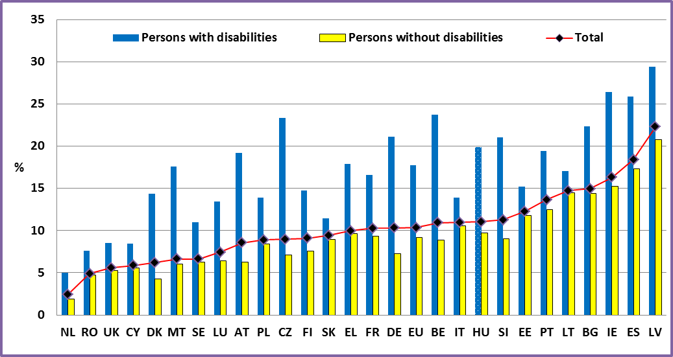
Data source: EU-SILC 2009

Figure 11: Difference in unemployment rates of people with and without disabilities, age: 20-64, 2009

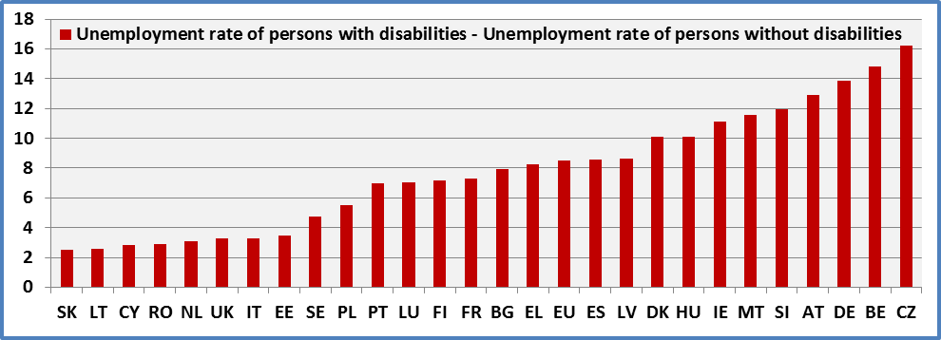
Data source: EU-SILC 2009

Figure 12: Change in the unemployment rate of people with disabilities by Member State (age 20- 64)

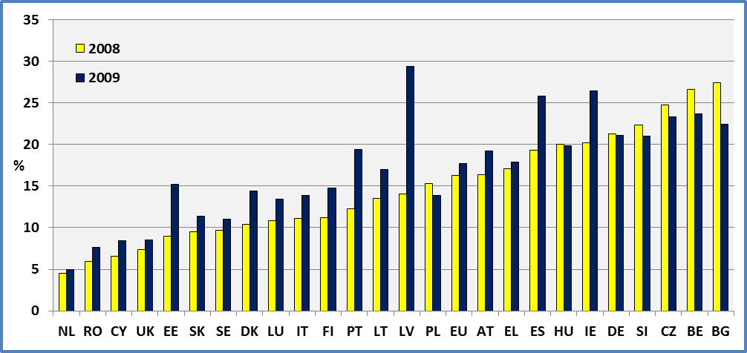
Data source: EU-SILC 2008 ; EU-SILC 2009

Figure 13: Unemployment rate by disability status and age group, 2009

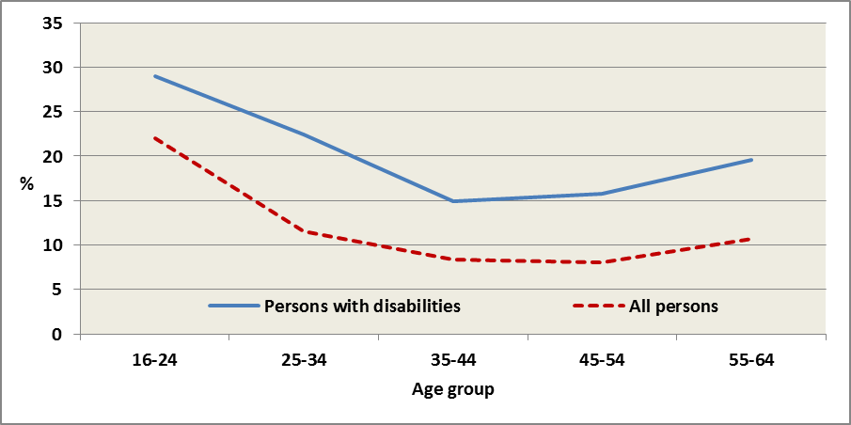
Data source: EU-SILC 2009

Figure 14: Unemployment rate by disability status, gender and Member State (age 20-64), 2009

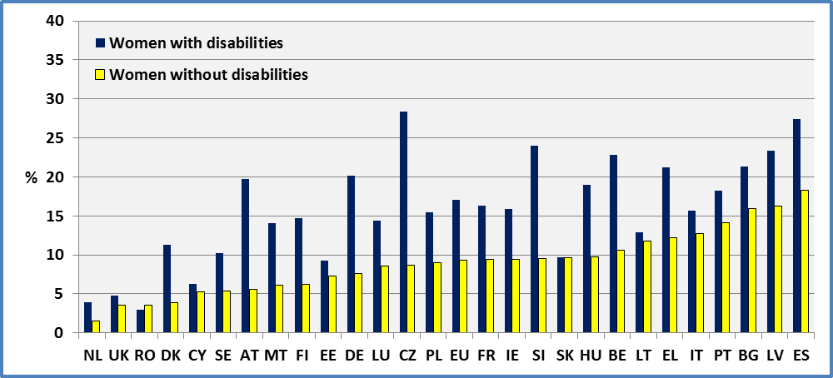

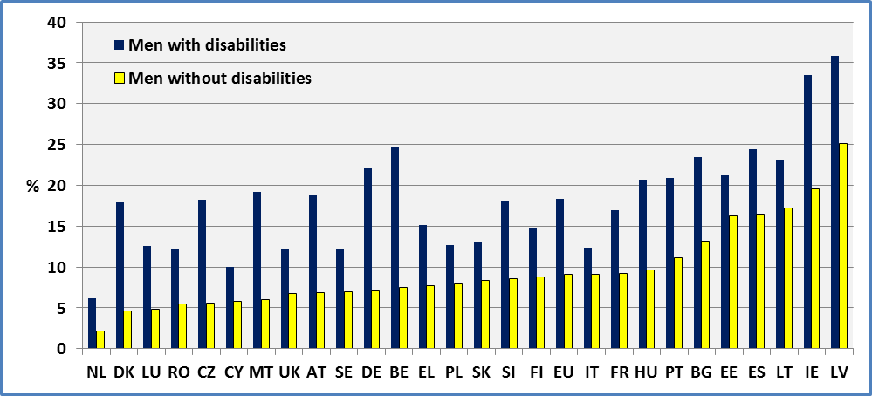
Data source: EU-SILC 2009

Data

Table 7: Unemployment rate by disability status and Member State (age 20-64)

 | 2008 |  |  |  | 2009
 | Men + Women |  |  |  | Men + Women
 | Disability |  |  | All observations | Disability |  |  | All observations
 | Yes | No | Total |  | Yes | No | Total
AT | 16.4 | 4.4 | 6.6 | 6.6 | 19.2 | 6.3 | 8.5 | 8.5
BE | 26.6 | 7.5 | 9.9 | 9.9 | 23.7 | 8.9 | 10.9 | 10.9
BG | 27.4 | 13.8 | 14.7 | 14.6 | 22.4 | 14.4 | 14.9 | 15.0
CY | 6.6 | 3.6 | 3.9 | 3.9 | 8.4 | 5.6 | 5.9 | 5.9
CZ | 24.7 | 7.1 | 8.9 | 9.0 | 23.3 | 7.1 | 9.0 | 9.0
DE | 21.3 | 6.8 | 10.2 | 10.5 | 21.1 | 7.3 | 10.3 | 10.8
DK | 10.4 | 2.7 | 4.0 | 4.1 | 14.4 | 4.3 | 6.2 | 6.1
EE | 9.0 | 4.5 | 5.1 | 5.1 | 15.2 | 11.8 | 12.3 | 12.3
EL | 17.1 | 7.9 | 8.5 | 8.5 | 17.9 | 9.6 | 10.0 | 10.0
ES | 19.3 | 10.3 | 11.3 | 11.3 | 25.8 | 17.3 | 18.4 | 18.4
FI | 11.2 | 6.7 | 7.6 | 7.9 | 14.8 | 7.6 | 9.1 | 9.4
FR |  |  |  |  | 16.6 | 9.3 | 10.3 | 10.3
HU | 20.0 | 9.9 | 11.2 | 11.2 | 19.8 | 9.7 | 11.0 | 10.9
IE | 20.2 | 9.9 | 10.9 | 10.9 | 26.4 | 15.3 | 16.3 | 16.3
IT | 11.1 | 8.9 | 9.2 | 9.2 | 13.9 | 10.6 | 11.0 | 11.0
LT | 13.5 | 6.4 | 7.2 | 7.1 | 17.0 | 14.5 | 14.7 | 14.9
LU | 10.8 | 3.5 | 4.5 | 4.5 | 13.4 | 6.4 | 7.4 | 7.4
LV | 14.0 | 7.6 | 8.9 | 8.9 | 29.4 | 20.8 | 22.3 | 22.3
MT |  |  |  |  | 17.6 | 6.1 | 6.6 | 6.6
NL | 4.5 | 1.1 | 1.7 | 1.7 | 5.0 | 1.9 | 2.5 | 2.5
PL | 15.3 | 8.9 | 9.4 | 9.4 | 13.9 | 8.4 | 8.9 | 8.9
PT | 12.3 | 8.6 | 9.2 | 9.2 | 19.4 | 12.5 | 13.6 | 13.7
RO | 5.9 | 4.8 | 4.9 | 4.9 | 7.6 | 4.7 | 4.9 | 4.9
SE | 9.7 | 4.4 | 5.0 | 5.1 | 11.0 | 6.2 | 6.6 | 6.7
SI | 22.3 | 8.7 | 11.2 | 11.0 | 21.0 | 9.0 | 11.3 | 12.0
SK | 9.5 | 6.6 | 7.2 | 7.2 | 11.4 | 8.9 | 9.4 | 9.5
UK | 7.4 | 3.2 | 3.6 | 3.6 | 8.5 | 5.3 | 5.6 | 5.6
EU | 16.3 | 7.3 | 8.5 | 8.4 | 17.7 | 9.2 | 10.4 | 10.2
Data source: EU-SILC 2008; EU-SILC 2009
All: includes observations for which we do not dispose information on disability status.
Table 8: Unemployment rate by disability status, gender and Member State (age 20-64)

 | 2008 |  |  |  |  |  | 2009
 | Females |  |  | Males |  |  | Females |  |  | Males
 | Disability |  |  | Disability |  |  | Disability |  |  | Disability
 | Yes | No | Total | Yes | No | Total | Yes | No | Total | Yes | No | Total
AT | 15.5 | 4.8 | 6.8 | 17.1 | 4.1 | 6.5 | 19.7 | 5.5 | 8.1 | 18.8 | 6.9 | 8.9
BE | 30.0 | 9.3 | 12.1 | 23.6 | 6.0 | 8.1 | 22.8 | 10.6 | 12.4 | 24.7 | 7.5 | 9.6
BG | 33.2 | 15.7 | 16.9 | 21.7 | 12.0 | 12.7 | 21.3 | 15.9 | 16.3 | 23.4 | 13.1 | 13.8
CY | 8.0 | 4.5 | 4.8 | 5.7 | 2.9 | 3.2 | 6.3 | 5.2 | 5.3 | 10.0 | 5.8 | 6.3
CZ | 28.4 | 9.0 | 11.2 | 20.9 | 5.4 | 7.0 | 28.4 | 8.7 | 11.1 | 18.3 | 5.6 | 7.0
DE | 20.8 | 7.3 | 10.4 | 21.8 | 6.5 | 10.0 | 20.1 | 7.6 | 10.4 | 22.1 | 7.0 | 10.3
DK | 13.7 | 3.1 | 5.1 | 6.7 | 2.3 | 3.0 | 11.3 | 3.9 | 5.4 | 18.0 | 4.6 | 7.0
EE | 3.2 | 2.5 | 2.6 | 14.3 | 6.3 | 7.5 | 9.3 | 7.2 | 7.5 | 21.2 | 16.2 | 17.0
EL | 18.5 | 10.9 | 11.4 | 16.0 | 5.7 | 6.4 | 21.2 | 12.2 | 12.6 | 15.1 | 7.7 | 8.0
ES | 20.8 | 11.8 | 12.9 | 18.0 | 9.1 | 10.1 | 27.5 | 18.3 | 19.6 | 24.4 | 16.5 | 17.5
FI | 10.0 | 6.4 | 7.2 | 12.5 | 7.0 | 7.9 | 14.7 | 6.2 | 8.1 | 14.9 | 8.8 | 10.0
FR |  |  |  |  |  |  | 16.3 | 9.4 | 10.4 | 17.0 | 9.2 | 10.1
HU | 20.6 | 10.0 | 11.4 | 19.5 | 9.8 | 11.0 | 19.0 | 9.8 | 11.1 | 20.7 | 9.7 | 11.0
IE | 11.4 | 6.2 | 6.6 | 25.9 | 12.8 | 14.1 | 15.9 | 9.5 | 10.0 | 33.5 | 19.6 | 20.9
IT | 11.2 | 10.9 | 10.9 | 11.0 | 7.6 | 8.0 | 15.6 | 12.8 | 13.1 | 12.4 | 9.1 | 9.5
LT | 13.4 | 5.1 | 6.1 | 13.5 | 7.7 | 8.3 | 12.9 | 11.8 | 11.9 | 23.2 | 17.2 | 17.6
LU | 8.8 | 3.8 | 4.5 | 12.6 | 3.3 | 4.5 | 14.4 | 8.6 | 9.5 | 12.6 | 4.8 | 5.8
LV | 11.2 | 5.8 | 6.9 | 17.0 | 9.2 | 10.7 | 23.3 | 16.3 | 17.6 | 35.8 | 25.2 | 27.0
MT |  |  |  |  |  |  | 14.1 | 6.2 | 6.5 | 19.2 | 6.0 | 6.7
NL | 4.2 | 1.1 | 1.7 | 4.7 | 1.1 | 1.6 | 4.0 | 1.6 | 2.1 | 6.1 | 2.2 | 2.8
PL | 16.3 | 11.3 | 11.7 | 14.6 | 6.8 | 7.5 | 15.4 | 9.0 | 9.5 | 12.6 | 7.9 | 8.4
PT | 11.5 | 10.1 | 10.4 | 13.2 | 7.3 | 8.1 | 18.2 | 14.1 | 14.9 | 20.9 | 11.1 | 12.5
RO | 2.9 | 3.2 | 3.2 | 8.7 | 5.9 | 6.1 | 2.9 | 3.6 | 3.5 | 12.2 | 5.5 | 5.9
SE | 9.3 | 4.2 | 4.9 | 10.2 | 4.6 | 5.1 | 10.2 | 5.4 | 5.9 | 12.2 | 7.0 | 7.3
SI | 22.9 | 10.5 | 12.8 | 21.9 | 7.1 | 9.8 | 24.0 | 9.5 | 12.4 | 18.1 | 8.6 | 10.3
SK | 10.7 | 8.1 | 8.7 | 8.1 | 5.2 | 5.7 | 9.7 | 9.6 | 9.6 | 13.1 | 8.4 | 9.3
UK | 6.2 | 2.1 | 2.6 | 8.7 | 4.2 | 4.6 | 4.8 | 3.5 | 3.7 | 12.1 | 6.7 | 7.3
EU | 16.1 | 7.9 | 9.1 | 16.6 | 6.7 | 8.0 | 17.1 | 9.3 | 10.5 | 18.3 | 9.1 | 10.3
Data source: EU-SILC 2008 ; EU-SILC 2009
Table 9: Unemployment rate by disability status, age group and Member State

 | 2008
 | Persons with disabilities |  |  |  |  |  | All persons
 | 16-24 | 25-  34 | 35-  44 | 45-54 | 55-64 | 16-64 | 16-24 | 25-34 | 35-44 | 45-54 | 55-64 | 16-64
AT | 14.8 | 17.8 | 12.9 | 15.8 | 20.9 | 16.2 | 7.0 | 6.1 | 6.1 | 6.4 | 11.2 | 6.8
BE | 34.3 | 20.6 | 22.4 | 24.6 | 40.6 | 26.8 | 17.3 | 7.3 | 7.3 | 8.1 | 23.0 | 10.1
BG | 63.9 | 12.4 | 33.2 | 26.7 | 27.7 | 28.7 | 26.2 | 13.0 | 13.1 | 13.7 | 19.0 | 15.6
CY | 2.2 | 17.2 | 3.2 | 7.5 | 4.7 | 6.6 | 8.0 | 4.9 | 3.1 | 2.8 | 3.1 | 3.9
CZ | 5.8 | 17.5 | 24.3 | 29.4 | 23.5 | 24.7 | 21.2 | 7.8 | 7.4 | 9.4 | 8.9 | 9.4
DE | 15.0 | 23.5 | 16.2 | 20.8 | 26.2 | 21.2 | 8.1 | 10.6 | 7.4 | 10.5 | 16.9 | 10.4
DK | 24.5 | 10.5 | 13.3 | 7.5 | 9.0 | 11.4 | 10.1 | 4.8 | 3.8 | 2.8 | 5.1 | 4.5
EE | 5.7 | 13.0 | 12.1 | 9.3 | 5.6 | 9.1 | 9.4 | 4.5 | 4.9 | 5.9 | 3.8 | 5.4
EL | 7.2 | 25.5 | 28.4 | 14.8 | 8.9 | 17.1 | 23.4 | 12.2 | 6.3 | 4.9 | 5.1 | 8.7
ES | 35.2 | 18.1 | 19.7 | 16.1 | 22.2 | 19.5 | 18.7 | 11.6 | 10.5 | 9.5 | 13.3 | 11.6
FI | 8.1 | 10.3 | 9.5 | 8.6 | 16.4 | 11.1 | 10.5 | 5.9 | 7.8 | 6.9 | 11.1 | 8.0
FR
HU | 33.2 | 14.0 | 24.7 | 20.4 | 16.0 | 20.1 | 23.3 | 10.4 | 10.6 | 10.5 | 9.0 | 11.6
IE | 43.0 | 28.0 | 16.6 | 7.0 | 19.1 | 20.0 | 21.3 | 10.7 | 9.1 | 7.0 | 11.0 | 11.3
IT | 29.7 | 15.1 | 11.1 | 10.0 | 8.4 | 11.5 | 33.2 | 13.5 | 6.9 | 5.5 | 4.9 | 9.8
LT | 29.1 | 8.6 | 9.1 | 13.0 | 19.5 | 13.5 | 7.5 | 6.7 | 5.4 | 7.7 | 10.7 | 7.2
LU | 29.4 | 8.1 | 12.3 | 11.0 | 7.1 | 11.2 | 15.5 | 4.4 | 3.9 | 3.7 | 3.1 | 4.7
LV | 16.2 | 15.8 | 13.3 | 15.2 | 12.0 | 14.1 | 13.3 | 8.2 | 8.0 | 9.2 | 8.6 | 9.1
MT
NL | 10.6 | 2.2 | 4.6 | 3.0 | 6.3 | 4.4 | 4.5 | 1.2 | 1.6 | 1.0 | 3.2 | 1.8
PL | 20.3 | 16.5 | 11.8 | 15.9 | 15.2 | 15.3 | 17.5 | 8.7 | 7.3 | 9.2 | 10.3 | 9.5
PT | 23.8 | 15.2 | 15.8 | 10.8 | 9.0 | 12.4 | 18.9 | 8.9 | 8.1 | 7.9 | 9.3 | 9.4
RO | 9.3 | 7.1 | 5.7 | 6.7 | 3.3 | 5.8 | 13.7 | 5.2 | 4.0 | 3.4 | 3.8 | 5.2
SE | 33.5 | 12.7 | 14.5 | 7.8 | 4.4 | 11.2 | 20.1 | 5.3 | 4.1 | 3.3 | 4.2 | 5.7
SI | 35.8 | 18.3 | 18.8 | 20.8 | 37.7 | 22.4 | 23.4 | 10.6 | 6.7 | 11.0 | 22.4 | 11.1
SK | 15.5 | 8.3 | 9.5 | 10.6 | 7.1 | 9.5 | 15.7 | 7.4 | 5.8 | 6.9 | 5.5 | 7.5
UK | 19.3 | 11.9 | 8.4 | 4.8 | 3.7 | 7.5 | 11.7 | 4.0 | 3.0 | 2.4 | 2.5 | 3.9
EU | 22.1 | 17.0 | 14.8 | 15.6 | 17.9 | 16.4 | 16.0 | 9.0 | 6.7 | 7.2 | 9.7 | 8.6
Data source: EU-SILC 2008
Table 10: Unemployment rate by disability status, age group and Member State

 | 2009
 | Persons with disabilities |  |  |  |  |  | All persons
 | 16-24 | 25-34 | 35-44 | 45-54 | 55-64 | 16-64 | 16-24 | 25-34 | 35-44 | 45-54 | 55-64 | 16-64
AT | 11.1 | 32.1 | 18.4 | 15.5 | 20.3 | 19.0 | 12.1 | 10.6 | 7.6 | 7.0 | 10.3 | 8.8
BE | 44.1 | 19.5 | 17.1 | 21.9 | 37.5 | 24.0 | 23.0 | 9.6 | 7.3 | 8.6 | 20.8 | 11.1
BG | 32.8 | 12.6 | 17.8 | 29.5 | 22.6 | 22.7 | 32.7 | 14.2 | 11.9 | 13.9 | 16.6 | 15.7
CY | 11.2 | 14.1 | 8.8 | 6.1 | 6.9 | 8.4 | 14.4 | 6.6 | 3.3 | 4.7 | 7.4 | 5.9
CZ | 21.7 | 21.2 | 22.1 | 25.9 | 22.5 | 23.4 | 20.8 | 8.7 | 6.3 | 10.3 | 8.7 | 9.5
DE | 23.7 | 27.4 | 16.0 | 18.7 | 25.9 | 21.3 | 10.9 | 11.9 | 8.5 | 9.2 | 15.7 | 10.7
DK | 24.8 | 20.4 | 8.2 | 17.3 | 7.6 | 14.2 | 15.3 | 7.9 | 4.3 | 6.1 | 4.1 | 6.4
EE | 21.6 | 15.6 | 17.9 | 15.8 | 11.8 | 15.3 | 28.8 | 12.4 | 10.0 | 11.5 | 8.8 | 12.7
EL | 39.8 | 79.8 | 26.9 | 13.5 | 12.8 | 18.2 | 30.2 | 13.5 | 8.1 | 6.2 | 5.6 | 10.2
ES | 43.2 | 28.3 | 24.0 | 21.3 | 30.9 | 26.3 | 37.2 | 19.9 | 16.5 | 14.3 | 19.2 | 19.0
FI | 12.0 | 11.9 | 13.5 | 13.5 | 20.1 | 14.9 | 16.3 | 8.7 | 7.7 | 7.8 | 12.9 | 9.7
FR | 28.6 | 18.9 | 14.2 | 14.3 | 19.2 | 16.7 | 24.7 | 10.8 | 8.5 | 6.7 | 12.9 | 10.7
HU | 63.8 | 21.8 | 22.2 | 18.6 | 14.7 | 20.0 | 25.3 | 11.2 | 10.5 | 9.4 | 7.5 | 11.3
IE | 36.0 | 25.6 | 26.8 | 28.0 | 22.0 | 26.7 | 28.9 | 17.3 | 17.0 | 12.5 | 11.9 | 17.0
IT | 38.9 | 25.0 | 12.8 | 10.9 | 10.0 | 14.1 | 39.9 | 15.8 | 8.7 | 6.6 | 5.5 | 11.7
LT | 39.5 | 26.1 | 15.5 | 12.2 | 17.2 | 17.1 | 30.7 | 17.0 | 13.1 | 10.3 | 13.6 | 15.1
LU | 38.3 | 10.0 | 12.3 | 12.3 | 21.5 | 13.5 | 20.0 | 7.7 | 6.3 | 5.6 | 6.1 | 7.4
LV | 50.2 | 34.8 | 31.7 | 25.9 | 26.0 | 29.9 | 39.3 | 23.8 | 19.9 | 19.8 | 19.7 | 23.2
MT | 19.4 | 15.3 | 8.1 | 22.1 | 15.6 | 17.5 | 18.0 | 5.1 | 4.3 | 7.2 | 4.9 | 7.9
NL | 7.3 | 5.3 | 3.1 | 3.4 | 8.6 | 5.0 | 7.3 | 2.3 | 1.6 | 1.7 | 3.8 | 2.6
PL | 27.4 | 23.5 | 9.6 | 13.2 | 10.7 | 14.0 | 19.4 | 9.2 | 6.1 | 8.7 | 7.4 | 9.1
PT | 25.8 | 21.6 | 18.7 | 21.0 | 16.4 | 19.6 | 25.2 | 13.7 | 12.3 | 12.2 | 13.2 | 13.8
RO | 22.6 | 9.2 | 9.5 | 7.1 | 3.5 | 7.6 | 17.3 | 4.3 | 3.8 | 4.1 | 2.2 | 5.2
SE | 48.3 | 11.4 | 15.7 | 6.6 | 6.9 | 12.3 | 25.4 | 6.2 | 4.9 | 5.2 | 6.3 | 7.5
SI | 37.4 | 24.2 | 14.8 | 21.2 | 27.3 | 21.1 | 25.7 | 12.4 | 7.5 | 11.1 | 23.3 | 12.2
SK | 30.0 | 9.9 | 10.6 | 12.5 | 8.4 | 11.5 | 27.3 | 8.6 | 7.4 | 9.0 | 6.3 | 9.9
UK | 26.4 | 12.9 | 4.6 | 7.9 | 8.8 | 9.4 | 17.1 | 6.4 | 4.1 | 4.8 | 4.7 | 6.5
EU | 29.0 | 22.4 | 14.9 | 15.7 | 19.6 | 18.0 | 22.0 | 11.6 | 8.3 | 8.1 | 10.7 | 10.6
Data source: EU-SILC 2009

Data source

- EUSILC UDB 2008 – version 3 of March 2011
- EUSILC UDB 2009 – version 1 of March 2011

Methodology

The unemployment rate represents unemployed persons as a percentage of the labour force. The labour force includes the total number of people employed and unemployed.

EU-SILC 2008 includes a question (PL030) on ‘Self-defined current economic status’. The possible answers are:

- Working full time
- Working part-time
- Unemployed
- Pupil, student, further training, unpaid work experience
- In retirement or in early retirement or has given up business
- Permanently disabled or/and unfit to work
- In compulsory military community or service
- Fulfilling domestic tasks and care responsibilities
- Other inactive person

The EU average for 2008 covers all Member States except France and Malta.

In 2009, a new classification was introduced. It distinguishes:

- Employee working full-time
- Employee working part-time
- Self-employed working full-time (including family worker)
- Self-employed working part-time (including family worker)
- Unemployed
- Pupil, student, further training, unpaid work experience
- In retirement or in early retirement or has given up business
- Permanently disabled or/and unfit to work
- In compulsory military community or service
- Fulfilling domestic tasks and care responsibilities
- Other inactive person

For estimations distinguishing those ‘limited’ and ‘not limited’ in Denmark, Finland, Netherland, Sweden and Slovenia we have used personal cross sectional weights for selected persons (pb060). Otherwise, we have used personal cross sectional weights (pb040).

Notes

The data here may be slightly different from those presented by Eurostat on its web page as Eurostat presents estimations using the results of the Labour Force Surveys (LFS).
The data are based on self-declarations. The resulting unemployment rates may be different from those based on administrative registers.

ACTIVITY RATE

Relevance to EU strategy

The goals promoted by the Europe 2020 Strategy, building on those associated with the Lisbon strategy place a strong emphasis on participation in the labour market as a prerequisite for work that ensures economic independence, fosters personal achievement, and offers the best protection against poverty.

The participation of disabled people in the open labour market is promoted in Article 27 of the UNCRPD and employment is also one of the eight priority areas for action in the European Disability Strategy 2010-2020 adopted in 2010. The aim is to raise significantly the share of persons with disabilities working in the open labour market.

The European Disability Strategy 2010-2020 aims notably to exploit the full potential of the Europe 2020 Strategy and its Agenda for new skills and jobs by providing Member States with analysis, political guidance, information exchange and other support.

The calculation of indicators on employment and unemployment cannot be considered in isolation from an understanding of overall economic activity and participation in the labour market. This is especially true for population groups historically marginalised from such participation (notably, women and disabled people).

Headline findings

There is a significant difference in activity rates between people with and without disabilities, in all Member States both for men and women. In 2009, the average economic activity rate for people with disabilities (those reporting activity limitations) was 55.5%, compared to 79.5% for people without limitations. The activity rate for people with disabilities is particularly low in Romania (32%), Greece (38%) and Poland (39%) while it reaches 68% in Germany.

Women with disabilities face a double disadvantage. In general, the activity rate of women is lower than that for men. Similarly, the activity rate of women with disabilities (50.6%) is lower than that for men with disabilities (61.1%).

At the EU level, there was a small increase in the activity rate of persons with disabilities between 2008 and 2009 (from 54.8% to 55.5%), despite a difficult environment following the onset of financial crisis. There were notable increases in Denmark, Luxembourg, Belgium, Spain and Finland but falls in Lithuania, Sweden, Greece, UK and Ireland.

From a life cycle perspective, the activity rate of people with disabilities is lower at all ages when compared to people without disabilities. The absolute difference increases with age until pre-retirement ages. Amongst older workers, the difference in activity rate between disabled and non-disabled people is decreasing (this may be due to certain Member States’ policies in favour of early retirement for people with disabilities).

The evolution of national activity rates indicates that change in activity rates for non-disabled people is not accompanied by a parallel change in the rate for people with disabilities (an increase in one may be accompanied by a decrease in the other). Countries with similar activity rates for non-disabled people present big differences in the activity rate for people with disabilities. This finding suggests that national interventions and policies make a difference and that there is scope to increase the economic activity of people with disabilities. However, increasing participation in the labour force should not be confused with movement into employment (although it may reflect Member States’ policies to move more people with disabilities from economic inactivity to active job search).

Figure 15: Activity rate by disability status and Member State (age 20-64), 2009

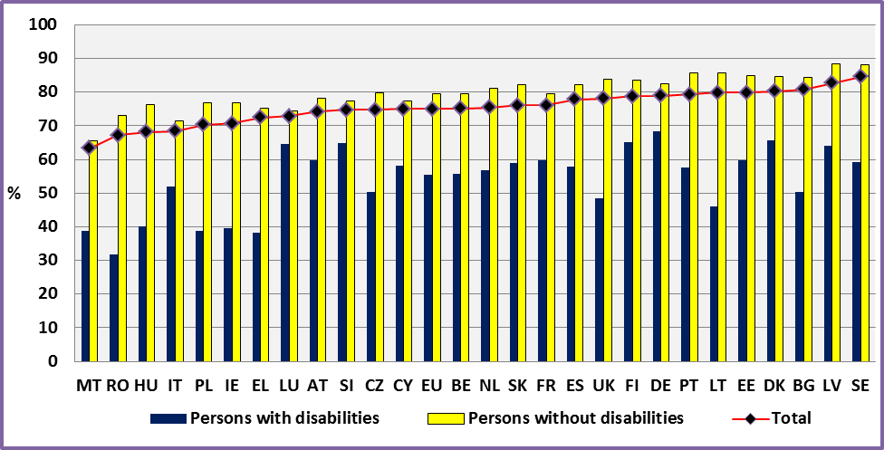
Data source: EU-SILC 2009

Figure 16: Activity rate of persons with disabilities (Age 16-64)

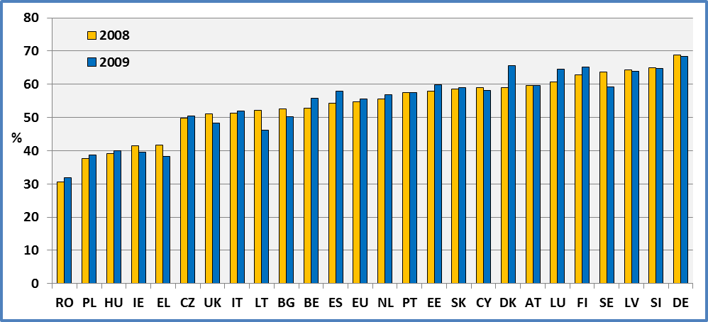
Data source: EU-SILC 2008; EU-SILC 2009

Figure 17: Activity rate by disability status and Member State (women aged 20-64), 2009

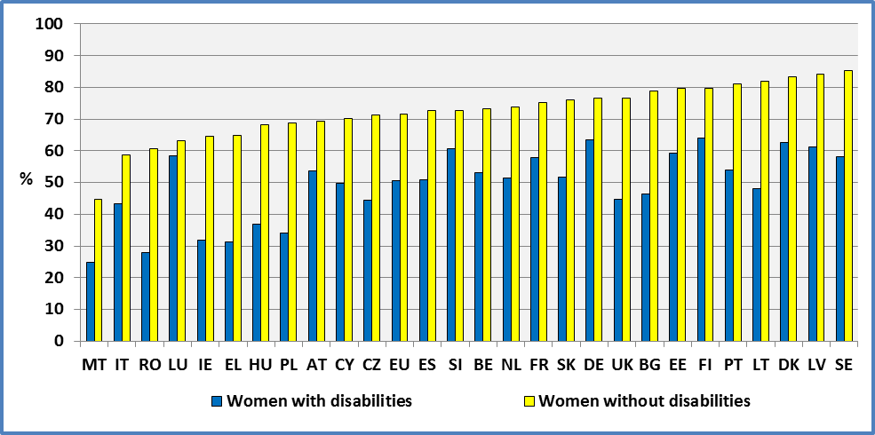
Data source: EU-SILC 2009

Figure 18: Activity rate by disability status and Member State (men age 20-64), 2009

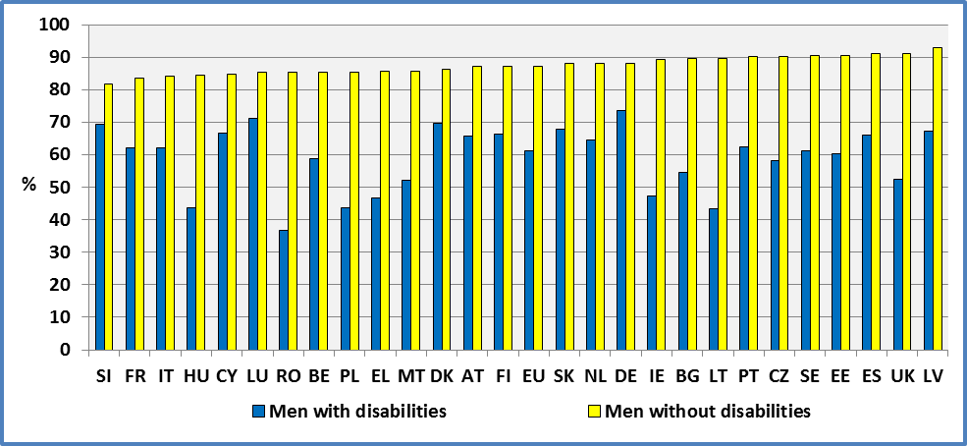
Data source: EU-SILC 2009

Data

Table 11: Activity rate by disability status and Member State (age 20-64)

 | 2008 |  |  |  | 2009
 | Women and Men |  |  |  | Women and Men
 | Disability |  |  |  | Disability
 | Yes | No | Total | All observations | Yes | No | Total | All observations
AT | 59.7 | 77.5 | 73.4 | 73.4 | 59.7 | 78.2 | 74.2 | 74.2
BE | 52.9 | 79.3 | 74.6 | 74.6 | 55.8 | 79.4 | 75.1 | 75.1
BG | 52.6 | 85.0 | 81.7 | 81.7 | 50.2 | 84.3 | 80.7 | 80.8
CY | 59.1 | 77.5 | 75.2 | 75.3 | 58.2 | 77.4 | 75.0 | 75.0
CZ | 49.8 | 80.3 | 75.4 | 76.0 | 50.4 | 79.9 | 74.8 | 75.7
DE | 68.9 | 82.4 | 78.9 | 78.9 | 68.4 | 82.4 | 78.9 | 79.0
DK | 59.1 | 83.5 | 77.8 | 77.1 | 65.7 | 84.7 | 80.2 | 79.8
EE | 58.0 | 85.5 | 79.8 | 79.8 | 59.8 | 84.8 | 79.9 | 79.9
EL | 41.8 | 75.7 | 72.0 | 72.0 | 38.2 | 75.3 | 72.4 | 72.4
ES | 54.2 | 81.2 | 76.9 | 76.9 | 57.9 | 82.1 | 77.8 | 77.8
FI | 62.8 | 84.1 | 78.9 | 78.1 | 65.1 | 83.5 | 78.8 | 78.1
FR |  |  |  |  | 59.7 | 79.4 | 76.1 | 76.1
HU | 39.1 | 76.0 | 67.5 | 67.6 | 40.1 | 76.2 | 68.2 | 68.5
IE | 41.5 | 78.7 | 72.5 | 72.5 | 39.5 | 76.8 | 70.7 | 70.7
IT | 51.4 | 72.4 | 68.8 | 68.9 | 51.9 | 71.6 | 68.5 | 68.4
LT | 52.1 | 85.4 | 79.6 | 79.2 | 46.1 | 85.7 | 79.9 | 79.9
LU | 60.6 | 75.3 | 72.8 | 72.8 | 64.5 | 74.5 | 72.8 | 72.9
LV | 64.4 | 85.4 | 80.2 | 80.2 | 63.9 | 88.3 | 82.7 | 82.7
MT |  |  |  |  | 38.8 | 65.5 | 63.4 | 63.4
NL | 55.6 | 80.2 | 74.6 | 75.2 | 56.8 | 81.1 | 75.4 | 76.0
PL | 37.6 | 76.0 | 70.0 | 70.0 | 38.7 | 76.7 | 70.3 | 70.3
PT | 57.4 | 85.1 | 79.3 | 79.3 | 57.6 | 85.8 | 79.3 | 79.3
RO | 30.7 | 72.8 | 67.3 | 67.3 | 31.8 | 73.1 | 67.2 | 67.2
SE | 63.7 | 88.4 | 85.1 | 84.6 | 59.3 | 88.1 | 84.5 | 84.8
SI | 64.9 | 77.5 | 74.8 | 74.0 | 64.8 | 77.5 | 74.7 | 74.2
SK | 58.6 | 83.7 | 77.2 | 77.2 | 58.9 | 82.1 | 76.1 | 76.1
UK | 51.0 | 84.0 | 78.8 | 78.8 | 48.4 | 83.9 | 78.1 | 78.1
EU | 54.8 | 79.3 | 74.8 | 75.0 | 55.5 | 79.5 | 75.1 | 75.3
Data source: EU-SILC 2008; EU-SILC 2009
All: includes observations for which we do not dispose information on disability status.
Table 12: Activity rate by year, gender, disability status and Member State (age 20-64)

 | 2008 |  |  |  |  |  | 2009
 | Females |  |  | Males |  |  | Females |  |  | Males
 | Disability |  |  | Disability |  |  | Disability |  |  | Disability
 | Yes | No | Total* | Yes | No | Total | Yes | No | Total* | Yes | No | Total
AT | 52.0 | 67.3 | 63.8 | 67.2 | 87.7 | 83.0 | 53.6 | 69.3 | 65.9 | 65.9 | 87.1 | 82.5
BE | 48.3 | 73.6 | 68.8 | 58.0 | 84.9 | 80.3 | 53.1 | 73.4 | 69.4 | 58.9 | 85.3 | 80.8
BG | 51.2 | 79.0 | 76.1 | 54.1 | 91.1 | 87.4 | 46.5 | 79.0 | 75.4 | 54.5 | 89.6 | 86.2
CY | 48.4 | 70.7 | 68.0 | 69.2 | 84.7 | 82.6 | 49.6 | 70.2 | 67.7 | 66.5 | 84.8 | 82.5
CZ | 45.3 | 70.7 | 66.5 | 55.4 | 91.1 | 85.6 | 44.5 | 71.2 | 66.4 | 58.1 | 90.3 | 85.0
DE | 63.1 | 76.4 | 72.9 | 74.7 | 88.5 | 84.9 | 63.5 | 76.8 | 73.4 | 73.5 | 88.2 | 84.6
DK | 54.5 | 80.4 | 73.6 | 65.1 | 86.5 | 82.1 | 62.7 | 83.2 | 77.8 | 69.6 | 86.2 | 82.7
EE | 54.9 | 79.5 | 74.6 | 61.2 | 92.2 | 85.6 | 59.3 | 79.7 | 75.8 | 60.2 | 90.6 | 84.4
EL | 33.3 | 64.3 | 60.5 | 52.1 | 87.0 | 83.5 | 31.4 | 64.8 | 61.9 | 46.7 | 85.7 | 83.0
ES | 48.3 | 71.3 | 67.3 | 60.7 | 90.6 | 86.2 | 51.0 | 72.7 | 68.5 | 65.9 | 91.0 | 87.0
FI | 62.9 | 79.8 | 75.4 | 62.7 | 88.2 | 82.4 | 63.9 | 79.7 | 75.5 | 66.4 | 87.2 | 82.2
FR |  |  |  |  |  |  | 57.8 | 75.3 | 72.1 | 62.0 | 83.6 | 80.3
HU | 36.1 | 68.0 | 60.5 | 42.4 | 84.4 | 74.9 | 37.0 | 68.2 | 61.1 | 43.6 | 84.4 | 75.8
IE | 32.3 | 68.4 | 62.3 | 50.9 | 89.1 | 82.8 | 31.8 | 64.5 | 59.2 | 47.2 | 89.4 | 82.4
IT | 42.0 | 59.2 | 56.1 | 62.9 | 85.0 | 81.7 | 43.5 | 58.6 | 56.0 | 62.2 | 84.1 | 80.9
LT | 51.0 | 80.9 | 75.5 | 53.5 | 90.5 | 84.2 | 48.0 | 81.9 | 76.6 | 43.5 | 89.8 | 83.6
LU | 51.7 | 64.9 | 62.4 | 71.3 | 85.2 | 83.0 | 58.5 | 63.3 | 62.5 | 71.0 | 85.2 | 83.0
LV | 61.1 | 78.7 | 74.1 | 68.4 | 92.5 | 86.8 | 61.1 | 84.1 | 78.7 | 67.2 | 92.9 | 87.2
MT |  |  |  |  |  |  | 24.9 | 44.8 | 43.2 | 52.1 | 85.8 | 83.1
NL | 51.4 | 71.9 | 66.5 | 61.7 | 88.2 | 83.1 | 51.3 | 73.8 | 67.8 | 64.5 | 88.2 | 83.4
PL | 33.0 | 67.5 | 62.3 | 42.1 | 84.7 | 77.9 | 34.0 | 68.8 | 63.0 | 43.6 | 85.4 | 78.3
PT | 53.4 | 79.5 | 73.5 | 62.5 | 90.4 | 85.2 | 54.0 | 81.1 | 74.0 | 62.5 | 90.2 | 84.7
RO | 27.3 | 60.6 | 55.9 | 34.8 | 84.8 | 78.9 | 28.0 | 60.7 | 55.5 | 36.7 | 85.3 | 79.2
SE | 61.2 | 85.8 | 81.9 | 67.3 | 90.7 | 88.2 | 58.1 | 85.4 | 81.2 | 61.3 | 90.5 | 87.8
SI | 60.3 | 72.4 | 69.8 | 69.5 | 82.6 | 79.8 | 60.6 | 72.7 | 69.9 | 69.3 | 81.9 | 79.4
SK | 53.6 | 78.3 | 71.3 | 65.3 | 89.3 | 83.7 | 51.8 | 76.0 | 69.2 | 67.8 | 88.1 | 83.3
UK | 49.1 | 77.5 | 72.8 | 53.4 | 91.3 | 85.6 | 44.7 | 76.8 | 71.4 | 52.5 | 91.1 | 85.1
EU | 49.4 | 70.8 | 66.6 | 60.8 | 87.9 | 83.1 | 50.6 | 71.7 | 67.6 | 61.1 | 87.2 | 82.7
Data source: EU-SILC 2008 & EU-SILC 2009

Table 13: Activity rate by age group and Member State

 | 2008
 | Persons with disabilities |  |  |  |  |  | All persons
 | 16-24 | 25-  34 | 35-  44 | 45-54 | 55-64 | 16-64 | 16-24 | 25-34 | 35-44 | 45-54 | 55-64 | 16-64
AT | 49.5 | 76.4 | 77.5 | 74.4 | 30.8 | 59.1 | 53.8 | 78.7 | 87.3 | 85.8 | 37.7 | 71.1
BE | 43.7 | 69.1 | 70.3 | 60.0 | 28.3 | 51.8 | 33.0 | 90.8 | 89.8 | 80.6 | 42.4 | 69.9
BG | 54.6 | 68.0 | 67.8 | 62.3 | 33.8 | 52.5 | 47.5 | 90.4 | 94.0 | 90.7 | 53.2 | 76.3
CY | 32.2 | 56.7 | 74.7 | 72.1 | 45.0 | 58.3 | 28.6 | 85.7 | 89.9 | 82.8 | 56.2 | 70.1
CZ | 28.7 | 62.5 | 79.8 | 64.4 | 27.6 | 49.0 | 38.7 | 80.9 | 92.4 | 91.0 | 46.9 | 71.3
DE | 45.6 | 75.9 | 81.6 | 79.5 | 50.2 | 67.7 | 42.1 | 77.0 | 89.3 | 89.0 | 61.9 | 74.6
DK | 43.5 | 72.0 | 76.5 | 68.5 | 34.8 | 58.1 | 38.6 | 80.1 | 91.9 | 89.0 | 55.9 | 73.3
EE | 36.2 | 69.6 | 72.9 | 66.8 | 43.6 | 57.0 | 38.6 | 84.8 | 89.8 | 88.8 | 65.9 | 74.1
EL | 24.7 | 45.4 | 56.8 | 58.1 | 27.2 | 41.5 | 34.0 | 84.4 | 84.1 | 77.3 | 46.0 | 68.5
ES | 42.2 | 75.4 | 70.2 | 55.8 | 34.2 | 53.7 | 44.3 | 89.7 | 86.2 | 78.9 | 50.9 | 73.9
FI | 52.7 | 72.6 | 79.2 | 73.7 | 45.5 | 62.2 | 40.2 | 82.2 | 88.0 | 89.9 | 62.2 | 73.7
FR
HU | 33.0 | 68.3 | 62.7 | 48.8 | 15.8 | 38.6 | 35.7 | 81.2 | 86.5 | 78.5 | 29.5 | 63.6
IE | 44.0 | 52.1 | 51.9 | 45.6 | 28.8 | 40.9 | 46.7 | 79.2 | 82.2 | 75.4 | 55.4 | 67.2
IT | 41.4 | 67.5 | 73.0 | 63.6 | 26.7 | 51.0 | 37.3 | 78.1 | 82.6 | 77.4 | 38.4 | 66.3
LT | 32.2 | 70.3 | 70.0 | 56.8 | 34.7 | 51.4 | 32.5 | 88.3 | 92.1 | 87.9 | 59.8 | 73.3
LU | 37.5 | 90.7 | 86.6 | 59.4 | 24.8 | 58.7 | 31.7 | 88.8 | 88.4 | 74.9 | 37.1 | 68.9
LV | 40.4 | 77.9 | 74.8 | 76.4 | 46.1 | 63.0 | 44.7 | 86.4 | 89.7 | 88.3 | 61.1 | 74.9
MT
NL | 40.6 | 73.9 | 65.4 | 64.9 | 35.9 | 54.8 | 36.5 | 89.3 | 86.2 | 83.8 | 51.4 | 71.6
PL | 32.0 | 54.4 | 55.1 | 47.8 | 19.6 | 37.0 | 36.3 | 84.8 | 88.2 | 77.8 | 31.9 | 65.5
PT | 38.5 | 62.8 | 70.6 | 67.1 | 43.1 | 56.6 | 45.1 | 89.9 | 89.5 | 85.1 | 54.7 | 75.6
RO | 21.6 | 59.1 | 58.1 | 34.4 | 15.4 | 30.3 | 35.2 | 82.2 | 85.0 | 72.1 | 31.2 | 63.3
SE | 56.4 | 83.0 | 79.4 | 70.7 | 46.3 | 62.7 | 43.1 | 86.9 | 93.7 | 92.7 | 75.7 | 79.7
SI | 24.8 | 83.2 | 90.9 | 80.7 | 27.4 | 62.7 | 22.9 | 89.6 | 96.1 | 88.3 | 31.0 | 69.3
SK | 34.1 | 83.4 | 84.9 | 78.6 | 29.3 | 56.9 | 33.3 | 92.2 | 94.9 | 91.7 | 40.6 | 70.9
UK | 48.3 | 62.9 | 65.1 | 53.1 | 35.7 | 50.4 | 53.2 | 84.5 | 86.6 | 83.8 | 61.3 | 75.4
EU | 42.2 | 69.2 | 72.3 | 63.5 | 34.4 | 54.0 | 41.2 | 83.4 | 87.3 | 82.7 | 49.6 | 71.2
Data source: EU-SILC 2008

Table 14: Activity rate by age group and Member State

 | 2009
 | Persons with disabilities |  |  |  |  |  | All persons
 | 16-24 | 25-  34 | 35-  44 | 45-  54 | 55-64 | 16-64 | 16-24 | 25-34 | 35-44 | 45-54 | 55-64 | 16-  64
AT | 52.5 | 79.7 | 80.9 | 73.9 | 27.7 | 59.3 | 52.5 | 79.5 | 89.5 | 86.8 | 38.0 | 71.7
BE | 39.8 | 78.4 | 74.4 | 59.0 | 32.4 | 54.9 | 32.6 | 90.7 | 90.0 | 81.8 | 44.7 | 70.5
BG | 53.4 | 71.1 | 67.0 | 65.5 | 32.1 | 50.0 | 46.0 | 89.0 | 94.2 | 92.0 | 56.0 | 77.0
CY | 33.7 | 70.1 | 71.0 | 63.9 | 46.2 | 57.2 | 24.8 | 86.5 | 90.2 | 83.2 | 56.0 | 69.7
CZ | 33.4 | 66.4 | 72.2 | 66.5 | 27.8 | 49.3 | 35.6 | 81.5 | 91.1 | 91.2 | 47.3 | 70.9
DE | 48.9 | 74.5 | 77.5 | 77.0 | 54.2 | 67.4 | 45.3 | 77.2 | 88.8 | 89.0 | 64.5 | 75.4
DK | 39.7 | 80.8 | 77.9 | 76.0 | 39.6 | 63.1 | 39.8 | 83.2 | 93.5 | 90.4 | 60.8 | 75.7
EE | 34.7 | 80.6 | 76.1 | 62.5 | 45.6 | 58.8 | 39.0 | 85.7 | 91.2 | 87.7 | 66.8 | 74.7
EL | 29.3 | 26.2 | 46.2 | 57.7 | 27.5 | 38.0 | 30.3 | 85.5 | 85.5 | 78.9 | 45.8 | 68.9
ES | 39.3 | 77.1 | 72.5 | 60.8 | 37.1 | 57.0 | 42.8 | 89.5 | 88.5 | 80.5 | 51.2 | 74.7
FI | 43.6 | 80.5 | 79.6 | 74.7 | 47.8 | 64.0 | 37.9 | 82.8 | 89.0 | 89.4 | 62.1 | 73.5
FR | 39.6 | 82.2 | 84.0 | 74.4 | 33.2 | 58.4 | 40.6 | 90.4 | 92.3 | 89.3 | 41.1 | 71.9
HU | 20.8 | 62.3 | 64.1 | 57.3 | 17.0 | 39.4 | 30.0 | 80.3 | 86.3 | 82.2 | 34.3 | 63.5
IE | 32.1 | 55.6 | 49.4 | 43.6 | 24.5 | 38.2 | 42.4 | 78.9 | 78.4 | 73.2 | 53.8 | 65.1
IT | 33.9 | 72.9 | 70.1 | 66.8 | 26.6 | 51.3 | 36.2 | 77.7 | 81.3 | 77.5 | 39.4 | 65.8
LT | 22.6 | 63.9 | 56.2 | 54.5 | 33.2 | 44.9 | 35.8 | 90.6 | 91.1 | 87.7 | 59.8 | 74.2
LU | 20.7 | 88.7 | 82.6 | 71.5 | 31.3 | 63.2 | 33.2 | 89.5 | 86.1 | 77.8 | 39.4 | 69.5
LV | 44.8 | 78.1 | 76.5 | 74.7 | 44.5 | 62.6 | 47.3 | 89.4 | 92.3 | 89.9 | 62.8 | 77.4
MT | 54.2 | 67.6 | 56.7 | 48.9 | 15.5 | 38.5 | 61.3 | 84.3 | 71.2 | 63.1 | 26.0 | 61.3
NL | 29.2 | 70.3 | 61.9 | 71.7 | 39.2 | 55.7 | 37.1 | 88.8 | 85.5 | 84.4 | 54.1 | 72.1
PL | 21.9 | 57.5 | 62.6 | 52.1 | 19.2 | 38.0 | 36.1 | 85.0 | 88.6 | 78.8 | 32.9 | 65.9
PT | 41.1 | 67.5 | 72.5 | 68.4 | 39.3 | 56.6 | 42.0 | 91.1 | 90.3 | 85.6 | 52.2 | 75.4
RO | 36.1 | 50.7 | 56.5 | 39.3 | 15.8 | 31.7 | 35.2 | 81.8 | 84.6 | 73.5 | 31.3 | 63.6
SE | 38.8 | 69.3 | 69.0 | 70.4 | 45.9 | 57.9 | 46.0 | 86.3 | 93.4 | 92.6 | 77.0 | 80.5
SI | 17.6 | 90.1 | 91.6 | 79.7 | 28.6 | 63.3 | 22.8 | 90.2 | 95.9 | 89.5 | 33.3 | 69.7
SK | 26.7 | 77.2 | 83.5 | 79.4 | 31.0 | 57.1 | 31.5 | 88.1 | 94.0 | 91.7 | 42.7 | 70.2
UK | 49.2 | 56.2 | 56.7 | 55.5 | 34.4 | 48.1 | 53.1 | 82.8 | 84.7 | 85.6 | 60.9 | 74.4
EU | 40.3 | 70.9 | 71.4 | 66.1 | 35.2 | 54.7 | 41.6 | 84.0 | 87.6 | 84.2 | 49.5 | 71.5
Data source: EU-SILC 2009

Data source

- EUSILC UDB 2008 – version 3 of March 2011
- EUSILC UDB 2009 – version 1 of March 2011
Methodology

The total adult population is divided into economically active and inactive populations. The economically active population includes those who are employed and those who are unemployed. An active person is therefore a person who is economically active in the labour market (in work or actively seeking work).

The activity rate is the ratio of economically active people in the labour market (employed or unemployed) to the total population of the same age group.

EU-SILC 2008 includes a question (PL030) on ‘Self-defined current economic status’. The possible answers are:

- Working full time
- Working part-time
- Unemployed
- Pupil, student, further training, unpaid work experience
- In retirement or in early retirement or has given up business
- Permanently disabled or/and unfit to work
- In compulsory military community or service
- Fulfilling domestic tasks and care responsibilities
- Other inactive person

The EU average for 2008 covers all Member States except France and Malta.

In 2009, a new classification was introduced. It distinguishes:

- Employee working full-time
- Employee working part-time
- Self-employed working full-time (including family worker)
- Self-employed working part-time (including family worker)
- Unemployed
- Pupil, student, further training, unpaid work experience
- In retirement or in early retirement or has given up business
- Permanently disabled or/and unfit to work
- In compulsory military community or service
- Fulfilling domestic tasks and care responsibilities
- Other inactive person

We have included in the group of inactive people categories from ‘6’ to ‘11’.

For estimations distinguishing those ‘limited’ and ‘not limited’ in Denmark, Finland, Netherland, Sweden and Slovenia we have used personal cross sectional weights for selected persons (pb060). Otherwise, we have used personal cross sectional weights (pb040).

Notes

In order to make this indicator comparable to the Europe 2020 indicators, we focus on people aged 20-64. However, estimations by age group follow the standard Eurostat age groups.

EU-SILC estimators may overestimate the percentage of people with disabilities who participate in the labour force, since persons living in collective households and in institutions are generally excluded from the sample and are more likely to be economically inactive.

EDUCATION

EARLY LEAVERS FROM EDUCATION AND TRAINING

Relevance to EU policy / strategy

The eight priority areas for action in the EU Disability Strategy 2010-2020 include ‘Education and training’. The aim is to promote inclusive education and lifelong learning for students and pupils with disabilities. The Commission considers that access to mainstream education for children with severe disabilities is difficult and sometimes segregated. People with disabilities, in particular children, need to be integrated appropriately into the general education system and provided with individual support in the best interest of the child.

The European Disability Strategy will support national efforts to remove legal and organisational barriers for people with disabilities to general education and lifelong learning systems; provide timely support for inclusive education and personalised learning, and early identification of special needs. A reduction of early school leavers constitutes one indicator of success of such policies.

Europe 2020 considers that reducing the number of early school-leavers is crucial - better educational levels help employability and increasing the employment rate helps to reduce poverty. It considers essential that all people have sufficient basic knowledge and skills to fully participate in European society. This is viewed as crucial in both social and political life but also for entering the labour market, and will enable young people to understand and adapt to quickly-evolving societies.

Europe 2020 sets a target of not more than 10% early school leavers amongst the population aged 18-24 and refers to those with at most lower secondary education and not in further education or training.

Headline findings

Thirteen Member States have reached the target of 10% or less for the general population aged 18-24. Fourteen countries have attained this target for persons without disabilities but only two for persons with disabilities (Slovakia and Slovenia).

At the EU level, there is a difference of 10.9 percentage points between young people with disabilities (23.3%) and young without disabilities (12.4%). There is a disadvantage of 10 or more percentage points for young people with disabilities in 15 Member States. The gap is very great in Romania, where there is also a high number of persons with disabilities who have never been in education.
Generally, young women have better achievements (lower share of early school levers) than young men. This applies also to young women with disabilities in comparison to young men with disabilities.

The number of observations concerning people with disabilities (those reporting activity limitations in the EU-SILC data) aged 18-24 is small. For this reason caution must be exercised and we add estimations for the wider age group 18-29 for comparison, which are more robust.

There was a very small overall improvement of the situation of young people with disabilities at the EU level between 2008 and 2009 but with significant differences across Member States. In fact, there was an improvement in only 12 Member States (out of 25 for which we dispose information).

Figure 19: Share of early school leavers (aged 18-24), 2009

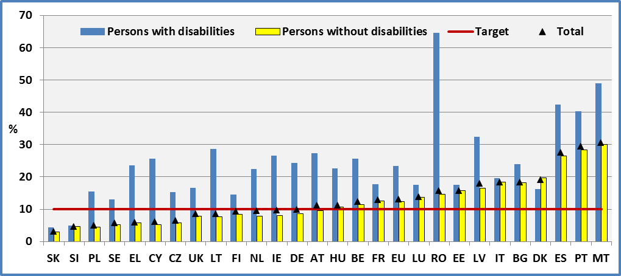
Data source: EU-SILC 2009

Figure 20: Persons with disabilities (aged 18-24), share of early school leavers by gender, 2009

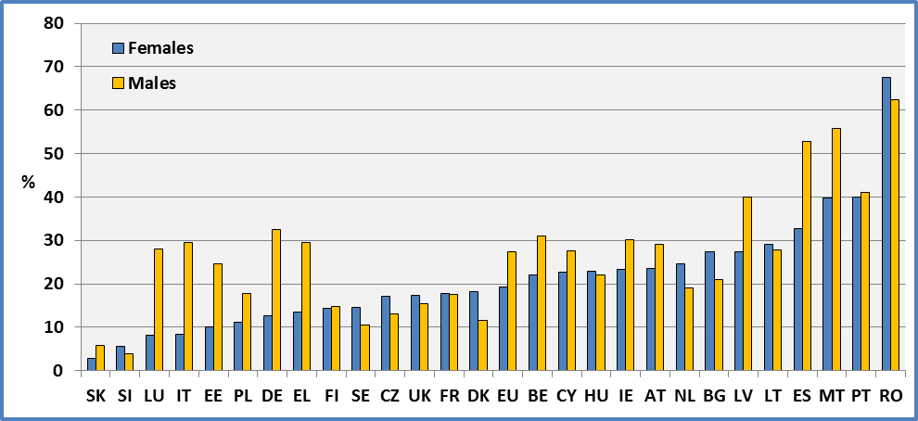
Data source: EU-SILC 2009

Figure 21: Share of early school leavers (aged 18-29) 2009

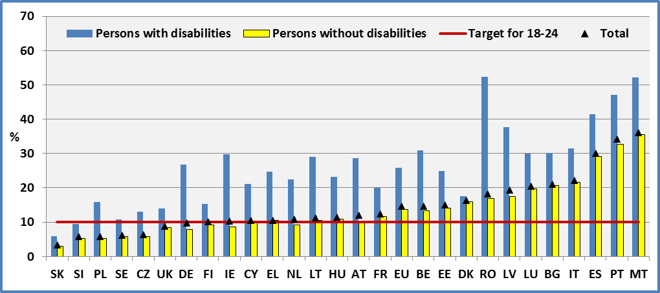
Data source: EU-SILC 2009

Figure 22: People with disabilities early school leavers (aged 18-29), Comparison between 2008 and 2009

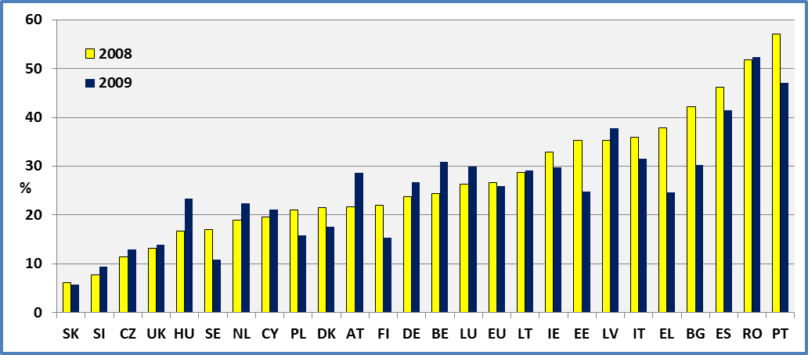
Data source: EU-SILC 2008 & EU-SILC 2009

Data

Table 15: Share of early school leavers (Age 18-24)

 | 2008 |  |  |  |  | 2009
 | Men + Women |  |  |  |  | Men + Women
 | Disability |  |  | All | LFS | Disability |  |  | All | LFS
 | Yes | No | Total |  |  | Yes | No | Total
AT | 24.6 | 12.6 | 13.6 | 13.6 | 10.1 | 27.3 | 9.5 | 11.2 | 11.2 | 8.7
BE | 27.1 | 9.9 | 11.2 | 12.7 | 12.0 | 25.7 | 11.5 | 12.4 | 12.4 | 11.1
BG | 54.7 | 21.9 | 23.1 | 23.1 | 14.8 | 23.9 | 18.2 | 18.4 | 18.4 | 14.7
CY | 22.8 | 8.4 | 8.9 | 8.9 | 13.7 | 25.7 | 5.2 | 6.1 | 6.1 | 11.7
CZ | 9.7 | 5.7 | 5.9 | 6.5 | 5.6 | 15.3 | 5.8 | 6.5 | 6.6 | 5.4
DE | 19.9 | 8.0 | 9.1 | 9.5 | 11.8 | 24.3 | 8.6 | 10.0 | 10.4 | 11.1
DK | 27.2 | 16.8 | 18.7 | 17.1 | 11.3 | 16.2 | 19.6 | 19.1 | 21.3 | 10.6
EE | 28.3 | 13.7 | 14.6 | 14.6 | 14.0 | 17.6 | 15.7 | 15.8 | 15.8 | 13.9
EL | 36.0 | 10.1 | 10.5 | 10.5 | 14.8 | 23.5 | 5.9 | 6.0 | 6.0 | 14.5
ES | 40.5 | 27.7 | 28.4 | 28.4 | 31.9 | 42.3 | 26.5 | 27.6 | 27.6 | 31.2
FI | 26.8 | 8.7 | 11.0 | 10.9 | 9.8 | 14.5 | 8.4 | 9.3 | 10.0 | 9.9
FR |  |  |  |  | 11.9 | 17.7 | 12.6 | 13.0 | 13.0 | 12.4
HU | 20.3 | 12.3 | 12.7 | 12.7 | 11.7 | 22.5 | 10.8 | 11.3 | 11.5 | 11.2
IE | 31.3 | 10.1 | 11.9 | 11.9 | 11.3 | 26.5 | 8.1 | 9.8 | 9.8 | 11.3
IT | 32.5 | 17.0 | 17.9 | 18.0 | 19.7 | 19.5 | 18.3 | 18.4 | 18.4 | 19.2
LT | 11.8 | 5.8 | 6.1 | 5.7 | 7.4 | 28.7 | 7.6 | 8.6 | 9.2 | 8.7
LU | 24.1 | 12.1 | 13.0 | 13.1 | 13.4 | 17.6 | 13.6 | 13.8 | 14.0 | 7.7
LV | 29.1 | 15.1 | 16.3 | 16.3 | 15.5 | 32.5 | 16.5 | 17.9 | 17.9 | 13.9
MT |  |  |  |  | 38.1 | 48.9 | 30.1 | 30.6 | 30.5 | 36.8
NL | 21.0 | 8.1 | 9.5 | 13.1 | 11.4 | 22.5 | 7.8 | 9.6 | 13.4 | 10.9
PL | 17.1 | 3.7 | 4.4 | 4.4 | 5.0 | 15.5 | 4.4 | 5.0 | 5.0 | 5.3
PT | 58.5 | 33.1 | 34.8 | 34.8 | 35.4 | 40.4 | 28.3 | 29.4 | 29.4 | 31.2
RO | 65.9 | 14.6 | 16.1 | 16.1 | 15.9 | 64.6 | 14.7 | 15.8 | 15.8 | 16.6
SE | 12.4 | 6.1 | 6.6 | 7.2 | 12.2 | 13.0 | 5.2 | 5.7 | 8.0 | 10.7
SI | 8.3 | 4.2 | 4.7 | 4.8 | 5.1 | 4.9 | 4.6 | 4.6 | 4.9 | 5.3
SK | 4.5 | 2.4 | 2.5 | 2.6 | 6.0 | 4.5 | 3.0 | 3.1 | 3.1 | 4.9
UK | 16.1 | 6.8 | 7.6 | 7.6 | 17.0 | 16.6 | 7.9 | 8.5 | 8.6 | 15.7
EU | 25.2 | 12.4 | 13.3 | 13.3 | 14.9 | 23.3 | 12.4 | 13.2 | 13.3 | 14.4
Data source: EU-SILC 2008 ; EU-SILC 2009
DK: The number of observations concerning people with disabilities is very small and a high number declare to be in further education or training.
All: includes observations for which we do not dispose information on disability status.
Table 16: Share of early school leavers (Age 18-29)

 | 2008 |  |  | 2009
 | Men + Women |  |  | Men + Women
 | Disability |  |  | Disability
 | Yes | No | Total | Yes | No | Total
AT | 21.7 | 11.1 | 12.2 | 28.7 | 10.2 | 12.0
BE | 24.4 | 11.7 | 12.7 | 30.9 | 13.3 | 14.6
BG | 42.2 | 24.3 | 25.0 | 30.2 | 20.6 | 21.1
CY | 19.6 | 10.7 | 11.1 | 21.1 | 9.8 | 10.4
CZ | 11.4 | 5.4 | 5.8 | 13.0 | 5.9 | 6.4
DE | 23.8 | 8.6 | 10.2 | 26.7 | 7.9 | 9.7
DK | 21.5 | 14.3 | 15.7 | 17.6 | 16.0 | 16.3
EE | 35.2 | 14.4 | 16.0 | 24.8 | 14.0 | 14.9
EL | 37.9 | 12.1 | 12.7 | 24.7 | 10.4 | 10.5
ES | 46.2 | 28.8 | 29.9 | 41.4 | 29.0 | 30.0
FI | 22.0 | 8.2 | 9.9 | 15.3 | 9.2 | 10.2
FR |  |  |  | 20.1 | 11.7 | 12.3
HU | 16.7 | 11.4 | 11.8 | 23.3 | 10.9 | 11.5
IE | 32.8 | 11.7 | 13.4 | 29.7 | 8.6 | 10.4
IT | 36.0 | 21.1 | 22.1 | 31.5 | 21.6 | 22.2
LT | 28.7 | 8.9 | 10.2 | 29.1 | 10.4 | 11.3
LU | 26.3 | 19.2 | 19.8 | 29.9 | 19.7 | 20.4
LV | 35.2 | 17.1 | 19.0 | 37.7 | 17.4 | 19.4
MT |  |  |  | 52.1 | 35.6 | 36.1
NL | 18.9 | 8.8 | 10.0 | 22.4 | 9.1 | 10.9
PL | 21.0 | 4.4 | 5.3 | 15.8 | 5.2 | 5.8
PT | 57.0 | 35.9 | 37.4 | 47.1 | 32.7 | 34.1
RO | 51.8 | 17.4 | 18.5 | 52.3 | 16.9 | 18.2
SE | 17.1 | 7.0 | 7.7 | 10.8 | 5.8 | 6.1
SI | 7.8 | 4.9 | 5.2 | 9.4 | 5.2 | 5.7
SK | 6.1 | 2.4 | 2.8 | 5.8 | 3.0 | 3.3
UK | 13.2 | 7.0 | 7.6 | 13.9 | 8.4 | 8.8
EU | 26.6 | 13.9 | 14.9 | 25.9 | 13.6 | 14.5
Data source: EU-SILC 2008 ; EU-SILC 2009
Table 17: Share of early school leavers by gender (aged 18-24)

 | 2008 |  |  |  |  |  |  | 2009
 | Females |  |  |  | Males |  |  | Females |  |  | Males
 | Disability |  |  |  | Disability |  |  | Disability |  |  | Disability
 | Yes | No | Total |  | Yes | No | Total | Yes | No | Total | Yes | No | Total
AT | 19.4 | 12.9 |  | 13.4 | 29.1 | 12.3 | 13.8 | 23.5 | 10.7 | 11.5 | 29.2 | 8.4 | 10.8
BE | 29.5 | 7.5 |  | 9.2 | 24.3 | 12.3 | 13.1 | 22.0 | 9.0 | 10.1 | 31.1 | 13.9 | 14.8
BG | 58.9 | 21.4 |  | 23.0 | 48.7 | 22.4 | 23.2 | 27.5 | 18.3 | 18.6 | 20.9 | 18.1 | 18.3
CY | 23.4 | 6.6 |  | 7.1 | 22.4 | 10.3 | 10.8 | 22.7 | 4.0 | 4.6 | 27.7 | 6.5 | 7.6
CZ | 10.9 | 5.0 |  | 5.4 | 8.3 | 6.4 | 6.5 | 17.1 | 4.6 | 5.6 | 13.0 | 6.9 | 7.3
DE | 14.6 | 8.0 |  | 8.6 | 24.7 | 8.1 | 9.5 | 12.7 | 8.6 | 8.9 | 32.5 | 8.6 | 10.9
DK | 17.9 | 18.7 |  | 18.5 | 41.6 | 14.9 | 18.9 | 18.2 | 15.9 | 16.4 | 11.6 | 22.7 | 21.6
EE | 27.8 | 9.0 |  | 10.0 | 28.6 | 18.4 | 19.1 | 10.0 | 11.5 | 11.4 | 24.7 | 19.7 | 20.1
EL | 41.3 | 9.0 |  | 9.4 | 32.9 | 11.2 | 11.6 | 13.6 | 5.1 | 5.2 | 29.6 | 6.6 | 6.8
ES | 36.3 | 19.9 |  | 20.9 | 45.7 | 35.2 | 35.7 | 32.7 | 20.3 | 21.2 | 52.8 | 32.4 | 33.7
FI | 28.8 | 6.2 |  | 9.6 | 23.7 | 11.0 | 12.3 | 14.4 | 6.1 | 7.7 | 14.7 | 10.5 | 10.9
FR |  |  |  |  |  |  |  | 17.8 | 11.5 | 12.1 | 17.6 | 13.6 | 13.9
HU | 10.8 | 11.8 |  | 11.7 | 29.2 | 12.9 | 13.7 | 23.0 | 8.8 | 9.4 | 22.1 | 12.7 | 13.1
IE | 24.7 | 7.9 |  | 9.3 | 36.1 | 11.9 | 14.1 | 23.3 | 6.7 | 8.5 | 30.1 | 9.2 | 10.9
IT | 28.1 | 13.4 |  | 14.4 | 37.6 | 20.4 | 21.4 | 8.4 | 17.0 | 16.5 | 29.5 | 19.6 | 20.2
LT | 10.5 | 3.3 |  | 3.7 | 13.5 | 8.4 | 8.7 | 29.2 | 3.7 | 5.1 | 27.8 | 12.4 | 13.0
LU | 36.3 | 9.8 |  | 12.0 | 9.0 | 14.5 | 14.1 | 8.1 | 14.8 | 14.4 | 28.1 | 12.5 | 13.3
LV | 14.7 | 10.5 |  | 10.9 | 47.9 | 19.4 | 21.5 | 27.5 | 12.0 | 13.8 | 40.0 | 20.6 | 21.9
MT |  |  |  |  |  |  |  | 39.7 | 25.3 | 25.7 | 55.9 | 34.6 | 35.2
NL | 18.1 | 7.8 |  | 9.2 | 25.9 | 8.4 | 9.7 | 24.6 | 5.3 | 8.1 | 19.0 | 10.4 | 11.2
PL | 10.4 | 2.0 |  | 2.3 | 21.2 | 5.4 | 6.4 | 11.2 | 2.3 | 2.6 | 17.8 | 6.6 | 7.4
PT | 57.0 | 22.1 |  | 24.5 | 59.9 | 43.7 | 44.8 | 39.9 | 20.1 | 22.4 | 41.1 | 35.7 | 36.1
RO | 51.1 | 14.7 |  | 15.7 | 77.0 | 14.5 | 16.6 | 67.5 | 14.0 | 15.0 | 62.4 | 15.4 | 16.5
SE | 11.0 | 5.6 |  | 6.1 | 14.7 | 6.6 | 7.0 | 14.5 | 3.9 | 4.8 | 10.6 | 6.3 | 6.5
SI | 3.2 | 2.1 |  | 2.3 | 14.5 | 6.0 | 7.0 | 5.6 | 3.1 | 3.4 | 3.9 | 6.0 | 5.8
SK | 3.4 | 2.3 |  | 2.4 | 5.6 | 2.4 | 2.7 | 2.9 | 2.6 | 2.6 | 5.8 | 3.3 | 3.6
UK | 16.0 | 5.8 |  | 6.8 | 16.4 | 7.9 | 8.4 | 17.4 | 7.8 | 8.6 | 15.4 | 8.0 | 8.5
EU | 21.0 | 10.2 |  | 11.0 | 29.8 | 14.5 | 15.4 | 19.3 | 10.7 | 11.4 | 27.4 | 14.1 | 15.0
Data source: EU-SILC 2008 & EU-SILC 2009
Note: Due to the small number of observations concerning young people with disabilities, the estimations m be treated with caution.

Data source

- EUSILC UDB 2008 – version 3 of March 2011
- EUSILC UDB 2009 – version 1 of March 2011

Methodology

Eurostat publishes on its webpage the percentage of early leavers from education and training. Early leavers refer to persons aged 18 to 24 fulfilling the following two conditions:

- the highest level of education or training attained is ISCED 0, 1, 2 or 3c short,
- the respondents declared not having received any education or training in the four weeks preceding the survey (numerator).

The denominator consists of the total population of the same age group, excluding ‘no’ answers to the questions ’highest level of education or training attained‘ and ’participation to education and training‘. Both the numerators and the denominators come from the EU Labour Force Survey.

Eurostat uses the results of the LFS (Labour Force Survey). From 20 November 2009, this indicator is based on annual averages of quarterly data instead of one unique reference quarter in spring.

The EU-SILC survey reports the ‘Highest ISCED level attained’ (Question: PE040). It distinguishes:

0 pre-primary education,
1 primary education,
2 lower secondary education,
3 (upper) secondary education,
4 post-secondary non tertiary education,
5 first stage of tertiary education (not leading directly to an advanced research qualification) and second stage of tertiary education (leading to an advanced research qualification)

The level is recorded according to the International Standard Classification of Education 1997. Value ’5‘ corresponds to the usual ISCED values 5 and 6.

If the person has never been in education, we include her/him in the category ‘pre-primary education’.

We define early leavers from education as those who have attained level 0, 1 or 2 and are not currently participating in an educational activity.

For estimations, distinguishing those ‘limited’ and ‘not limited’ in Denmark, Finland, Netherland, Sweden and Slovenia we have used personal cross sectional weights for selected persons (pb060). Otherwise, we have used personal cross sectional weights (pb040).

Due to the small number of observations, notably for data concerning people with disabilities by sex in the Europe 2020 target age group, we provide for comparison estimations for the age group from 18 to 29 years.

When we compare LFS and EU-SILC results, we must keep in mind that LFS includes a category ’3c short‘ while the EU-SILC survey presents only a category ’3: (upper) secondary education’.

Notes

Analysis by Member State may be considered to be robust for most countries. However, analysis by gender presents a certain number of statistical problems due to the low number of observations. Consequently, estimations for the age group 18-24 ought to be treated with caution, particularly for estimations concerning gender. The reader may compare with estimations concerning the age group 18-29 which are more robust.

The estimations of early school leavers in the UK ought to be treated with caution. In fact, it is important to note that the share of observations with missing information on education is about 30%, in 2009. Also, the Danish results are very sensitive to different specifications.

A high number of persons aged 18-24 who did not attain lower secondary education level report that they follow an education or training programme. This percentage is higher for persons with disabilities. This relatively higher percentage may be the result of adapted longer curricula for children with disabilities or specialised programmes of post-compulsory education.

COMPLETION OF TERTIARY OR EQUIVALENT EDUCATION

Relevance to EU policy / strategy

The Europe 2020 strategy for jobs and smart, sustainable and inclusive growth aims to help Europe recover from the crisis by boosting competitiveness, productivity, growth potential, social cohesion and economic convergence.
The EU considers that education has a central role in fostering both societal and economic progress across the EU. It notes that education is crucial for young people's transitions from education into the labour market and for their successful integration in society. Higher educational attainment levels increase employability and reduce poverty in the context of a knowledge-based economy.

The European Council gave its political endorsement on 17 June 2010 to increase participation in tertiary education: the Europe 2020 target is for the share 30-34 years olds having completed tertiary or equivalent education to be at least 40%.

The eight priority areas for action in the EU Disability Strategy 2010-2020 include ‘Education and training’. The aim is to promote inclusive education and lifelong learning for students and pupils with disabilities.

Headline findings

The proportion of those who have completed a tertiary or equivalent education aged 30-34 in 2009 was 21.4% for people with disabilities and 35.1% for people without disabilities. Women face an advantage in comparison to men.

Between 2008 and 2009, in the majority of the Member States and at EU level, there was an improvement of the situation but national situations vary sharply. Greece, Germany, Belgium, Sweden and Lithuania had the highest absolute differences between people with and without disabilities.

Due to the limited number of persons with disabilities in the age group 30-34 years old, and the very small representation in the sample, estimations for this age group must be interpreted with caution. For this reason, we present also estimations for the age group 30-39 years old. The share of those who have completed a tertiary or equivalent education for this age group is 20.1% for people with disabilities and 33.4% for persons without disabilities – an EU tertiary education gap for people with disabilities of 13.3 percentage points.

Eleven Member States reached the EU average target of 40% for their general population (Cyprus, Luxembourg, Netherlands, Denmark, United-Kingdom, Spain, France, Sweden, Finland, Belgium and Ireland). Twelve Member States attained this target for people without disabilities but none for people with disabilities.

Figure 23: Percent of persons (aged 30-34) who completed tertiary or equivalent education by Member State and disability status, 2009

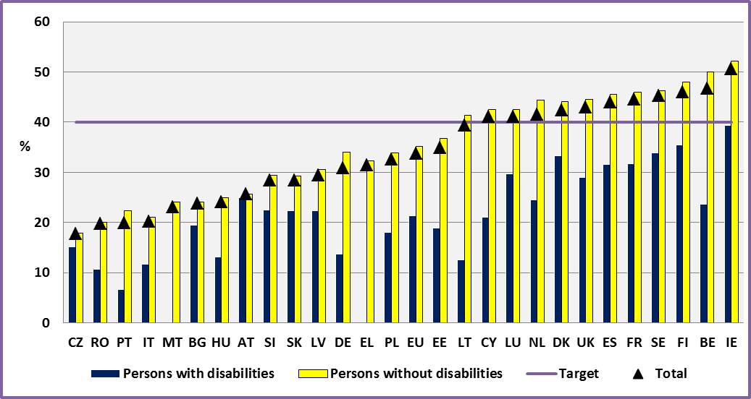
Data source: EU-SILC 2009 Note: Due to the limited number of observations, estimations ought to be interpreted with caution.

Figure 24: Percent of persons with disabilities (aged 30-34) who completed tertiary education by gender, 2009

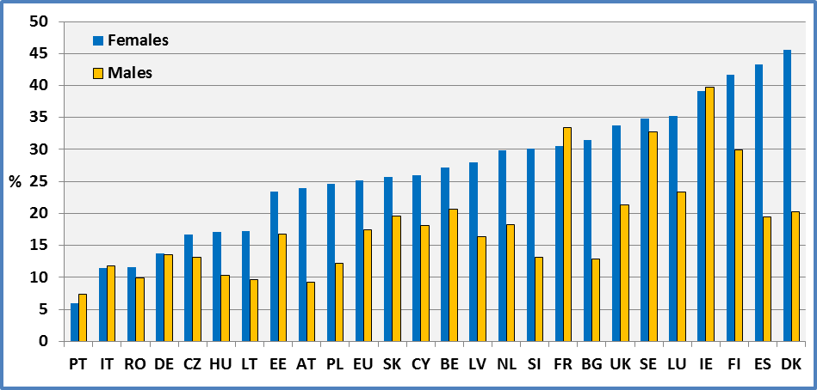
Data source: EU-SILC 2009 AT: Data for AT refer to 2008.Note: Due to the limited number of observations, estimations should be interpreted with caution.
Figure 25: Percent of persons (age: 30-39) who completed tertiary or equivalent education by Member State and disability status, 2009

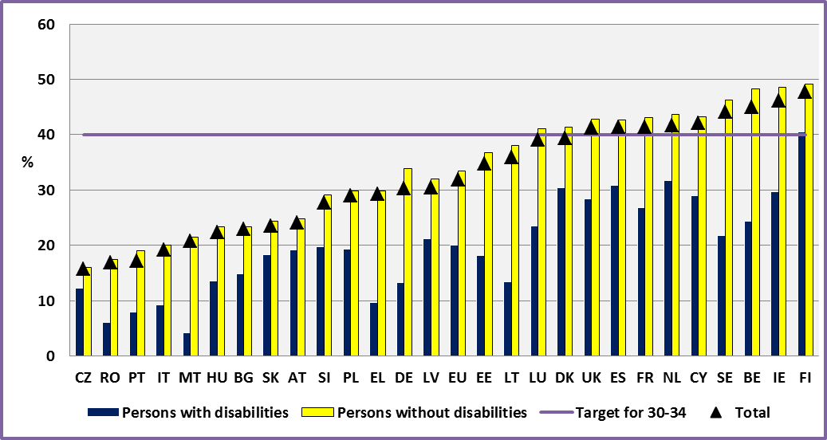
Data source: EU-SILC 2009

Figure 26: Percent of persons with disabilities (age: 30-39) who completed tertiary or equivalent education by Member State.

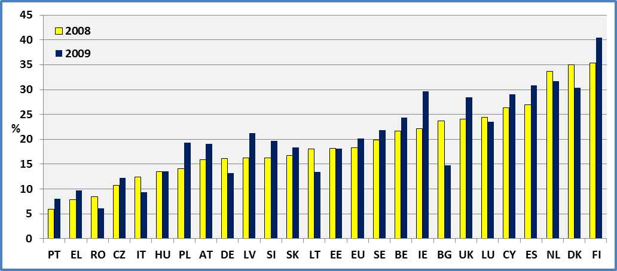
Data source: EU-SILC 2008 ; EU-SILC 2009

Data

Table 18: Percent of persons who have completed tertiary or equivalent education by Member State and disability status (age 30-34).
 | 2008 |  |  |  |  |  |  | 2009
 | Men + Women |  |  |  |  |  |  | Men + Women
 | Disability |  |  | All |  | LFS |  | Disability |  |  | All | LFS
 | Yes | No | Total |  |  |  |  | Yes | No | Total
AT | 15.7 | 28.5 | 26.8 |  | 26.8 |  | 22.2 | 25.0 | 25.7 | 25.6 | 25.6 | 23.5
BE | 28.6 | 53.8 | 51.0 |  | 50.5 |  | 42.9 | 23.6 | 50.0 | 46.7 | 46.6 | 42.0
BG | 24.1 | 23.7 | 23.7 |  | 23.7 |  | 27.1 | 19.5 | 24.0 | 23.8 | 23.8 | 27.9
CY | 26.3 | 43.6 | 42.7 |  | 42.7 |  | 47.1 | 21.0 | 42.5 | 41.1 | 41.1 | 44.7
CZ | 16.8 | 15.8 | 15.9 |  | 15.8 |  | 15.4 | 15.1 | 17.9 | 17.7 | 17.3 | 17.5
DE | 16.3 | 32.6 | 30.0 |  | 29.5 |  | 27.7 | 13.7 | 34.0 | 30.9 | 30.3 | 29.4
DK | 39.8 | 43.3 | 42.7 |  | 43.3 |  | 45.4 | 33.3 | 44.1 | 42.4 | 42.4 | 48.1
EE | 23.8 | 35.5 | 34.2 |  | 34.2 |  | 34.1 | 18.9 | 36.8 | 34.9 | 34.9 | 35.9
EL | 4.4 | 30.8 | 29.4 |  | 29.4 |  | 25.6 | 0.0 | 32.3 | 31.4 | 31.4 | 26.5
ES | 32.9 | 45.0 | 44.0 |  | 44.0 |  | 39.8 | 31.6 | 45.5 | 44.0 | 44.0 | 39.4
FI | 36.2 | 46.7 | 45.1 |  | 46.8 |  | 45.7 | 35.4 | 48.0 | 46.0 | 46.4 | 45.9
FR |  |  |  |  |  |  |  | 31.7 | 46.0 | 44.6 | 44.6 | 43.2
HU | 12.7 | 24.2 | 22.9 |  | 22.9 |  | 22.4 | 13.1 | 25.0 | 24.1 | 24.1 | 23.9
IE | 27.8 | 47.6 | 45.6 |  | 45.6 |  | 46.1 | 39.4 | 52.2 | 50.6 | 50.6 | 49.0
IT | 13.9 | 20.2 | 19.6 |  | 19.5 |  | 19.2 | 11.7 | 21.0 | 20.2 | 20.2 | 19.0
LT | 26.4 | 44.9 | 42.8 |  | 42.2 |  | 39.9 | 12.6 | 41.4 | 39.4 | 39.0 | 40.6
LU | 31.4 | 39.8 | 38.7 |  | 38.8 |  | 39.8 | 29.7 | 42.5 | 41.1 | 41.2 | 46.6
LV | 24.7 | 28.6 | 28.1 |  | 28.1 |  | 27.0 | 22.3 | 30.5 | 29.4 | 29.4 | 30.1
MT |  |  |  |  |  |  |  | 0.0 | 24.1 | 23.1 | 23.1 | 21.0
NL | 36.6 | 44.3 | 43.3 |  | 43.0 |  | 40.2 | 24.5 | 44.4 | 41.5 | 40.8 | 40.5
PL | 15.4 | 31.6 | 30.4 |  | 30.4 |  | 29.7 | 18.0 | 33.9 | 32.6 | 32.6 | 32.8
PT | 6.3 | 19.2 | 17.7 |  | 17.7 |  | 21.6 | 6.7 | 22.4 | 19.9 | 19.9 | 21.1
RO | 5.5 | 16.6 | 16.1 |  | 16.1 |  | 16.0 | 10.7 | 20.0 | 19.7 | 19.7 | 16.8
SE | 31.1 | 48.7 | 47.7 |  | 45.0 |  | 42.0 | 33.8 | 46.2 | 45.3 | 43.6 | 43.9
SI | 20.8 | 29.3 | 28.1 |  | 27.3 |  | 30.9 | 22.5 | 29.4 | 28.4 | 28.7 | 31.6
SK | 16.8 | 22.0 | 21.4 |  | 21.5 |  | 15.8 | 22.4 | 29.2 | 28.4 | 28.0 | 17.6
UK | 26.1 | 45.4 | 43.9 |  | 43.9 |  | 39.7 | 29.0 | 44.6 | 42.9 | 42.8 | 41.5
EU | 19.8 | 32.8 | 31.5 |  | 31.6 |  | 31.1 | 21.4 | 35.1 | 33.7 | 33.6 | 32.3
Data source: EU-SILC 2008 ; EU-SILC 2009 Note: Due to the limited number of observations, estimations ought to be interpreted with caution. There is a high variability of the percentage of persons with a ‘post-secondary non tertiary education’ across countries. This may mean that in certain countries this level is included in ‘tertiary education’. All: This includes observations for which we do not dispose information on disability status.
Table 19: Percent of persons who have completed a tertiary or equivalent education by Member State and disability status (age 30-39).

 | 2008 |  |  | 2009
 | Men + Women |  |  | Men + Women
 | Disability |  |  | Disability
 | Yes | No | Total | Yes | No | Total
AT | 15.9 | 26.6 | 24.9 | 19.1 | 24.8 | 24.0
BE | 21.7 | 50.4 | 47.0 | 24.3 | 48.3 | 45.0
BG | 23.7 | 21.4 | 21.5 | 14.8 | 23.4 | 22.9
CY | 26.3 | 41.4 | 40.3 | 29.0 | 43.2 | 42.1
CZ | 10.7 | 15.5 | 15.1 | 12.2 | 16.0 | 15.7
DE | 16.1 | 31.9 | 29.1 | 13.2 | 33.9 | 30.3
DK | 35.0 | 42.8 | 41.3 | 30.4 | 41.4 | 39.4
EE | 18.2 | 34.7 | 32.8 | 18.1 | 36.7 | 34.8
EL | 7.8 | 29.2 | 28.0 | 9.7 | 29.9 | 29.3
ES | 26.9 | 42.4 | 40.7 | 30.9 | 42.7 | 41.3
FI | 35.3 | 47.7 | 45.6 | 40.4 | 49.2 | 47.6
FR |  |  |  | 26.8 | 43.1 | 41.3
HU | 13.5 | 22.7 | 21.6 | 13.5 | 23.3 | 22.4
IE | 22.1 | 44.7 | 42.2 | 29.7 | 48.6 | 46.1
IT | 12.4 | 19.0 | 18.3 | 9.3 | 20.1 | 19.1
LT | 18.0 | 36.0 | 33.9 | 13.4 | 38.0 | 35.9
LU | 24.4 | 34.7 | 33.4 | 23.5 | 41.1 | 39.1
LV | 16.3 | 29.5 | 27.5 | 21.2 | 32.0 | 30.4
MT |  |  |  | 4.2 | 21.5 | 20.8
NL | 33.7 | 42.8 | 41.4 | 31.7 | 43.6 | 41.6
PL | 14.1 | 27.6 | 26.6 | 19.3 | 29.9 | 29.0
PT | 5.9 | 16.4 | 14.9 | 8.0 | 19.0 | 17.2
RO | 8.4 | 14.3 | 14.0 | 6.1 | 17.5 | 16.8
SE | 19.9 | 44.7 | 42.9 | 21.8 | 46.2 | 44.1
SI | 16.3 | 29.8 | 27.8 | 19.7 | 29.1 | 27.7
SK | 16.7 | 19.9 | 19.5 | 18.3 | 24.4 | 23.5
UK | 24.1 | 42.3 | 40.5 | 28.4 | 42.8 | 41.2
EU | 18.3 | 30.7 | 29.3 | 20.1 | 33.4 | 31.9
Data source: EU-SILC 2008 & EU-SILC 2009
Table 20: Percent of persons who have completed a tertiary or equivalent education by Member State, gender and disability status (age 30-34, 2008)

 | 2008 |  |  |  |  |  |  | 2009
 | Females |  |  |  | Males |  |  | Females |  |  | Males
 | Disability |  |  |  | Disability |  |  | Disability |  |  | Disability
 | Yes | No | Total |  | Yes | No | Total | Yes | No | Total | Yes | No | Total
AT | 24.0 | 27.8 |  | 27.4 | 9.2 | 29.3 | 26.1 | 20.1 | 26.4 | 25.6 | *29.6 | 25.0 | 25.6
BE | 27.2 | 61.7 |  | 57.8 | 30.1 | 46.3 | 44.6 | 27.2 | 59.4 | 55.7 | 20.7 | 41.0 | 38.2
BG | 19.5 | 30.9 |  | 30.3 | *27.5 | 17.1 | 17.8 | 31.5 | 32.4 | 32.3 | 12.9 | 15.3 | 15.2
CY | 39.4 | 50.4 |  | 49.8 | 10.5 | 36.9 | 35.6 | 26.0 | 47.4 | 46.4 | 18.1 | 37.4 | 35.8
CZ | 13.7 | 15.8 |  | 15.6 | *20.4 | 15.9 | 16.1 | 16.7 | 19.0 | 18.8 | 13.1 | 16.8 | 16.5
DE | 16.7 | 31.8 |  | 29.3 | 16.0 | 33.5 | 30.6 | 13.7 | 31.3 | 28.7 | 13.6 | 36.8 | 33.1
DK | 42.3 | 47.3 |  | 46.3 | 36.4 | 39.1 | 38.7 | 45.6 | 46.7 | 46.5 | 20.2 | 41.2 | 37.9
EE | 38.6 | 47.4 |  | 46.5 | 10.6 | 23.2 | 21.7 | 23.4 | 49.6 | 47.8 | 16.8 | 23.7 | 22.8
EL | 0.0 | 35.2 |  | 34.1 | 6.1 | 26.5 | 25.0 | 0.0 | 38.5 | 37.8 | 0.0 | 25.8 | 24.8
ES | 37.4 | 48.2 |  | 47.3 | 28.4 | 42.0 | 40.9 | 43.3 | 50.6 | 49.8 | 19.5 | 40.7 | 38.5
FI | 40.4 | 56.3 |  | 53.5 | 31.5 | 38.3 | 37.3 | 41.7 | 56.6 | 54.5 | 29.9 | 39.1 | 37.5
FR |  |  |  |  |  |  |  | 30.6 | 51.8 | 49.4 | 33.4 | 40.2 | 39.6
HU | 15.5 | 29.4 |  | 27.9 | 10.2 | 19.6 | 18.6 | 17.1 | 30.3 | 29.5 | 10.3 | 19.9 | 19.0
IE | 39.5 | 55.4 |  | 53.8 | 14.6 | 38.0 | 35.6 | 39.1 | 55.9 | 53.7 | 39.8 | 47.6 | 46.6
IT | 17.1 | 24.2 |  | 23.5 | 10.9 | 16.5 | 15.9 | 11.5 | 25.5 | 24.3 | 11.8 | 16.5 | 16.1
LT | 37.0 | 56.7 |  | 54.8 | 18.5 | 30.8 | 29.0 | 17.2 | 53.6 | 51.6 | 9.6 | 28.3 | 26.7
LU | 30.6 | 40.7 |  | 39.1 | 32.6 | 39.0 | 38.4 | 35.3 | 46.2 | 45.0 | 23.4 | 38.6 | 37.0
LV | 44.9 | 39.5 |  | 40.2 | 6.0 | 18.4 | 16.7 | 28.0 | 36.8 | 35.5 | 16.4 | 24.2 | 23.1
MT |  |  |  |  |  |  |  | 0.0 | 22.9 | 22.3 | 0.0 | 25.1 | 23.8
NL | 27.5 | 43.6 |  | 41.4 | *47.0 | 45.0 | 45.3 | 29.8 | 44.9 | 42.6 | 18.3 | 43.8 | 40.2
PL | 22.2 | 37.8 |  | 36.9 | 10.8 | 25.3 | 24.1 | 24.6 | 40.1 | 39.0 | 12.2 | 27.1 | 25.9
PT | 3.3 | 24.4 |  | 22.5 | 8.2 | 13.7 | 12.9 | 5.9 | 28.9 | 25.5 | 7.4 | 15.6 | 14.3
RO | 10.1 | 18.1 |  | 17.7 | 0.0 | 15.1 | 14.5 | 11.6 | 23.3 | 22.9 | 9.9 | 16.8 | 16.6
SE | 24.5 | 55.4 |  | 52.9 | *45.3 | 42.9 | 43.0 | 34.8 | 53.1 | 51.6 | 32.7 | 40.0 | 39.5
SI | 25.9 | 38.9 |  | 37.2 | 16.9 | 20.0 | 19.5 | 30.1 | 39.1 | 37.6 | 13.2 | 21.3 | 20.4
SK | 16.1 | 23.0 |  | 22.1 | 17.5 | 21.0 | 20.6 | 25.7 | 29.5 | 29.1 | 19.6 | 28.9 | 27.9
UK | 25.7 | 47.7 |  | 46.1 | 26.5 | 42.8 | 41.4 | 33.8 | 47.3 | 45.5 | 21.3 | 41.9 | 40.0
EU | 22.1 | 36.0 |  | 34.7 | 17.5 | 29.6 | 28.4 | 25.1 | 38.8 | 37.4 | 17.4 | 31.4 | 30.0
Data source: EU-SILC 2008 ; EU-SILC 2009
*: We have constructed the confidence intervals for these estimations and found that they were very large.

Data source

- EUSILC UDB 2008 – version 3 of March 2011
- EUSILC UDB 2009 – version 1 of March 2011

Methodology

We estimate the share of population who have successfully completed university or university-like (tertiary-level) education. This means an education level of 5-6 in terms of ISCED 1997 (International Standard Classification of Education).

The Europe 2020 indicator refers to the age group 30-34.

Eurostat presents an indicator based on the LFS survey. The LFS survey presents the following categories concerning ’Highest level of education or training successfully completed’:

- No education
- ISCED 1 (Primary education)
- ISCED 2 (Lower secondary education)
- ISCED 3 (Upper secondary education - without distinction a, b or c possible)
- ISCED 3c (Programmes not designed to lead to ISCED 5A or 5B - shorter than 3 years)
- ISCED 3c (Programmes not designed to lead to ISCED 5A or 5B - 3 years of more)
- ISCED 3b (Programmes designed to provide direct access to ISCED 5B)
- ISCED 3a (Programmes designed to provide direct access to ISCED 5A)
- ISCED 4 (Post-secondary non tertiary)
- ISCED 5b (First stage of tertiary education - practically oriented/ occupationally specific)
- ISCED 5a (First stage of tertiary education - theoretically based)
- ISCED 6 (Second stage of tertiary education)

The EU-SILC survey presents a slightly different regrouping concerning ’Highest ISCED level attained’:

- pre-primary education
- primary education
- lower secondary education
- (upper) secondary education
- post-secondary non tertiary education
- first stage of tertiary education (not leading directly to an advanced research qualification) and second stage of tertiary education (leading to an advanced research qualification)
Value ’5‘ correspond to usual ISCED values 5 and 6.
The percentage of persons with a ‘post-secondary non tertiary education’ (ISCED 4) varies from 0% to 15% in the EU-SILC survey. This most likely means that similar levels are included in (upper) secondary or ‘tertiary education’ in different countries.

EU-SILC codes persons with no education (who are illiterate) separately (-2). They are not included in ‘0’. In order to ensure comparability with the results of the LFS survey, we include illiterate people into category ‘0’. The percentage of illiterate people is equal to or less than 1%, except in Belgium and Portugal. This means that raw EU-SILC data may slightly overestimate the number of persons who have successfully completed university or university-like (tertiary-level) education in Belgium and Portugal.

The number of missing observations concerning education is high in Poland and the UK.

Notes

Analysis by Member State may be considered as robust for most countries. However, analysis by gender presents a certain number of statistical problems due to a low number of observations.

Eurostat notes that selection of the age group (30-34 years) excludes persons who complete tertiary education at a higher age (i.e. people returning to formal education in their thirties).

There is a very high variability in the percentage of persons with a ‘post-secondary non tertiary education’ (level 4) which might be included in a) (upper) secondary (level 3), or b) ‘tertiary education’ (level 5) in certain countries. For example, in Belgium we observe a very low percentage of persons with a ‘post-secondary non tertiary education’ which might explain the very high percentage of persons with a tertiary education.

EU-SILC estimators may overestimate the percentage of people with disabilities who have completed a tertiary education, since those living in collective households and in institutions are generally excluded from the sample.

POVERTY

LOW WORK INTENSITY

Relevance to EU strategy

The European Disability Strategy 2010-2020 highlights the need to ‘promote decent living conditions’ through poverty reduction and social protection, as well as to ‘enable many more people with disabilities to earn their living on the open labour market’. It recognises that the high rate of poverty is ‘partly due to limited access to employment’.

The Europe 2020 strategy aims to help Europe recover from the crisis by boosting competitiveness, productivity, growth potential, social cohesion and economic convergence in ‘smart, sustainable and inclusive’ ways. EU-wide agreed objectives, to reduce by at least 20 million the number of Europeans exposed to poverty and social exclusion by 2020, include work intensity as one component in the Europe 2020 headline indicator for ’population at risk of poverty or social exclusion‘ .

People living in households with very low work intensity are more likely to be exposed to social exclusion and risk of poverty, due to their dependency on social transfers and their difficulty in accessing common goods and services. The work intensity of a household is defined as the ratio between the number of months that all working-age household members worked during the income reference year and the total number of months that could have been worked in the same period.

Headline findings

EU | 21.2 | 5.8 | 8.2 | 8.1 | 9.0 | 21.2 | 6.5 | 8.8 | 8.7 | 9.0

An average of 21.2% of people with disabilities across the EU live in a household where no-one works (i.e. people who report activity limitations and live in households where work intensity is zero). This is an extremely high rate when compared with 6.5% of people without disabilities.

At the EU level, there is a gap of about 15 percentage points between persons with and without disabilities on this measure. Surprisingly, the highest rates are not found in the poorest Member States but in countries like Ireland, UK, Belgium and Sweden.
Despite a general worsening of the situation in 2009, following the banking crisis towards the end 2008, the situation of persons with disabilities remained stable at the EU level on this measure (although it worsened somewhat for people without disabilities).

Gender differences are very small overall. There is a small advantage for non-disabled men over non-disabled women. Women with disabilities have worse rates compared to men with disabilities in some Member States (14) but the opposite is true in others (13).

This disadvantage for people with disabilities at the lower extreme (jobless households) is mirrored at the opposite extreme (households with full employment) where their presence is very low. The situation between these extremes is more similar for persons with and without disabilities.

Figure 27: Percent of persons (aged 16-59) living in jobless households (WI=0), 2009

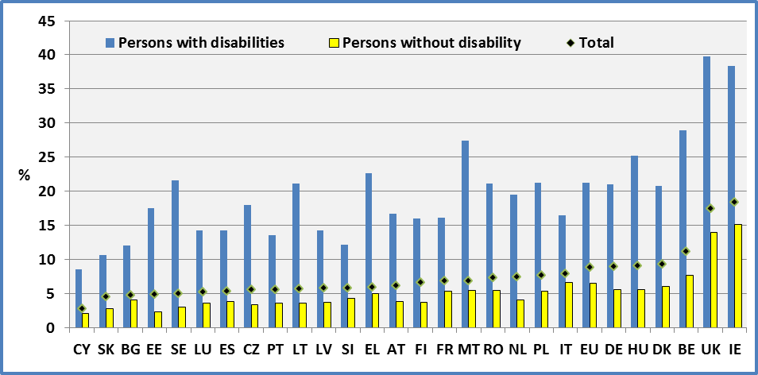
Data source: EU-SILC 2009

Figure 28: Percent of persons with disabilities (aged 16-59) living in jobless households (WI=0), 2009

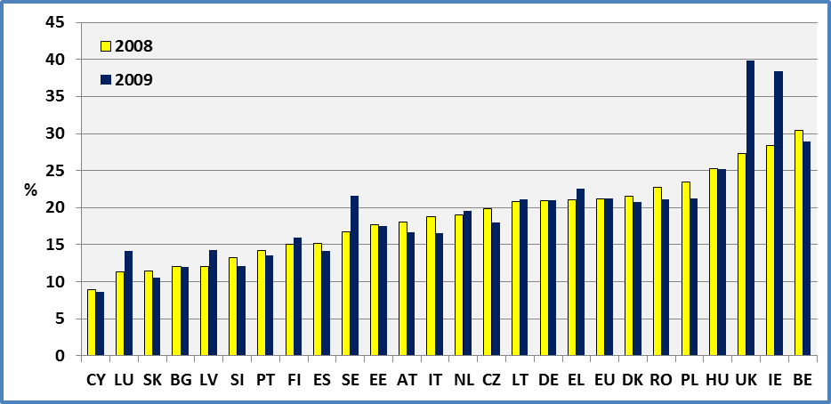
Data source: EU-SILC 2008 ; EU-SILC 2009

Figure 29: Distribution of work intensity by disability status, EU 2009

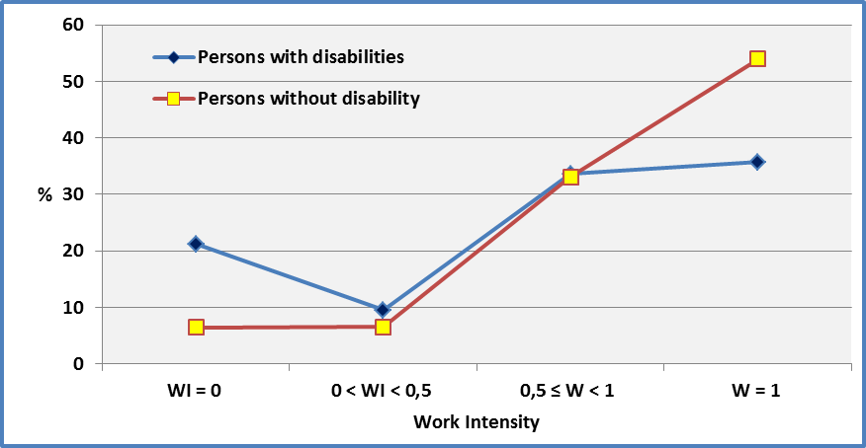
Data source: EU-SILC 2009

Figure 30: Percent of women and men (aged 16-59) living in jobless households (WI=0)

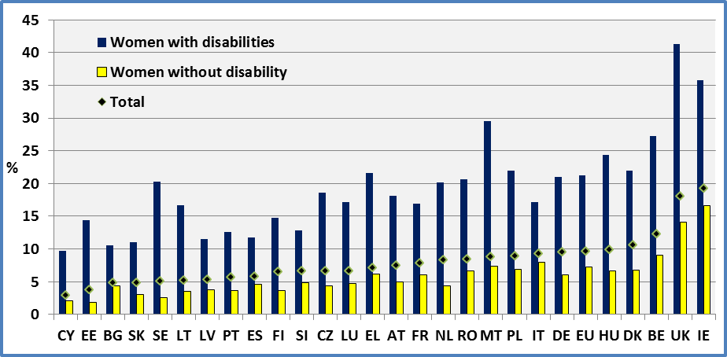

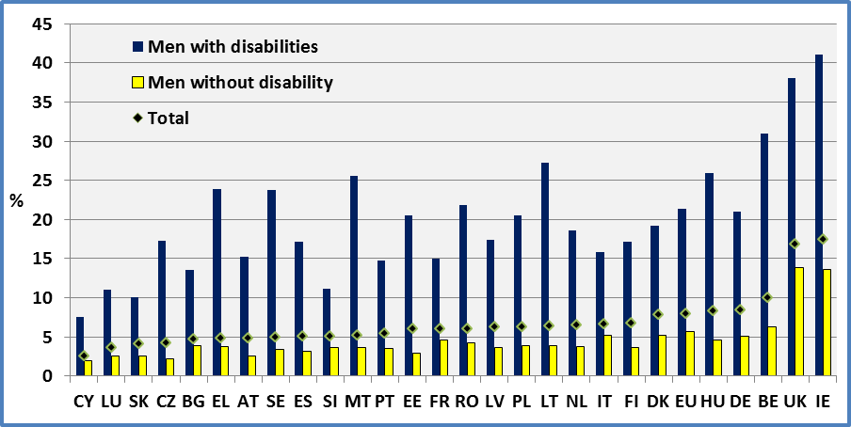
Data source: EU-SILC 2009

Data

Table 21: Percent of persons (aged 16-59) living in households with very low work intensity % in jobless households (WI=0) compared to Eurostat very low work intensity (WI<20)

 | Men + Women
 | 2008 |  |  |  |  | 2009
 | Disability |  |  | All | Eurostat  Age:0-59  WI<20 | Disability |  |  | All | Eurostat  Age:0-59  WI<20
 | With | Without | Total |  |  | With | Without | Total
AT | 18.0 | 4.5 | 7.3 | 7.3 | 7.8 | 16.7 | 3.8 | 6.2 | 6.2 | 7.2
BE | 30.4 | 7.0 | 10.8 | 10.8 | 11.7 | 28.9 | 7.7 | 11.2 | 11.2 | 12.3
BG | 12.1 | 4.5 | 5.2 | 5.2 | 8.1 | 12.0 | 4.1 | 4.8 | 4.8 | 6.9
CY | 8.9 | 2.4 | 3.1 | 3.0 | 4.1 | 8.6 | 2.1 | 2.8 | 2.8 | 4.0
CZ | 19.9 | 4.3 | 6.4 | 6.0 | 7.2 | 18.0 | 3.4 | 5.6 | 5.2 | 6.0
DE | 20.9 | 6.6 | 9.8 | 10.0 | 11.6 | 21.0 | 5.6 | 9.0 | 9.3 | 10.8
DK | 21.5 | 5.6 | 9.1 | 9.3 | 8.3 | 20.8 | 6.0 | 9.3 | 9.4 | 8.5
EE | 17.7 | 2.0 | 4.7 | 4.7 | 5.3 | 17.5 | 2.3 | 4.9 | 4.9 | 5.6
EL | 21.1 | 5.1 | 6.5 | 6.5 | 7.4 | 22.6 | 5.0 | 5.9 | 5.9 | 6.5
ES | 15.2 | 3.1 | 4.8 | 4.8 | 6.2 | 14.2 | 3.8 | 5.4 | 5.4 | 7.0
FI | 15.1 | 3.5 | 6.1 | 6.2 | 7.3 | 16.0 | 3.7 | 6.6 | 6.5 | 8.2
FR |  |  |  |  | 8.8 | 16.1 | 5.3 | 6.9 | 6.9 | 8.3
HU | 25.3 | 5.9 | 9.8 | 9.8 | 12.0 | 25.2 | 5.6 | 9.1 | 9.0 | 11.3
IE | 28.4 | 6.9 | 9.9 | 9.9 | 13.6 | 38.4 | 15.1 | 18.4 | 18.4 | 19.8
IT | 18.8 | 7.0 | 8.7 | 8.7 | 9.8 | 16.5 | 6.6 | 7.9 | 8.0 | 8.8
LT | 20.8 | 2.5 | 5.2 | 5.3 | 5.1 | 21.1 | 3.6 | 5.7 | 5.7 | 6.9
LU | 11.3 | 2.7 | 4.0 | 4.0 | 4.7 | 14.2 | 3.6 | 5.2 | 5.2 | 6.3
LV | 12.1 | 2.1 | 4.3 | 4.3 | 5.1 | 14.3 | 3.7 | 5.8 | 6.0 | 6.7
MT |  |  |  |  | 8.2 | 27.4 | 5.5 | 6.9 | 7.0 | 8.4
NL | 19.0 | 4.3 | 7.4 | 7.7 | 8.1 | 19.5 | 4.1 | 7.4 | 7.8 | 8.3
PL | 23.5 | 6.0 | 8.3 | 8.3 | 7.9 | 21.2 | 5.4 | 7.7 | 7.7 | 6.9
PT | 14.2 | 3.0 | 5.0 | 5.0 | 6.3 | 13.6 | 3.6 | 5.6 | 5.6 | 6.9

 | Men + Women
 | 2008 |  |  |  |  | 2009
 | Disability |  |  | All | Eurostat  Age:0-59  WI<20 | Disability |  |  | All | Eurostat  Age:0-59  WI<20
 | With | Without | Total |  |  | With | Without | Total
RO | 22.7 | 6.0 | 7.7 | 7.7 | 8.2 | 21.1 | 5.5 | 7.3 | 7.3 | 7.7
SE | 16.7 | 2.8 | 4.4 | 4.4 | 5.4 | 21.6 | 3.0 | 5.0 | 5.0 | 6.2
SI | 13.2 | 5.2 | 6.8 | 6.7 | 6.7 | 12.1 | 4.3 | 5.8 | 5.9 | 5.6
SK | 11.4 | 2.8 | 4.6 | 4.8 | 5.2 | 10.6 | 2.8 | 4.5 | 4.5 | 5.6
UK* | 27.3 | 7.4 | 10.1 | 10.1 | 10.4 | 39.8 | 14.0 | 17.5 | 17.6 | 12.5
EU | 21.2 | 5.8 | 8.2 | 8.1 | 9.0 | 21.2 | 6.5 | 8.8 | 8.7 | 9.0
Data source: EU-SILC 2008 ; EU-SILC 2009
All: includes observations for which we do not dispose information on disability status.
Eurostat : People living in households with very low work intensity are people aged 0-59 living in households where the adults work less than 20% of their total work potential during the past year. As expected, the Eurostat indicator is higher than the one used here (Work intensity=0) as it includes certain people working part-time (except for Denmark, Lithuania and Poland in 2008, and Denmark, Poland, Slovenie and UK in 2009).
http://epp.eurostat.ec.europa.eu/portal/page/portal/europe_2020_indicators/headline_indicators
UK: The difference between 2008 and 2009 appears too big in the data and ought to be treated with caution.

Table 22: Percent of persons (aged 16-59) living in households with very low work intensity % in jobless households

 | 2008 |  |  |  |  |  | 2009
 | Women |  |  | Men |  |  | Women |  |  | Men
 | Disability |  |  | Disability |  |  | Disability |  |  | Disability
 | No | Yes | Total | Yes | No | Total | Yes | No | Total | Yes | No | Total
AT | 20.3 | 5.4 | 8.4 | 15.8 | 3.6 | 6.1 | 18.1 | 5.0 | 7.5 | 15.2 | 2.5 | 4.9
BE | 30.2 | 8.2 | 11.9 | 30.7 | 5.9 | 9.7 | 27.2 | 9.1 | 12.3 | 31.0 | 6.3 | 10.0
BG | 12.1 | 4.7 | 5.3 | 12.0 | 4.4 | 5.0 | 10.5 | 4.4 | 4.9 | 13.5 | 3.9 | 4.7
CY | 8.9 | 3.0 | 3.6 | 8.8 | 1.8 | 2.5 | 9.7 | 2.1 | 2.9 | 7.6 | 2.0 | 2.6
CZ | 19.7 | 5.3 | 7.4 | 20.2 | 3.1 | 5.3 | 18.6 | 4.4 | 6.7 | 17.3 | 2.2 | 4.3
DE | 21.9 | 7.5 | 10.8 | 19.9 | 5.8 | 8.9 | 21.0 | 6.1 | 9.5 | 21.0 | 5.1 | 8.5
DK | 21.8 | 5.3 | 9.3 | 21.1 | 5.9 | 8.8 | 22.0 | 6.8 | 10.6 | 19.2 | 5.2 | 7.9
EE | 15.0 | 1.9 | 4.0 | 20.2 | 2.2 | 5.4 | 14.4 | 1.8 | 3.8 | 20.5 | 2.9 | 6.0
EL | 21.4 | 6.5 | 7.9 | 20.6 | 3.7 | 5.0 | 21.6 | 6.2 | 7.1 | 23.9 | 3.8 | 4.8
ES | 12.1 | 3.8 | 5.1 | 18.7 | 2.3 | 4.5 | 11.7 | 4.6 | 5.8 | 17.1 | 3.1 | 5.1
FI | 14.7 | 3.2 | 6.0 | 15.5 | 3.8 | 6.2 | 14.8 | 3.7 | 6.5 | 17.2 | 3.7 | 6.8
FR |  |  |  |  |  |  | 16.9 | 6.1 | 7.8 | 15.0 | 4.6 | 6.0
HU | 26.5 | 7.0 | 10.9 | 24.1 | 4.8 | 8.6 | 24.4 | 6.6 | 9.9 | 25.9 | 4.6 | 8.3
IE | 25.3 | 8.0 | 10.5 | 31.6 | 5.8 | 9.3 | 35.8 | 16.6 | 19.3 | 41.1 | 13.6 | 17.4
IT | 19.5 | 8.3 | 10.1 | 17.9 | 5.6 | 7.2 | 17.1 | 8.0 | 9.3 | 15.8 | 5.2 | 6.6
LT | 20.0 | 2.6 | 5.2 | 21.8 | 2.5 | 5.3 | 16.7 | 3.5 | 5.2 | 27.3 | 3.9 | 6.4
LU | 10.4 | 3.5 | 4.7 | 12.2 | 1.9 | 3.3 | 17.2 | 4.7 | 6.7 | 11.0 | 2.5 | 3.7
LV | 10.2 | 2.1 | 4.0 | 14.5 | 2.0 | 4.6 | 11.5 | 3.8 | 5.3 | 17.4 | 3.7 | 6.3
MT |  |  |  |  |  |  | 29.5 | 7.4 | 8.8 | 25.5 | 3.7 | 5.2
NL | 18.7 | 5.2 | 8.5 | 19.3 | 3.4 | 6.2 | 20.1 | 4.4 | 8.3 | 18.6 | 3.8 | 6.5
PL | 23.6 | 7.4 | 9.5 | 23.5 | 4.6 | 7.2 | 21.9 | 6.9 | 8.9 | 20.5 | 3.9 | 6.3
PT | 13.4 | 3.3 | 5.3 | 15.2 | 2.8 | 4.7 | 12.6 | 3.7 | 5.7 | 14.7 | 3.5 | 5.5
RO | 22.8 | 7.1 | 8.9 | 22.4 | 4.9 | 6.5 | 20.6 | 6.7 | 8.5 | 21.8 | 4.3 | 6.1
SE | 15.5 | 3.1 | 4.9 | 18.4 | 2.6 | 4.0 | 20.3 | 2.6 | 5.1 | 23.8 | 3.4 | 5.0
SI | 11.2 | 5.7 | 6.8 | 15.4 | 4.7 | 6.8 | 12.8 | 4.9 | 6.6 | 11.2 | 3.7 | 5.1
SK | 12.5 | 3.2 | 5.4 | 10.0 | 2.4 | 3.8 | 11.0 | 3.0 | 4.9 | 10.1 | 2.6 | 4.1
UK | 26.6 | 8.3 | 10.9 | 28.0 | 6.6 | 9.2 | 41.3 | 14.1 | 18.0 | 38.1 | 13.9 | 16.9
EU | 21.1 | 6.8 | 9.2 | 21.2 | 4.8 | 7.3 | 21.2 | 7.2 | 9.6 | 21.3 | 5.7 | 8.0
Data source: EU-SILC 2008 ; EU-SILC 2009

Data source

- EUSILC UDB 2008 – version 3 of March 2011
- EUSILC UDB 2009 – version 1 of March 2011
- http://epp.eurostat.ec.europa.eu/portal/page/portal/europe_2020_indicators/headline_indicators

Methodology

The Europe 2020 indicator defines people living in households with very low work intensity as ‘people aged 0-59 living in households where the adults work less than 20% of their total work potential during the past year’ [t2020_51]. Thus, they do not include older people. The conclusions presented for people with disabilities concern persons in jobless households (Work Intensity-WI=0) although persons in quasi-jobless households (WI<20) share similar results.

Work intensity measures the employment rate of the household but does not take into account the distribution of employment inside a household (including several adults).

For example, a work intensity of 20% in a household with two adults might mean that one person works 40% of his/her time or that each person works 20% of his/her time.

The EU-SILC cross-sectional data present an indicator which is slightly different from the definition in Europe 2020. The methodology adopted in EU-SILC may be summarised as follows.

A working age person is defined as a person aged 18-64. For each working age person (Wage/person) two figures are computed:

• The number of months during the income reference period for which information on his/her activity status is available (the ‘workable’ months: NWAm)
• The number of months during the income reference period for which the person has been classified as a worker (Number of ‘worked’ months: NWm )

In each household, EU-SILC UDB (User Data Base) calculates the derived variables:

TNWm = $\sum_{\text{household} \text{members}}{\text{NWm}}$
TNWAm = $\sum_{\text{household} \text{members}}{\text{NWAm}}$

WI = $\frac{\text{TNWm}}{\text{TNWAm}}$ (WI : Work Intensity)

EU-SILC UDB presents:

WI = 0 (EU-SILC variable HX020 = 1)
0 < WI < 0.5 (EU-SILC variable HX020 = 2)
0.5 ≤ W < 1 (EU-SILC variable HX020 = 3)
W = 1 (EU-SILC variable HX020 = 4)

The same work intensity status is assigned to each household member.

WI=0 means that no adult was working in the household (a jobless household).
WI=1 means that all the adults in the household were in full employment during the whole year.

For estimations distinguishing those ‘limited’ and ‘not limited’ in Denmark, Finland, Netherland, Sweden and Slovenia we have used personal cross sectional weights for selected persons (pb060). Otherwise, we have used personal cross sectional weights (pb040).

We have used the age at the end of the income reference period (px020).

Notes

Eurostat presents an indicator covering people aged 0-59 living in households where the adults worked less than 20% of their total work potential during the past year. As the EU-SILC survey presents information on disability only for people aged 16 or more, we present the percentage of people with and without disabilities aged 16 to 59. Thus the indicator cannot take account of disabled children living in households of low work intensity or of the household situation of older workers.

Another limitation concerns work intensity. The Europe 2020 indicator refers to very low work intensity: people living in households with very low work intensity are those aged 0-59 living in households where the adults work less than 20% of their total work potential during the past year.

EU-SILC UDB data provides the four categories for work intensity (WI): WI = 0; 0 < WI < 0.5; 0.5 ≤ WI < 1; and, WI = 1.

The closest proxy for the Europe 2020 indicator provided by our data is WI=0. Consequently, we have indicated the number of jobless households.

Work intensity, in the case of jobless households, may also be seen as an indicator of the employment rate of the household.

The UK results for 2009 ought to be interpreted with caution.

PEOPLE AT RISK OF POVERTY AFTER SOCIAL TRANSFERS

Relevance to EU strategy

The European Disability Strategy 2010-2020 recognises that there is a high rate of poverty amongst people with disabilities. One of its key areas for action is to ‘promote decent living conditions for people with disabilities’. In particular, the strategy focuses on the need for social protection and poverty reduction programmes, including adequate disability benefits.

The Lisbon European Council (2000) established a social inclusion process in order to combating poverty and the Barcelona European Council (2002) stressed the importance of the fight against poverty and social exclusion, inviting Member States to set targets, in their National Action Plans, for significantly reducing the number of people at risk of poverty and social exclusion by 2010. The European Platform against Poverty (referred to in the European Disability Strategy) is one of the flagship initiatives of Europe 2020, and aims to ensure that the benefits of growth and jobs are widely shared and that people experiencing poverty and social exclusion are enabled to live in dignity and take an active part in society.

The Europe 2020 strategy includes a high level commitment to ‘lift at least 20 million people out of the risk of poverty or exclusion’. The risk of poverty after social transfers is one of three indicators relating to this headline target and relates to persons with an equivalised disposable income below the risk-of-poverty threshold, which is set at 60% of the national median (after social transfers).

Headline findings

People with disabilities (people who report activity limitations) face a higher risk of poverty. At the EU level, 19.9% of persons with disabilities live in households with a disposable income of less than 60% of the median national average after social transfers, compared to 14.3% of persons without disabilities.

The situation of women is worse compared to men for both disabled and non-disabled women. In Latvia the share of disabled women at risk of poverty is 43% but only 10.6% in Hungary. Generally, the poverty rates of disabled women and men are correlated.

Comparing the situation between 2008 and 2009, there was an improvement in the average situation of people with disabilities at the EU level of 1.3 percentage points (from 21.2% to 19.9%). However, improvements in the situation of non-disabled people at the national level are not necessarily associated with an improvements of the situation of disabled people.

In some Member States the difference between people with and without disabilities is relatively low, notably in Hungary (0.4 percentage points), Slovakia (1.5), Luxembourg (2.2) and Denmark (2.2) but in others the difference is relatively high, notably in Latvia (22.6), Cyprus (22.1) and Estonia (16.4).
When we compare the situation of younger and older adults with disabilities, there is a small difference at the EU level but a large variation between the Member States. At the EU level, 20.5% people with disabilities aged 16-64 are at risk of poverty compared with 19.2% of persons with disabilities aged 65 or over. However, it is important to note that special allowances aiming to ensure autonomy, or pay extra medical expenses, may artificially reduce the poverty rate among people with disabilities (i.e. help with the additional costs of living with disability are not adjusted in calculations of equivalised income).

Figure 31: People (aged 16+) at risk of poverty after social transfers, 2009

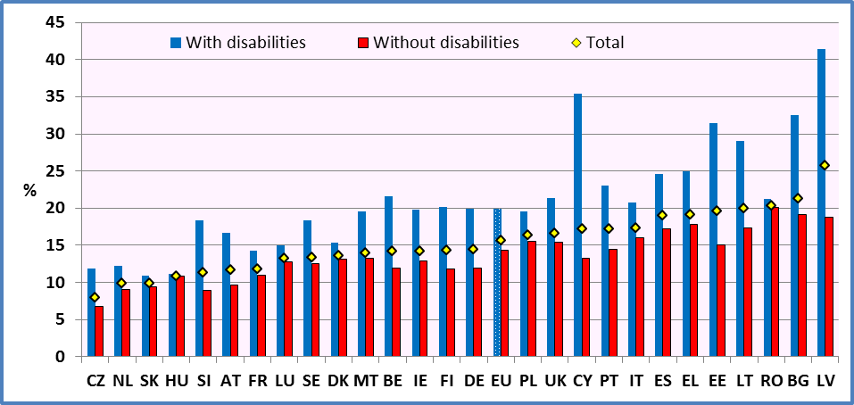
Data source: EU-SILC 2009

Figure 32: People with disabilities (aged 16+) at risk of poverty after social transfers by age group, 2009

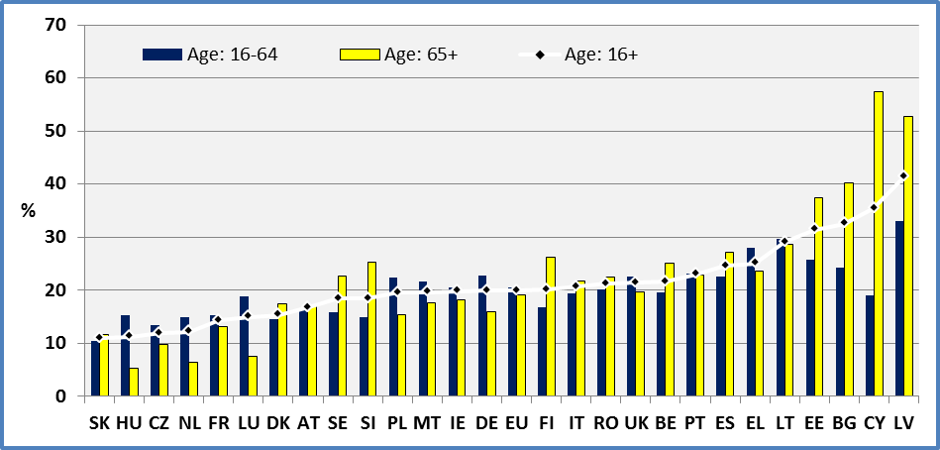
Data source: EU-SILC 2009
Figure 33: People with disabilities (aged 16+) at risk of poverty after social transfers by age group

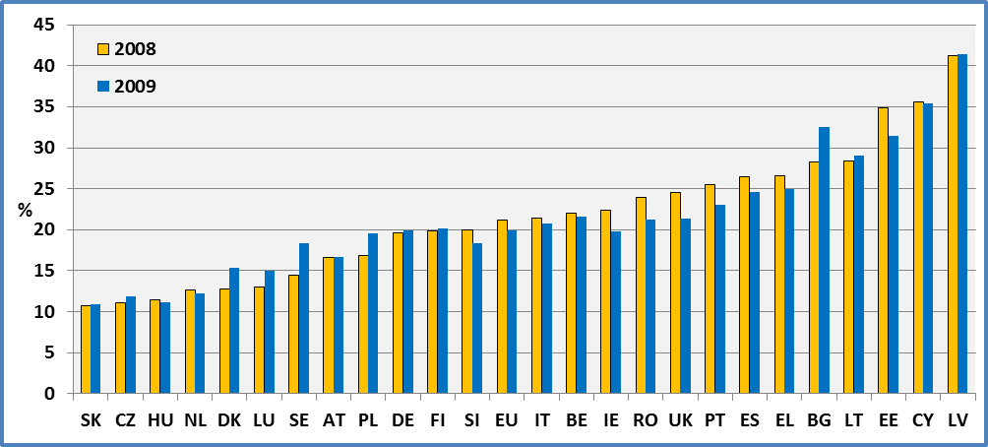
Data source: EU-SILC 2008 ; EU-SILC 2009

Figure 34: Women and men (age 16+) at risk of poverty after social transfers by disability status, 2009

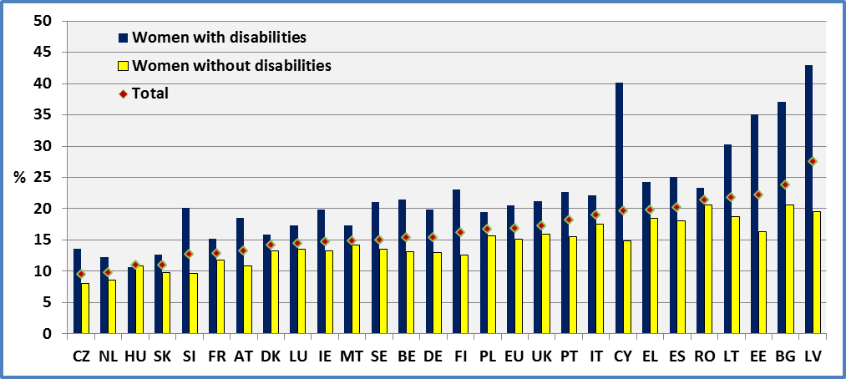

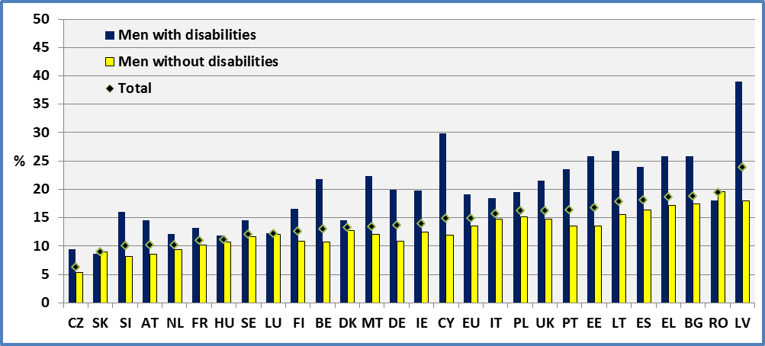
Data source: EU-SILC 2009

Figure 35: Poverty disadvantage of people with disabilities by gender

Percentage points difference in poverty rates between people with and without disabilities

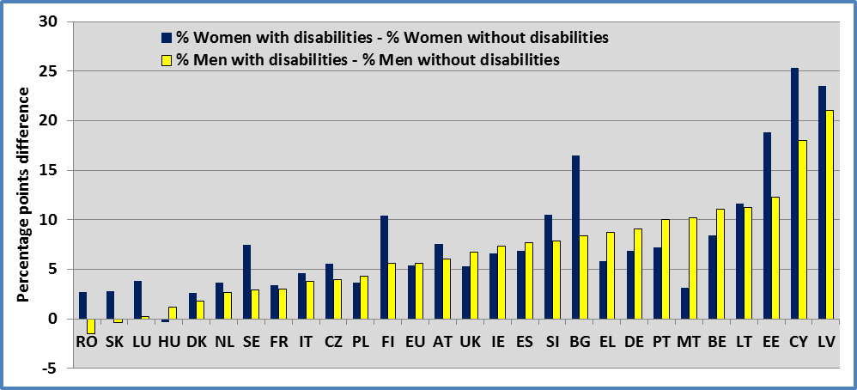
Data source: EU-SILC 2009

Data

Table 23: People (aged 16+) at risk of poverty by disability status and Member State - Percent of people living in households with a household equivalised disposable income less than 60% of the median national household equivalised disposable income
Men + Women
 | 2008 |  |  |  | 2009
 | Disability |  |  | All | Disability |  |  | All
 | Yes | No | Total |  | Yes | No | Total
AT | 16.6 | 9.8 | 11.8 | 11.8 | 16.7 | 9.7 | 11.7 | 11.7
BE | 22.0 | 12.0 | 14.3 | 14.3 | 21.6 | 11.9 | 14.2 | 14.2
BG | 28.3 | 19.4 | 20.8 | 20.8 | 32.5 | 19.1 | 21.3 | 21.3
CY | 35.6 | 12.8 | 16.9 | 16.9 | 35.4 | 13.3 | 17.2 | 17.2
CZ | 11.1 | 7.8 | 8.6 | 8.4 | 11.9 | 6.8 | 8.0 | 7.8
DE | 19.6 | 11.6 | 14.2 | 14.6 | 19.9 | 11.9 | 14.5 | 14.9
DK | 12.8 | 12.3 | 12.5 | 12.5 | 15.3 | 13.1 | 13.6 | 13.6
EE | 34.9 | 13.4 | 20.0 | 19.9 | 31.4 | 15.0 | 19.6 | 19.6
EL | 26.6 | 18.0 | 19.6 | 19.6 | 25.0 | 17.8 | 19.1 | 19.1
ES | 26.5 | 16.6 | 18.9 | 18.9 | 24.6 | 17.2 | 19.0 | 19.0
FI | 19.9 | 11.5 | 14.0 | 14.0 | 20.1 | 11.8 | 14.3 | 14.2
FR |  |  |  | 12.7 | 14.3 | 11.0 | 11.8 | 11.8
HU | 11.4 | 10.7 | 10.9 | 10.9 | 11.2 | 10.8 | 10.9 | 10.8
IE | 22.4 | 12.9 | 14.7 | 14.7 | 19.8 | 12.9 | 14.2 | 14.2
IT | 21.4 | 16.1 | 17.6 | 17.6 | 20.7 | 16.0 | 17.3 | 17.4
LT | 28.4 | 16.4 | 19.4 | 19.5 | 29.1 | 17.3 | 20.0 | 19.9
LU | 13.0 | 11.5 | 11.8 | 11.8 | 15.0 | 12.8 | 13.2 | 13.2
LV | 41.2 | 18.3 | 25.7 | 25.7 | 41.4 | 18.8 | 25.7 | 25.9
MT |  |  |  | 14.6 | 19.6 | 13.2 | 14.0 | 14.0
NL | 12.6 | 8.4 | 9.5 | 9.8 | 12.2 | 9.0 | 9.9 | 10.0
PL | 16.9 | 15.7 | 15.9 | 15.9 | 19.5 | 15.5 | 16.4 | 16.4
PT | 25.5 | 14.4 | 17.7 | 17.7 | 23.0 | 14.4 | 17.2 | 17.2
RO | 23.9 | 21.0 | 21.6 | 21.6 | 21.2 | 20.1 | 20.3 | 20.3
SE | 14.5 | 11.6 | 12.1 | 12.2 | 18.4 | 12.5 | 13.4 | 13.4
SI | 20.0 | 9.9 | 12.5 | 12.5 | 18.4 | 8.9 | 11.3 | 11.3
SK | 10.7 | 9.5 | 9.9 | 10.0 | 10.9 | 9.4 | 9.9 | 10.0
UK | 24.5 | 15.8 | 17.5 | 17.4 | 21.4 | 15.4 | 16.6 | 16.5
EU | 21.2 | 14.8 | 16.4 | 16.1 | 19.9 | 14.3 | 15.7 | 15.5
Data source: EU-SILC 2008 ; EU-SILC 2009
FR and MT: Microdata delivered by Eurostat for 2008 do not include France and Malta.
All: This includes observations for which we do not dispose information on disability status.
Table 24: People at risk of poverty by gender, year, disability status and Member State - Percent of people living in households with a household equivalised disposable income less than 60% of the median national household equivalised disposable income
 | Age group 16+
 | Women |  |  |  |  |  | Men
 | 2008 |  |  | 2009 |  |  | 2008 |  |  | 2009
 | Disability |  |  | Disability |  |  | Disability |  |  | Disability
 | Yes | No | Total | Yes | Not | Total | Yes | No | Total | Yes | No | Total
AT | 18.2 | 10.6 | 13.0 | 18.5 | 10.9 | 13.1 | 14.7 | 9.0 | 10.6 | 14.6 | 8.6 | 10.1
BE | 22.4 | 13.1 | 15.4 | 21.5 | 13.1 | 15.3 | 21.3 | 11.0 | 13.1 | 21.8 | 10.7 | 12.9
BG | 31.0 | 20.9 | 22.7 | 37.1 | 20.6 | 23.7 | 24.6 | 17.8 | 18.7 | 25.9 | 17.5 | 18.7
CY | 39.8 | 14.6 | 19.4 | 40.1 | 14.8 | 19.5 | 30.8 | 11.0 | 14.3 | 29.9 | 11.9 | 14.8
CZ | 12.4 | 8.9 | 9.7 | 13.6 | 8.0 | 9.4 | 9.4 | 6.6 | 7.2 | 9.4 | 5.4 | 6.2
DE | 20.1 | 12.3 | 15.0 | 19.9 | 13.0 | 15.3 | 19.1 | 10.8 | 13.4 | 19.9 | 10.8 | 13.6
DK | 13.5 | 12.8 | 13.0 | 15.9 | 13.3 | 14.0 | 11.9 | 11.9 | 11.9 | 14.6 | 12.8 | 13.2
EE | 39.0 | 15.1 | 23.0 | 35.1 | 16.3 | 22.1 | 28.8 | 11.5 | 16.3 | 25.8 | 13.5 | 16.6
EL | 26.7 | 18.7 | 20.5 | 24.3 | 18.5 | 19.7 | 26.3 | 17.2 | 18.8 | 25.8 | 17.1 | 18.5
ES | 27.2 | 17.8 | 20.3 | 25.0 | 18.1 | 20.0 | 25.5 | 15.5 | 17.4 | 24.0 | 16.3 | 18.0
FI | 21.2 | 12.4 | 15.2 | 23.0 | 12.6 | 16.0 | 18.3 | 10.5 | 12.6 | 16.5 | 10.9 | 12.5
FR |  |  |  | 15.2 | 11.8 | 12.7 |  |  |  | 13.2 | 10.2 | 10.9
HU | 11.1 | 10.9 | 10.9 | 10.6 | 10.9 | 10.8 | 12.0 | 10.5 | 10.9 | 11.9 | 10.7 | 11.0
IE | 23.1 | 14.3 | 16.1 | 19.8 | 13.2 | 14.6 | 21.6 | 11.5 | 13.4 | 19.8 | 12.5 | 13.8
IT | 22.8 | 17.8 | 19.4 | 22.1 | 17.5 | 18.9 | 19.3 | 14.5 | 15.7 | 18.5 | 14.7 | 15.5
LT | 30.4 | 18.8 | 22.0 | 30.3 | 18.7 | 21.7 | 25.1 | 13.5 | 16.1 | 26.8 | 15.6 | 17.7
LU | 10.5 | 13.3 | 12.7 | 17.3 | 13.5 | 14.3 | 16.3 | 9.8 | 11.0 | 12.2 | 12.0 | 12.0
LV | 43.1 | 20.3 | 28.6 | 43.0 | 19.5 | 27.4 | 38.2 | 16.2 | 22.3 | 39.0 | 18.0 | 23.7
MT |  |  |  | 17.3 | 14.2 | 14.7 |  |  |  | 22.3 | 12.1 | 13.3
NL | 12.9 | 8.6 | 10.0 | 12.3 | 8.6 | 9.7 | 12.1 | 8.1 | 9.0 | 12.1 | 9.4 | 10.1
PL | 16.1 | 15.7 | 15.8 | 19.4 | 15.7 | 16.6 | 17.8 | 15.7 | 16.1 | 19.5 | 15.2 | 16.1
PT | 26.1 | 15.3 | 19.0 | 22.7 | 15.5 | 18.1 | 24.5 | 13.5 | 16.3 | 23.5 | 13.5 | 16.2
RO | 24.8 | 22.0 | 22.6 | 23.3 | 20.6 | 21.2 | 22.5 | 20.0 | 20.4 | 18.1 | 19.6 | 19.3
SE | 17.3 | 12.3 | 13.2 | 21.0 | 13.5 | 14.9 | 10.6 | 10.9 | 10.9 | 14.5 | 11.6 | 11.9
SI | 20.7 | 11.1 | 13.7 | 20.1 | 9.6 | 12.6 | 19.2 | 8.7 | 11.1 | 16.0 | 8.1 | 9.9
SK | 12.1 | 9.8 | 10.7 | 12.6 | 9.8 | 10.8 | 8.7 | 9.1 | 9.0 | 8.6 | 9.0 | 8.9
UK | 24.6 | 17.6 | 19.1 | 21.2 | 15.9 | 17.1 | 24.4 | 14.0 | 15.9 | 21.5 | 14.8 | 16.1
EU | 21.9 | 15.9 | 17.5 | 20.5 | 15.1 | 16.7 | 20.2 | 13.8 | 15.2 | 19.1 | 13.5 | 14.8
Data source: EU-SILC 2008 ; EU-SILC 2009
FR and MT: Microdata delivered by Eurostat for 2008 do not include France and Malta.
Table 25: People at risk of poverty by age, year, disability status and Member State - Percent of people living in households with a household equivalised disposable income less than 60% of the median national household equivalised disposable income
 | Men + Women
 | Age group 16-64 |  |  |  |  |  | Age group 65+
 | 2008 |  |  | 2009 |  |  | 2008 |  |  | 2009
 | Disability |  |  | Disability |  |  | Disability |  |  | Disability
 | Yes | No | Total | Yes | No | Total | Yes | No | Total | Yes | No | Total
AT | 16.3 | 9.6 | 11.0 | 16.5 | 9.3 | 10.8 | 17.1 | 11.9 | 15.0 | 17.1 | 12.6 | 15.1
BE | 20.4 | 11.0 | 12.6 | 19.5 | 10.8 | 12.3 | 24.3 | 18.6 | 21.2 | 25.1 | 18.8 | 21.6
BG | 25.5 | 16.8 | 17.7 | 24.2 | 15.9 | 16.7 | *30.9 | *33.5 | 32.4 | 40.2 | 38.4 | 39.2
CY | 18.8 | 10.3 | 11.3 | 19.0 | 10.6 | 11.6 | 56.9 | 38.6 | 48.3 | 57.4 | 40.2 | 48.6
CZ | 13.1 | 8.0 | 8.8 | 13.4 | 7.0 | 8.1 | 8.5 | 6.4 | 7.5 | 9.7 | 5.8 | 7.7
DE | 22.0 | 11.7 | 14.3 | 22.8 | 11.8 | 14.5 | 16.3 | 10.7 | 14.1 | 16.0 | 12.3 | 14.5
DK | 11.7 | 10.9 | 11.1 | 14.5 | 11.5 | 12.2 | *16.3 | *19.0 | 18.2 | *17.5 | *20.3 | 19.3
EE | 28.1 | 12.0 | 15.1 | 25.8 | 13.8 | 16.0 | 41.8 | 31.3 | 39.1 | 37.5 | 26.7 | 34.0
EL | 26.6 | 18.0 | 18.9 | 28.0 | 17.7 | 18.4 | 26.5 | 17.6 | 22.3 | 23.6 | 18.4 | 21.5
ES | 22.0 | 15.9 | 16.8 | 22.6 | 16.4 | 17.5 | 32.0 | 22.3 | 27.4 | 27.2 | 23.2 | 25.4
FI | 16.2 | 10.5 | 11.8 | 16.7 | 10.8 | 12.3 | 26.5 | 17.8 | 22.5 | 26.3 | 17.8 | 22.4
FR |  |  |  | 15.3 | 11.5 | 12.1 |  |  |  | 13.2 | 7.5 | 10.6
HU | 15.4 | 11.5 | 12.3 | 15.3 | 11.5 | 12.3 | 5.0 | 3.1 | 4.3 | 5.2 | 3.7 | 4.6
IE | 21.6 | 12.3 | 13.7 | 20.6 | 12.7 | 13.9 | 24.0 | 18.7 | 21.1 | 18.2 | 14.6 | 16.2
IT | 19.1 | 16.1 | 16.6 | 19.4 | 16.1 | 16.6 | 23.3 | 16.7 | 20.9 | 21.7 | 15.6 | 19.4
LT | 24.8 | 15.4 | 17.0 | 29.6 | 16.9 | 18.7 | 32.3 | 24.8 | 29.4 | 28.6 | 20.5 | 25.3
LU | 17.3 | 12.3 | 13.2 | 18.8 | 13.8 | 14.6 | 4.2 | 6.1 | 5.4 | 7.5 | 5.0 | 6.1
LV | 31.3 | 16.1 | 19.7 | 33.1 | 17.0 | 20.5 | 56.0 | 41.6 | 51.5 | 52.8 | 36.8 | 47.5
MT |  |  |  | 21.6 | 12.3 | 13.0 |  |  |  | 17.6 | 19.9 | 19.0
NL | 12.3 | 8.6 | 9.4 | 14.9 | 9.0 | 10.4 | 13.2 | 7.0 | 10.0 | *6.4 | 8.8 | 7.7
PL | 20.2 | 16.1 | 16.7 | 22.4 | 15.6 | 16.7 | 12.3 | 10.8 | 11.6 | 15.4 | 13.9 | 14.8
PT | 25.4 | 14.3 | 16.5 | 23.2 | 14.4 | 16.4 | 25.5 | 15.6 | 22.3 | 22.8 | 14.6 | 20.1
RO | 21.2 | 20.5 | 20.6 | 20.1 | 20.2 | 20.2 | 26.9 | 25.2 | 26.0 | 22.4 | 19.3 | 21.0
SE | 12.2 | 11.3 | 11.4 | 15.9 | 11.8 | 12.3 | 18.5 | 13.2 | 14.8 | 22.6 | 15.8 | 17.7
SI | 17.2 | 8.7 | 10.5 | 14.9 | 7.8 | 9.3 | 25.8 | 18.0 | 21.7 | 25.3 | 15.7 | 20.2
SK | 10.6 | 9.6 | 9.9 | 10.5 | 9.5 | 9.8 | 10.9 | 6.2 | 10.1 | 11.7 | 6.9 | 10.7
UK | 23.5 | 13.6 | 15.0 | 22.5 | 13.8 | 15.1 | 26.0 | 28.3 | 27.4 | 19.7 | 24.2 | 22.4
EU | 20.8 | 14.3 | 15.5 | 20.5 | 14.0 | 15.2 | 21.6 | 18.4 | 20.1 | 19.2 | 16.5 | 18.0
Data source: EU-SILC 2008 ; EU-SILC 2009
FR and MT: Microdata delivered by Eurostat for 2008 do not include France and Malta.
*: The confidence for 65+ intervals are: 2008, DK: 12-21 (with a disability) and 16-22 (without disability); 2009, DK: 14-21 (with a disability) and 17-23 (without disability); 2008, BG: 27-34 (with a disability) and 31-36 (without disability); 2009, NL: 4-9 (with a disability) and 6-11 (without disability)

Data source

- EUSILC UDB 2008 – version 3 of March 2011
- EUSILC UDB 2009 – version 1 of March 2011

Methodology

We use the poverty indicator (HX080) constructed in the framework of the EU-SILC survey. A household is at risk of poverty (HX080=1) if equivalised household disposable income (HX090) is lower than 60% of the median national household equivalised disposable income. The indicator refers to the household rather than the individual.

The EU-SILC personal file provides information on disability while the EU-SILC household file provides the poverty indicator. By combining both files, we estimate the percentage of persons (disabled and non-disabled) who live in households with a household equivalised disposable income lower than 60% of the median national household equivalised disposable income.

The EU-SILC survey computes first gross household income. This includes all sources of revenue (work, allowances, benefits, rents, profits, etc.) for a given household. Then it subtracts regular taxes on wealth, tax on income and social insurance contributions in order to arrive at the total disposable household income. It takes into account the household size in order to arrive at the equivalised disposable income before calculating median national household equivalised disposable income. A household is below the poverty threshold if his household equivalised disposable income is less than 60% of the median national household equivalised disposable income.

The EU-SILC survey provides also information on disability status. Consequently, we may estimate the percentage of persons with disabilities who live in poor households

Data delivered by Eurostat, for 2008, do not cover France and Malta.

For estimations distinguishing those ‘limited’ and ‘not limited’ in Denmark, Finland, Netherland, Sweden and Slovenia we have used personal cross sectional weights for selected persons (pb060). Otherwise, we have used personal cross sectional weights (pb040).
We have used the age at the end of the income reference period (px020).

Notes

The poverty rate of disabled people aged 65 or more seems smaller than for non-disabled aged 65 or more in certain Member States. As noted in the conclusions, special allowances might reduce, artificially, poverty rates among older disabled people if they are necessary to meet the extra cost of living with disability at an equivalent level.

SEVERELY MATERIALLY DEPRIVED PEOPLE

Relevance to EU strategy

The European Disability Strategy 2010-2020 recognises that there is a high rate of poverty amongst people with disabilities. One of its key areas for action is to ‘promote decent living conditions for people with disabilities’.

The Lisbon European Council (2000) established a social inclusion process in order to combating poverty and the Barcelona European Council (2002) stressed the importance of the fight against poverty and social exclusion, inviting Member States to set targets, in their National Action Plans, for significantly reducing the number of people at risk of poverty and social exclusion by 2010. The European Platform against Poverty (referred to also in the European Disability Strategy) is one of the flagship initiatives of Europe 2020, and aims to ensure that the benefits of growth and jobs are widely shared and that people experiencing poverty and social exclusion are enabled to live in dignity and take an active part in society.

The Europe 2020 strategy includes a high level commitment to ‘lift at least 20 million people out of the risk of poverty or exclusion’. An indicator of ‘Severely materially deprived people’ is one of three indicators of social exclusion, and expresses a person’s inability to afford certain goods or services that are considered of common use. This indicator complements income-related measures of poverty in order to provide a wider understanding of the various facets of social exclusion. The ’material deprivation‘ indicator includes items relating to economic strain, durables, housing and environment. The indicator presents the share of a population unable to afford at least four out of nine material deprivation items in the 'economic strain and durables' dimension.

Headline findings

Using the Europe 2020 measure, about 10.8% of people with disabilities in Europe are severely materially deprived, compared to about 7.1% of people without disabilities. If we include the lack of ‘at least 3 dimensions’, then the percentage of people with disabilities who are deprived more than doubles to 22.5%.

There was a slight improvement between 2008 and 2009 at the EU level for all people with disabilities (of about 1 percentage point) and in the majority of Member States.

The gap in material deprivation between women with and without disabilities ranges from 2 percentage points in Luxembourg to 22 in Bulgaria. For men, these percentages range from 0 percentage point in Luxembourg to 20 in Bulgaria.

There is a wide variety of material deprivation for the general population amongst the Member States (e.g. the share of severely materially deprived persons is less than 1% in Luxembourg but reaches 41% in Bulgaria). This absolute risk is much bigger than the risk of relative financial poverty. For people with disabilities, the variation is greater and the level of deprivation more severe (the share of severely materially deprived persons ranges from 1.6% in Luxembourg to 60% in Bulgaria).

From a life cycle perspective, the share of deprived people with disabilities is higher at all ages when compared to people without disabilities. However, people without disabilities experience a greater decrease of material poverty during their working-age lives than people with disabilities (this suggests the importance of employment in alleviating material deprivation).

Disability does not have the same importance across the nine deprivation items. It increases only marginally (although with statistical significance) the probability of deprivation in material items such as a colour TV, a telephone or a washing machine but having a disability increases by 20% the probability that a person cannot afford a one week holiday (although this item may also be affected by mobility/accessibility barriers, and additional costs for some disabled people).

Figure 36: Share of severely materially deprived persons by disability status and Member State, 2009

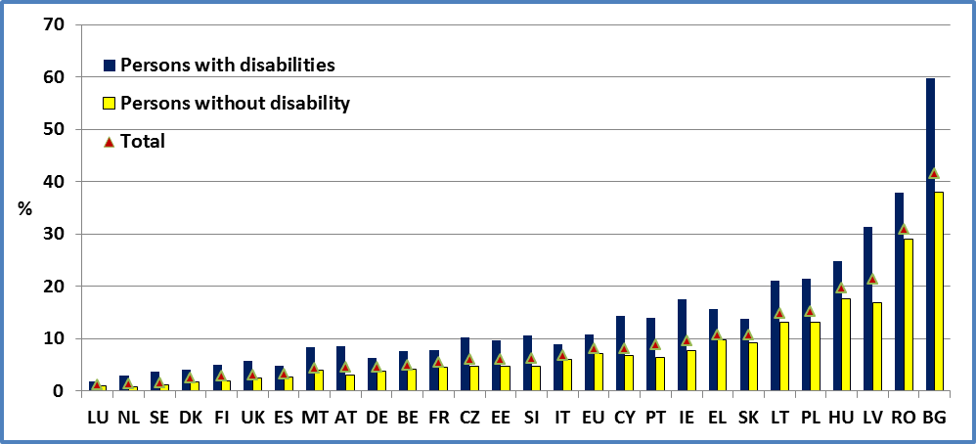
Data source: EU-SILC 2009

Figure 37: Share of persons with disabilities who are severely materially deprived, age 16+

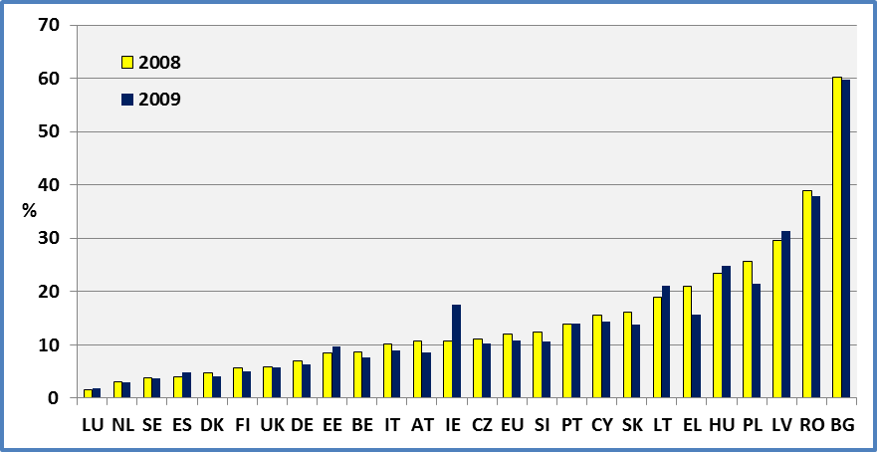
Data source: EU-SILC 2009

Figure 38: Increase in the probability of material deprivation associated with disability, 2009

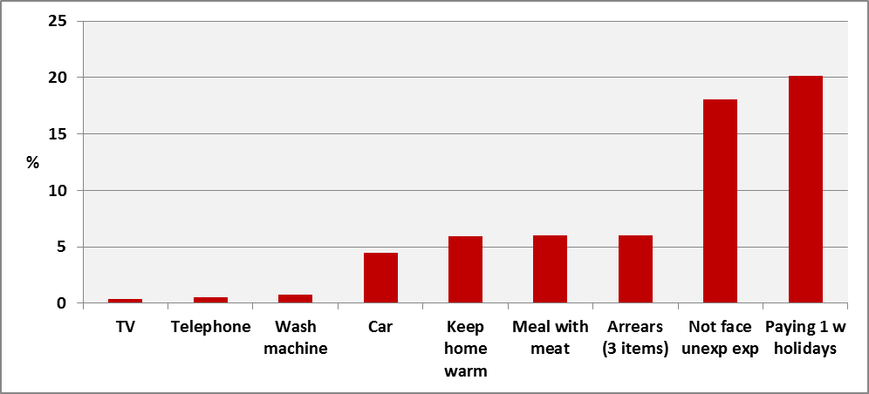
Note: We have run probit regressions with EU-SILC 2009 data (see Methodology).

Figure 39: Share of severely materially deprived persons by disability status and age, 2009

Percent of population with an enforced lack of at least four out of nine items

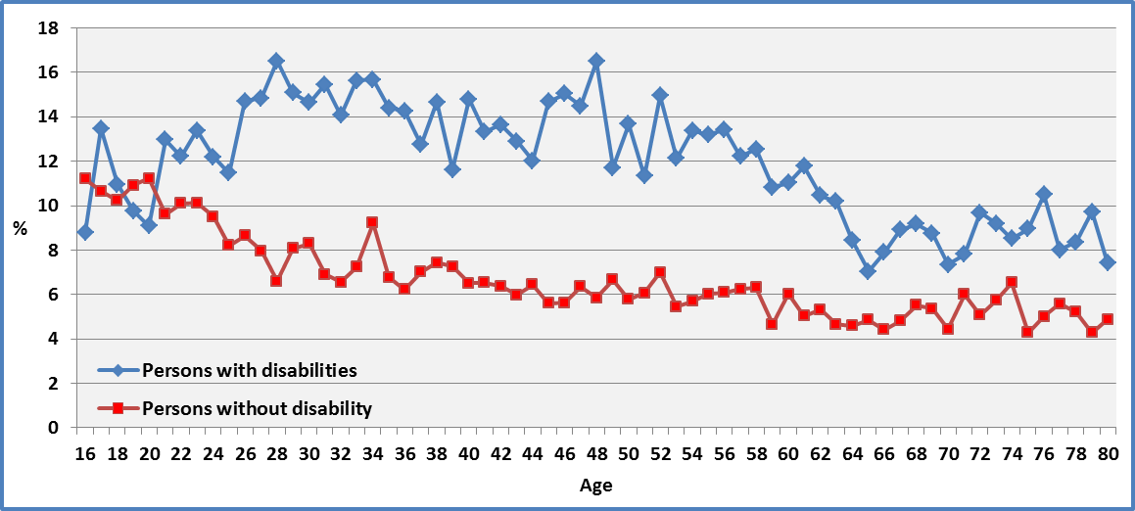
Data source: EU-SILC 2009

Figure 40: Share of severely materially deprived women and men (aged 16+) by disability status and Member State

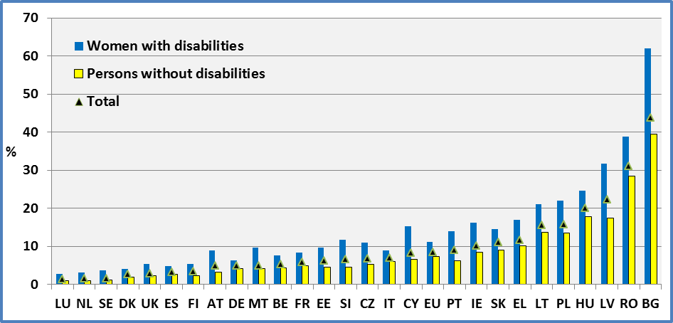

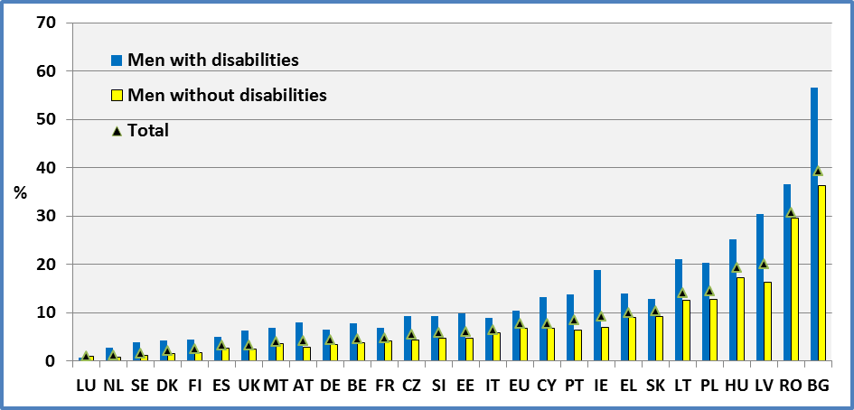
Data source: EU-SILC 2009

Data

Table 26: Percent of severely materially deprived persons by disability status and Member State (% population with an enforced lack of at least four out of nine material deprivation items in the 'economic strain and durables' dimension, age 16+)

 | Men + Women
 | 2008 |  |  |  | 2009
 | Disability |  |  | All | Disability |  |  | All
 | Yes | No | Total |  | Yes | No | Total
AT | 10.8 | 4.4 | 6.3 | 6.3 | 8.5 | 3.1 | 4.6 | 4.6
BE | 8.6 | 4.3 | 5.2 | 5.3 | 7.7 | 4.1 | 4.9 | 4.9
BG | 60.3 | 37.7 | 41.3 | 41.3 | 59.7 | 37.9 | 41.6 | 41.6
CY | 15.5 | 6.6 | 8.2 | 8.3 | 14.4 | 6.7 | 8.1 | 8.1
CZ | 11.0 | 5.4 | 6.6 | 6.6 | 10.3 | 4.8 | 6.1 | 5.9
DE | 7.0 | 3.7 | 4.8 | 4.9 | 6.4 | 3.8 | 4.6 | 4.9
DK | 4.8 | 0.9 | 1.9 | 1.9 | 4.1 | 1.8 | 2.4 | 2.4
EE | 8.5 | 3.1 | 4.7 | 4.7 | 9.7 | 4.7 | 6.1 | 6.1
EL | 21.0 | 9.1 | 11.4 | 11.4 | 15.7 | 9.7 | 10.8 | 10.8
ES | 4.0 | 2.0 | 2.5 | 2.5 | 4.9 | 2.7 | 3.2 | 3.3
FI | 5.7 | 2.7 | 3.6 | 3.6 | 5.0 | 2.0 | 2.9 | 2.9
FR |  |  |  | 5.4 | 7.8 | 4.6 | 5.4 | 5.4
HU | 23.4 | 14.7 | 17.2 | 17.2 | 24.9 | 17.6 | 19.7 | 19.8
IE | 10.8 | 3.8 | 5.1 | 5.1 | 17.5 | 7.7 | 9.6 | 9.6
IT | 10.2 | 6.0 | 7.2 | 7.2 | 8.9 | 6.0 | 6.7 | 6.8
LT | 18.9 | 9.5 | 11.9 | 12.2 | 21.0 | 13.2 | 14.9 | 15.1
LU | 1.6 | 0.4 | 0.6 | 0.6 | 1.9 | 0.9 | 1.1 | 1.1
LV | 29.6 | 13.9 | 19.0 | 19.0 | 31.3 | 16.9 | 21.3 | 21.4
MT |  |  |  | 4.0 | 8.4 | 3.9 | 4.4 | 4.4
NL | 3.1 | 0.7 | 1.4 | 1.4 | 3.0 | 0.8 | 1.4 | 1.5
PL | 25.6 | 15.5 | 17.7 | 17.7 | 21.4 | 13.2 | 15.1 | 15.1
PT | 13.8 | 7.4 | 9.3 | 9.3 | 13.9 | 6.4 | 8.8 | 8.8
RO | 38.9 | 30.3 | 31.9 | 31.9 | 37.9 | 29.0 | 30.9 | 30.9
SE | 3.8 | 0.9 | 1.3 | 1.4 | 3.7 | 1.1 | 1.5 | 1.5
SI | 12.3 | 5.2 | 7.0 | 7.0 | 10.7 | 4.7 | 6.2 | 6.2
SK | 16.2 | 9.3 | 11.7 | 11.7 | 13.8 | 9.2 | 10.8 | 10.9
UK | 5.8 | 3.8 | 4.2 | 4.1 | 5.8 | 2.4 | 3.1 | 3.1
EU | 12.0 | 7.9 | 8.9 | 8.6 | 10.8 | 7.1 | 8.0 | 7.8
Data source: EU-SILC 2008 ; EU-SILC 2009
All: This includes observations for which we do not dispose information on disability status.
Table 27: Percent of severely materially deprived persons by gender, disability status and Member State (% population with an enforced lack of at least four out of nine material deprivation items in the 'economic strain and durables' dimension (age 16 +)

 | 2008 |  |  |  |  |  | 2009
 | Females |  |  | Males |  |  | Females |  |  | Males
 | Disability |  |  | Disability |  |  | Disability |  |  | Disability
 | Yes | No | Total | Yes | No | Total | Yes | No | Total | Yes | No | Total
AT | 11.2 | 4.6 | 6.7 | 10.3 | 4.1 | 5.9 | 9.0 | 3.2 | 4.9 | 8.0 | 2.9 | 4.2
BE | 9.1 | 4.6 | 5.8 | 7.8 | 3.9 | 4.7 | 7.6 | 4.4 | 5.2 | 7.8 | 3.8 | 4.6
BG | 60.8 | 39.2 | 43.0 | 59.5 | 36.1 | 39.4 | 61.9 | 39.5 | 43.7 | 56.6 | 36.3 | 39.2
CY | 14.1 | 7.2 | 8.5 | 17.1 | 6.1 | 7.9 | 15.3 | 6.6 | 8.3 | 13.2 | 6.8 | 7.8
CZ | 12.0 | 5.7 | 7.2 | 9.6 | 5.0 | 5.9 | 10.9 | 5.3 | 6.7 | 9.3 | 4.3 | 5.4
DE | 6.9 | 3.8 | 4.8 | 7.1 | 3.7 | 4.8 | 6.4 | 4.1 | 4.9 | 6.5 | 3.4 | 4.3
DK | 5.1 | 1.1 | 2.2 | 4.4 | 0.7 | 1.5 | 4.1 | 2.0 | 2.6 | 4.2 | 1.5 | 2.1
EE | 7.9 | 3.0 | 4.6 | 9.4 | 3.1 | 4.9 | 9.6 | 4.6 | 6.2 | 9.9 | 4.7 | 6.0
EL | 22.4 | 9.8 | 12.6 | 19.1 | 8.3 | 10.2 | 16.9 | 10.2 | 11.6 | 14.0 | 9.1 | 9.9
ES | 3.7 | 2.0 | 2.4 | 4.4 | 2.0 | 2.5 | 4.8 | 2.7 | 3.3 | 5.1 | 2.7 | 3.2
FI | 6.2 | 3.3 | 4.2 | 4.9 | 2.1 | 2.9 | 5.4 | 2.3 | 3.4 | 4.4 | 1.7 | 2.5
FR |  |  |  |  |  |  | 8.4 | 5.0 | 5.9 | 6.9 | 4.2 | 4.8
HU | 24.5 | 14.5 | 17.7 | 21.8 | 14.8 | 16.7 | 24.7 | 17.8 | 20.0 | 25.2 | 17.3 | 19.3
IE | 10.1 | 4.1 | 5.3 | 11.6 | 3.4 | 4.9 | 16.3 | 8.5 | 10.1 | 18.9 | 7.0 | 9.2
IT | 10.6 | 6.0 | 7.5 | 9.7 | 6.0 | 6.9 | 8.9 | 6.1 | 7.0 | 8.9 | 5.8 | 6.5
LT | 20.2 | 10.0 | 12.8 | 16.7 | 8.9 | 10.6 | 21.0 | 13.7 | 15.6 | 21.0 | 12.5 | 14.1
LU | 1.6 | 0.4 | 0.7 | 1.5 | 0.3 | 0.5 | 2.8 | 0.9 | 1.3 | 0.8 | 1.0 | 1.0
LV | 31.3 | 14.8 | 20.8 | 26.9 | 12.9 | 16.8 | 31.8 | 17.5 | 22.3 | 30.5 | 16.3 | 20.1
MT |  |  |  |  |  |  | 9.7 | 4.2 | 4.9 | 6.8 | 3.6 | 3.9
NL | 2.5 | 0.9 | 1.4 | 4.1 | 0.5 | 1.3 | 3.1 | 0.9 | 1.6 | 2.7 | 0.8 | 1.2
PL | 25.7 | 15.9 | 18.1 | 25.4 | 15.2 | 17.2 | 22.1 | 13.5 | 15.7 | 20.4 | 12.8 | 14.4
PT | 13.7 | 7.4 | 9.6 | 14.1 | 7.4 | 9.1 | 14.0 | 6.3 | 9.1 | 13.8 | 6.4 | 8.4
RO | 40.0 | 30.1 | 32.2 | 37.2 | 30.4 | 31.5 | 38.8 | 28.5 | 31.0 | 36.6 | 29.5 | 30.7
SE | 4.0 | 1.0 | 1.5 | 3.6 | 0.8 | 1.2 | 3.7 | 1.1 | 1.6 | 3.8 | 1.2 | 1.5
SI | 11.9 | 5.6 | 7.3 | 12.8 | 4.8 | 6.6 | 11.8 | 4.5 | 6.6 | 9.3 | 4.8 | 5.9
SK | 17.0 | 9.5 | 12.3 | 15.1 | 9.2 | 10.9 | 14.5 | 9.1 | 11.1 | 12.9 | 9.3 | 10.3
UK | 5.9 | 4.2 | 4.5 | 5.7 | 3.4 | 3.8 | 5.3 | 2.3 | 2.9 | 6.3 | 2.5 | 3.2
EU | 12.3 | 8.1 | 9.3 | 11.6 | 7.6 | 8.5 | 11.1 | 7.3 | 8.4 | 10.4 | 6.8 | 7.7
Data source: EU-SILC 2008 & EU-SILC 2009

Table 28: Percent of severely materially deprived persons by age, disability status and Member State (% population with an enforced lack of at least four out of nine material deprivation items in the 'economic strain and durables' dimension)

 | Men + Women
 | 2008 |  |  |  |  |  | 2009
 | Age 16-64 |  |  | Age 65+ |  |  | Age 16-64 |  |  | Age 65+
 | Disability |  |  | Disability |  |  | Disability |  |  | Disability
 | Yes | No | Total | Yes | No | Total | Yes | No | Total | Yes | No | Total
AT | 14.1 | 4.7 | 6.8 | 5.9 | 2.2 | 4.4 | 11.8 | 3.3 | 5.0 | 3.8 | 1.7 | 2.9
BE | 11.0 | 4.7 | 5.7 | 4.8 | 1.8 | 3.2 | 9.7 | 4.5 | 5.4 | 4.6 | 1.8 | 3.1
BG | 53.4 | 34.3 | 36.2 | 66.6 | 56.5 | 60.5 | 54.3 | 35.4 | 37.3 | 64.7 | 53.0 | 57.9
CY | 18.2 | 6.5 | 7.9 | 12.0 | 8.4 | 10.3 | 16.6 | 6.8 | 7.9 | 11.3 | 6.4 | 8.8
CZ | 12.9 | 5.5 | 6.6 | 8.4 | 4.6 | 6.6 | 11.8 | 5.0 | 6.2 | 8.1 | 3.5 | 5.8
DE | 10.0 | 4.1 | 5.6 | 2.8 | 0.9 | 2.0 | 9.1 | 4.1 | 5.3 | 2.8 | 1.8 | 2.4
DK | 5.9 | 1.0 | 2.1 | 1.5 | 0.6 | 0.9 | 5.3 | 2.0 | 2.7 | 1.0 | 0.8 | 0.8
EE | 10.2 | 3.1 | 4.5 | 6.8 | 2.5 | 5.7 | 12.2 | 4.8 | 6.2 | 7.0 | 2.8 | 5.6
EL | 21.4 | 9.2 | 10.5 | 20.7 | 8.3 | 14.8 | 20.5 | 9.6 | 10.4 | 13.6 | 9.9 | 12.1
ES | 5.2 | 2.2 | 2.6 | 2.4 | 0.8 | 1.7 | 6.6 | 2.9 | 3.6 | 2.8 | 1.0 | 2.0
FI | 6.2 | 2.9 | 3.7 | 4.7 | 1.3 | 3.2 | 6.2 | 2.2 | 3.1 | 2.8 | 1.4 | 2.1
FR |  |  |  |  |  |  | 10.8 | 4.9 | 5.9 | 4.3 | 2.0 | 3.2
HU | 27.2 | 15.1 | 17.8 | 17.1 | 10.1 | 14.5 | 30.3 | 18.3 | 20.8 | 17.2 | 10.5 | 14.8
IE | 14.3 | 4.0 | 5.6 | 3.6 | 1.2 | 2.3 | 20.4 | 8.1 | 10.0 | 11.5 | 4.6 | 7.6
IT | 12.0 | 6.4 | 7.3 | 8.8 | 3.1 | 6.7 | 10.9 | 6.4 | 7.1 | 7.3 | 3.0 | 5.7
LT | 18.4 | 9.3 | 10.8 | 19.5 | 11.4 | 16.4 | 22.4 | 12.8 | 14.1 | 19.6 | 16.8 | 18.5
LU | 2.4 | 0.4 | 0.7 | 0.0 | 0.0 | 0.0 | 2.8 | 1.0 | 1.3 | 0.1 | 0.2 | 0.2
LV | 27.4 | 13.4 | 16.8 | 32.8 | 18.5 | 28.3 | 32.5 | 17.0 | 20.4 | 29.7 | 16.2 | 25.3
MT |  |  |  |  |  |  | 11.9 | 3.9 | 4.5 | 5.0 | 3.7 | 4.2
NL | 4.1 | 0.8 | 1.6 | 0.8 | 0.1 | 0.4 | 4.0 | 0.9 | 1.7 | 0.6 | 0.2 | 0.4
PL | 27.1 | 15.4 | 17.1 | 23.5 | 17.2 | 20.7 | 22.6 | 13.1 | 14.6 | 19.8 | 14.5 | 17.5
PT | 14.6 | 7.7 | 9.1 | 13.0 | 4.4 | 10.1 | 14.1 | 6.6 | 8.3 | 13.7 | 4.2 | 10.6
RO | 37.0 | 29.1 | 30.1 | 41.0 | 39.1 | 40.0 | 38.7 | 28.7 | 30.1 | 37.1 | 31.4 | 34.5
SE | 5.3 | 0.9 | 1.5 | 1.3 | 0.6 | 0.8 | 5.5 | 1.3 | 1.8 | 0.8 | 0.4 | 0.5
SI | 13.0 | 5.2 | 6.8 | 10.8 | 4.9 | 7.8 | 11.5 | 4.8 | 6.2 | 9.0 | 4.2 | 6.5
SK | 16.1 | 9.3 | 11.0 | 16.4 | 9.9 | 15.2 | 14.3 | 9.4 | 10.6 | 13.1 | 5.9 | 11.6
UK | 8.5 | 4.3 | 4.9 | 1.8 | 1.1 | 1.4 | 8.5 | 2.7 | 3.6 | 1.8 | 0.7 | 1.2
EU | 13.7 | 8.1 | 9.1 | 9.9 | 6.6 | 8.4 | 12.8 | 7.3 | 8.3 | 8.3 | 5.2 | 6.9
Data source: EU-SILC 2008 ; EU-SILC 2009
LU: No one aged 65+ lacking four or more material deprivation items was identified in the data.

Data source

- EUSILC UDB 2008 – version 3 of March 2011
- EUSILC UDB 2009 – version 1 of March 2011

Methodology

The indicator presents the share of population with an enforced lack of at least four out of nine material deprivation items in the 'economic strain and durables' dimension.

The nine items considered are:

- Arrears on mortgage or rent payments, utility bills, hire purchase instalments or other loan payments;
- Capacity to afford paying for one week's annual holiday away from home;
- Capacity to afford a meal with meat, chicken, fish (or vegetarian equivalent) every second day;
- Capacity to face unexpected financial expenses [set amount corresponding to the monthly national at-risk-of-poverty threshold of the previous year];
- Household cannot afford a telephone (including mobile phone);
- Household cannot afford a colour TV;
- Household cannot afford a washing machine;
- Household cannot afford a car and
- Ability of the household to pay for keeping its home adequately warm.

For estimations distinguishing those ‘limited’ and ‘not limited’ in Denmark, Finland, Netherland, Sweden and Slovenia we have used personal cross sectional weights for selected persons (pb060). Otherwise, we have used personal cross sectional weights (pb040). Also, we have used the age at the end of the income reference period (px020).

Where there is missing information on some items but the number of deprivations is between 1 and 3 we take the observation into consideration (in the denominator). Where there is deprivation for at least 4 items, even if we miss information for the remaining items, we include both in the nominator and denominator of the percentage. Other variants do not change the results and affect only marginally the second decimal of the percentage.

We have estimated the probabilities of material deprivation arising from disability by running probit regressions (using age, disability (limitation) and national dummies as explanatory variables). The aim is to establish a ranking for the nine items. For comparison, we have run probit regressions by including financial poverty risk as an explanatory variable in order to separate what is specific to disability and what is linked to income poverty. Both regressions provided similar estimators for disability (limitations). We have used the EU-SILC 2009 micro-data for our estimations.
The reported results include age, disability and national dummies as explanatory variables.

Notes

It is worth noting that income poverty depends on national conditions (median national income) while material deprivation is defined in the same way in all Member States (at least four out of nine material deprivation items). In addition, all items bear the same weight. There is thus considerably more variation in measures of material deprivation between Member States than for measures of relative income poverty.

The survey data indicates a focus on the affordability of some deprivation items. However, subjective and generational expectations may bias the meaning attached to responses. For example, some older people may respond that ’they don’t want or need it‘ instead of ’would like to have it but cannot afford it‘ even when the latter is also true (for example holidays, car, etc.). The share of older people in material deprivation may be biased downwards by the indicator.

PEOPLE AT RISK OF POVERTY OR SOCIAL EXCLUSION

Relevance to EU policy / Strategy

The European Disability Strategy 2010-2020 recognises that there is a high rate of poverty amongst people with disabilities. One of its key areas for action is to ‘promote decent living conditions for people with disabilities’. In particular, the strategy focuses on the need for social protection and poverty reduction programmes, including adequate disability benefits.

The Lisbon European Council (2000) established a social inclusion process in order to combating poverty and the Barcelona European Council (2002) stressed the importance of the fight against poverty and social exclusion, inviting Member States to set targets, in their National Action Plans, for significantly reducing the number of people at risk of poverty and social exclusion by 2010. The European Platform against Poverty (referred to also in the European Disability Strategy) is one of the flagship initiatives of Europe 2020, and aims to ensure that the benefits of growth and jobs are widely shared and that people experiencing poverty and social exclusion are enabled to live in dignity and take an active part in society.

The Europe 2020 strategy includes a high level commitment to ‘lift at least 20 million people out of the risk of poverty or exclusion’.

An over-arching indicator of the population at risk of poverty or exclusion is developed by combining three separate indicators for people living in households with very low work intensity, people at risk of poverty after social transfers, and severely materially deprived people (these are elaborated separately in the Europe 2020 indicator set and in our disability indicator set).

This indicator corresponds to the sum of persons who are either at risk of poverty or severely materially deprived or living in households with very low work intensity. Due to the additional requirement to identify people with disabilities, the results presented focus here on people aged 16 to 59 years.

Headline findings

At the European level, 37% of people with disabilities aged 16 to 59 are at risk of poverty or social exclusion compared to 21% of persons without a disability of the same age group.

Between 2008 and 2009 the data indicates a very small improvement in risk of poverty or social exclusion, both for people with and without disabilities, at the EU level but with national differences.

Although there is a small gender difference in favour of men (both for people with and without disabilities) the rates of risk are very close. This closure of the gender gap is not surprising, as the combined indicator is constructed at the household level rather than the individual level.

Employment is an important factor in reducing poverty risk but people with disabilities are over-represented amongst the working poor as they are amongst those out of work. Given the fact that people with disabilities also experience an employment gap, the overall poverty gap is increased. However, for people in employment there is still a significant gap, with 16% of persons with disabilities at a risk of poverty or social exclusion compared to 12% of people without a disability.

Financial poverty is not the only reason for material deprivation. Disability appears to be a disadvantaging factor (independently of income), which may be due to the extra costs of living with disability and additional barriers related to accessibility.
Table 41: Percent of people (aged 16-59) at-risk-of-poverty or social exclusion

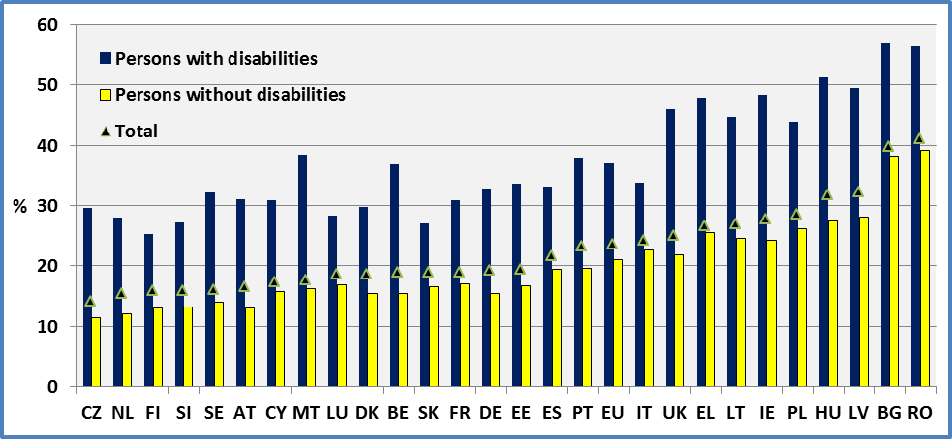
Data source: EU-SILC 2009

Table 42: People with disabilities (aged 16-59) at-risk-of-poverty or social exclusion in 2008 and 2009

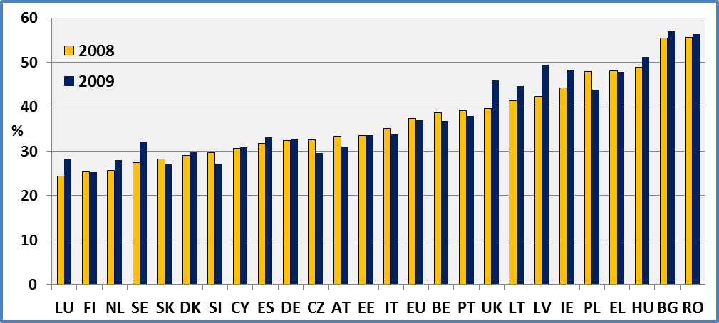
Data source: EU-SILC 2008 ; EU-SILC 2009

Figure 43: Share of people at-risk-of-poverty or social exclusion by age, 2009

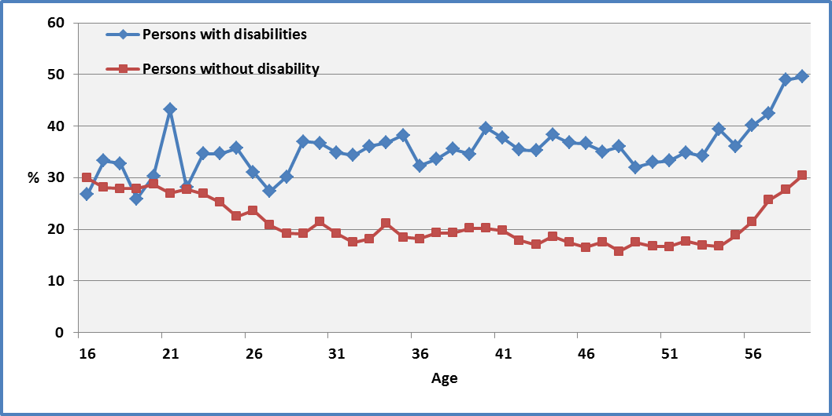
Data source: EU-SILC 2009

Figure 44: Share of women and men (aged 16-59) at-risk-of-poverty or social exclusion, 2009

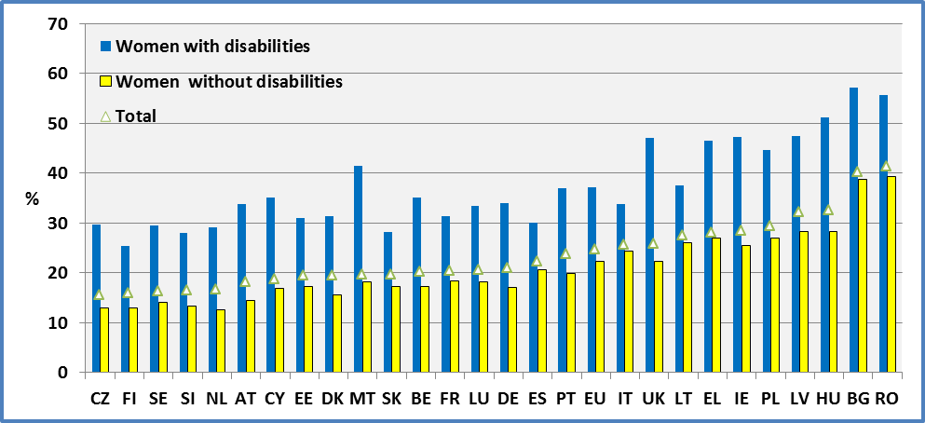

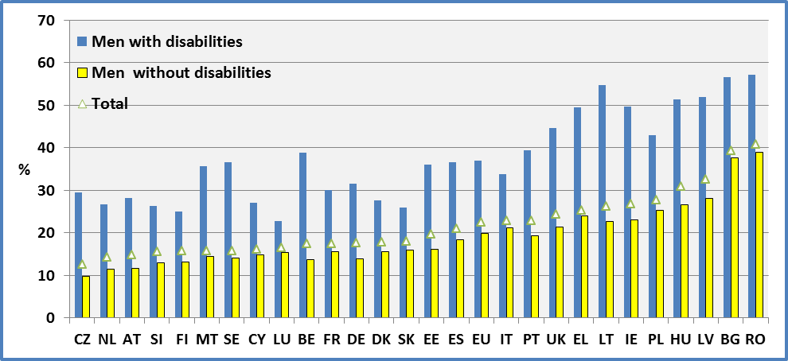
Data source: EU-SILC 2009

Figure 45: Difference in the risk-of-poverty or social exclusion by gender (aged 16-59) 2009
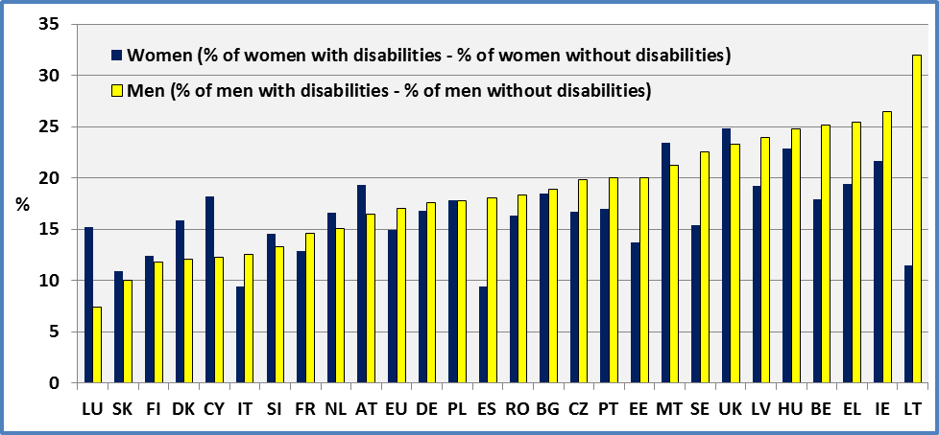
Data source: EU-SILC 2009

Data

Table 29: Percent of people (aged 16-59_at-risk-of-poverty or social exclusion by year and Member State

 | Men + Women
 | 2008 |  |  |  | 2009
 | Disability |  |  | All | Disability |  |  | All
 | Yes | No | Total |  | Yes | No | Total
AT | 33.3 | 14.7 | 18.5 | 18.5 | 31.0 | 13.0 | 16.5 | 16.5
BE | 38.6 | 15.6 | 19.3 | 19.3 | 36.8 | 15.4 | 18.9 | 19.0
BG | 55.4 | 36.5 | 38.1 | 38.1 | 56.9 | 38.2 | 39.8 | 39.8
CY | 30.6 | 15.3 | 16.8 | 16.8 | 30.9 | 15.8 | 17.4 | 17.4
CZ | 32.5 | 13.1 | 15.8 | 15.5 | 29.6 | 11.4 | 14.1 | 13.7
DE | 32.4 | 16.1 | 19.8 | 20.2 | 32.8 | 15.5 | 19.3 | 19.9
DK | 29.0 | 14.2 | 17.4 | 17.7 | 29.8 | 15.5 | 18.7 | 18.7
EE | 33.5 | 13.4 | 16.8 | 16.7 | 33.6 | 16.7 | 19.5 | 19.5
EL | 48.1 | 25.1 | 27.1 | 27.1 | 47.9 | 25.5 | 26.7 | 26.7
ES | 31.8 | 18.2 | 20.1 | 20.1 | 33.1 | 19.5 | 21.6 | 21.6
FI | 25.4 | 13.6 | 16.2 | 16.3 | 25.2 | 13.1 | 15.9 | 15.8
FR |  |  |  |  | 30.8 | 17.0 | 19.0 | 19.0
HU | 48.9 | 25.0 | 29.7 | 29.7 | 51.2 | 27.4 | 31.7 | 31.7
IE | 44.3 | 17.5 | 21.2 | 21.2 | 48.4 | 24.3 | 27.7 | 27.7
IT | 35.1 | 22.5 | 24.3 | 24.4 | 33.7 | 22.7 | 24.2 | 24.4
LT | 41.3 | 20.8 | 23.8 | 24.5 | 44.7 | 24.5 | 26.9 | 27.1
LU | 24.4 | 14.6 | 16.1 | 16.1 | 28.3 | 16.8 | 18.6 | 18.6
LV | 42.4 | 23.1 | 27.3 | 27.3 | 49.5 | 28.1 | 32.3 | 32.7
MT |  |  |  |  | 38.4 | 16.3 | 17.7 | 17.7
NL | 25.7 | 11.8 | 14.7 | 15.2 | 28.0 | 12.0 | 15.4 | 15.9
PL | 47.9 | 28.9 | 31.3 | 31.3 | 43.9 | 26.1 | 28.6 | 28.6
PT | 39.1 | 20.7 | 24.0 | 24.0 | 37.9 | 19.6 | 23.2 | 23.2
RO | 55.6 | 39.6 | 41.2 | 41.2 | 56.3 | 39.1 | 41.1 | 41.1
SE | 27.4 | 13.5 | 15.1 | 15.2 | 32.1 | 14.0 | 16.0 | 15.9
SI | 29.7 | 14.9 | 17.8 | 17.8 | 27.2 | 13.2 | 15.9 | 15.9
SK | 28.3 | 17.3 | 19.6 | 19.8 | 27.1 | 16.6 | 18.9 | 19.0
UK | 39.6 | 18.8 | 21.6 | 21.5 | 45.9 | 21.8 | 25.0 | 25.1
EU | 37.3 | 21.4 | 23.9 | 23.4 | 37.0 | 21.0 | 23.6 | 23.2
Data source: EU-SILC 2008 ; EU-SILC 2009
All: This includes observations for which we do not dispose information on disability status.

Table 30: Percent of people (aged 16-59) at-risk-of-poverty or social exclusion by gender and Member State
 | 2008 |  |  |  |  |  | 2009
 | Females |  |  | Males |  |  | Females |  |  | Males
 | Disability |  |  | Disability |  |  | Disability |  |  | Disability
 | Yes | No | Total | Yes | No | Total | Yes | No | Total | Yes | No | Total
AT | 36.1 | 15.9 | 20.0 | 30.5 | 13.6 | 17.0 | 33.7 | 14.4 | 18.1 | 28.2 | 11.7 | 14.8
BE | 38.8 | 17.0 | 20.8 | 38.4 | 14.2 | 17.9 | 35.1 | 17.2 | 20.3 | 38.9 | 13.7 | 17.5
BG | 58.4 | 37.0 | 38.8 | 52.3 | 36.0 | 37.4 | 57.2 | 38.7 | 40.3 | 56.6 | 37.7 | 39.2
CY | 32.0 | 17.0 | 18.5 | 29.2 | 13.4 | 15.1 | 35.0 | 16.8 | 18.7 | 27.1 | 14.8 | 16.1
CZ | 32.2 | 14.8 | 17.3 | 32.8 | 11.3 | 14.0 | 29.6 | 12.9 | 15.5 | 29.5 | 9.7 | 12.5
DE | 33.1 | 17.7 | 21.3 | 31.6 | 14.6 | 18.4 | 33.9 | 17.1 | 20.9 | 31.5 | 13.9 | 17.7
DK | 30.3 | 13.9 | 17.9 | 27.3 | 14.5 | 17.0 | 31.4 | 15.5 | 19.5 | 27.6 | 15.5 | 17.8
EE | 30.1 | 13.8 | 16.4 | 36.7 | 12.9 | 17.2 | 31.0 | 17.3 | 19.4 | 36.1 | 16.1 | 19.6
EL | 46.9 | 26.9 | 28.7 | 49.5 | 23.5 | 25.5 | 46.4 | 27.0 | 28.1 | 49.4 | 24.0 | 25.3
ES | 29.9 | 19.4 | 21.0 | 33.9 | 17.0 | 19.2 | 30.1 | 20.7 | 22.3 | 36.5 | 18.4 | 20.9
FI | 25.5 | 14.1 | 16.8 | 25.4 | 13.0 | 15.6 | 25.3 | 12.9 | 16.0 | 25.0 | 13.2 | 15.8
FR |  |  |  |  |  |  | 31.3 | 18.4 | 20.5 | 30.1 | 15.5 | 17.5
HU | 51.3 | 25.5 | 30.7 | 46.4 | 24.5 | 28.7 | 51.2 | 28.3 | 32.5 | 51.3 | 26.5 | 30.8
IE | 42.3 | 19.4 | 22.6 | 46.3 | 15.7 | 19.8 | 47.2 | 25.5 | 28.5 | 49.6 | 23.1 | 26.8
IT | 34.9 | 24.3 | 26.0 | 35.2 | 20.9 | 22.7 | 33.7 | 24.3 | 25.7 | 33.7 | 21.2 | 22.8
LT | 39.7 | 22.6 | 25.2 | 43.2 | 18.7 | 22.2 | 37.5 | 26.0 | 27.5 | 54.7 | 22.7 | 26.2
LU | 23.7 | 16.7 | 17.9 | 25.2 | 12.6 | 14.4 | 33.4 | 18.2 | 20.7 | 22.8 | 15.4 | 16.5
LV | 41.4 | 24.3 | 28.2 | 43.5 | 21.9 | 26.3 | 47.4 | 28.2 | 32.1 | 51.9 | 28.0 | 32.5
MT |  |  |  |  |  |  | 41.5 | 18.1 | 19.6 | 35.6 | 14.4 | 15.8
NL | 25.6 | 12.9 | 16.0 | 25.9 | 10.7 | 13.3 | 29.1 | 12.5 | 16.6 | 26.6 | 11.5 | 14.2
PL | 46.1 | 30.1 | 32.1 | 49.5 | 27.5 | 30.5 | 44.7 | 26.9 | 29.4 | 43.0 | 25.2 | 27.8
PT | 38.8 | 21.4 | 24.9 | 39.5 | 19.9 | 23.0 | 36.9 | 19.9 | 23.7 | 39.3 | 19.3 | 22.8
RO | 56.2 | 40.0 | 41.9 | 54.8 | 39.1 | 40.6 | 55.6 | 39.3 | 41.3 | 57.2 | 38.9 | 40.8
SE | 26.9 | 13.3 | 15.2 | 28.2 | 13.6 | 14.9 | 29.5 | 14.1 | 16.3 | 36.5 | 14.0 | 15.8
SI | 27.5 | 15.8 | 18.2 | 31.8 | 13.9 | 17.5 | 27.9 | 13.3 | 16.5 | 26.3 | 13.0 | 15.5
SK | 28.8 | 18.1 | 20.6 | 27.6 | 16.4 | 18.6 | 28.1 | 17.2 | 19.7 | 26.0 | 16.0 | 18.0
UK | 38.8 | 20.7 | 23.2 | 40.6 | 17.0 | 19.9 | 47.0 | 22.2 | 25.8 | 44.7 | 21.4 | 24.3
EU | 37.2 | 22.8 | 25.2 | 37.5 | 20.0 | 22.7 | 37.1 | 22.2 | 24.7 | 36.9 | 19.9 | 22.5
Data source: EU-SILC 2008 ; EU-SILC 2009

Data source

- EUSILC UDB 2008 – version 3 of March 2011
- EUSILC UDB 2009 – version 1 of March 2011
Methodology

This indicator is compiled from the three preceding sub-indicators and corresponds to the sum of persons who are either:

- At risk of poverty, or
- Severely materially deprived, or
- Living in households with very low work intensity.

The total population is however not a simple arithmetic sum of its three components because of overlaps between the populations covered by the three sub-indicators.

Eurostat defines a person at risk-of-poverty in relation to the three risks as follows:

- Persons with an equivalised disposable income below the risk-of-poverty threshold, which is set at 60 % of the national median equivalised disposable income (after social transfers).
- Material deprivation covers indicators relating to economic strain and durables. Severely materially deprived persons have living conditions severely constrained by a lack of resources, they experience at least 4 out of 9 following deprivations items: cannot afford i) to pay rent or utility bills, ii) keep home adequately warm, iii) face unexpected expenses, iv) eat meat, fish or a protein equivalent every second day, v) a week holiday away from home, vi) a car, vii) a washing machine, viii) a colour TV, or ix) a telephone.
- People living in households with very low work intensity are those aged 0-59 living in households where the adults (aged 18-59) work less than 20% of their total work potential during the past year.

Information concerning disability status (limitations) is only provided for persons aged 16 or more. We construct our indicator for the age group 16 to 59.

Notes

Our indicator covers persons aged 16 to 59 years old. The EU-SILC survey provides information on disability (limitations) for persons aged 16 or more. Eurostat includes children (i.e. those aged under 16) in the estimation of its indicator. Consequently, the indicator may under-represent the share of people with disabilities at risk of poverty. We use the age of 59 as the upper limit in order to be coherent with the work intensity indicator. This means that the indicator does not represent older people with disabilities.

ACCESSIBILITY

ACCESSIBILITY OF PUBLIC TRANSPORT

Relevance to EU Strategy

Accessibility has a high profile in the European Disability Strategy, as one of eight main areas for action. Accessibility is defined as meaning that people with disabilities have access, on an equal basis with others, to the physical environment, transportation, information and communications technologies and systems (ICT), and other facilities and services. This reflects also the commitments on accessibility identified in the UN Convention (in Article 9 and elsewhere).

The Commission considers that accessibility is a precondition for participation in society and in the economy, but the EU still has a long way to go in achieving this. The Commission proposes to develop legislative and other instruments, such as standardisation, to optimise the accessibility of the built environment, transport and ICT. Transport is fundamental to inclusion in the economy and community and people with disabilities and their families are more often dependent on public transport than non-disabled people.

One estimation of the accessibility of public transport can be derived from the level of ‘difficulty’ that people experience in using it. The available indicator considers the household as a whole.

Headline findings

The percentage of people with disabilities living in households for which access to public transport is reported to be difficult is 22% compared to 18% of people without disabilities. If we consider only persons who participated in household interviews, the respective rates are 23% and 17%.

The indicator is constructed at the level of the household rather than the individual and there is no significant gender difference between households including disabled women and men.

The difference between people with and without disabilities increases with age, notably after the age of 50 years. Thus, the respective rates for people aged 65 or more are 26% and 17%, compared to 22% and 18% for those aged 16-64.

There is a large variation between Member States. The proportion of households including people with disabilities that reported difficult was less than 10% in Denmark but more than 40% in Lithuania. However, in every Member State there was an accessibility gap between households including people with disabilities and other households (except in Malta where this applied only to men).

Figure 46: Percent of persons (aged 16+) in households with difficult access to public transport; 2009

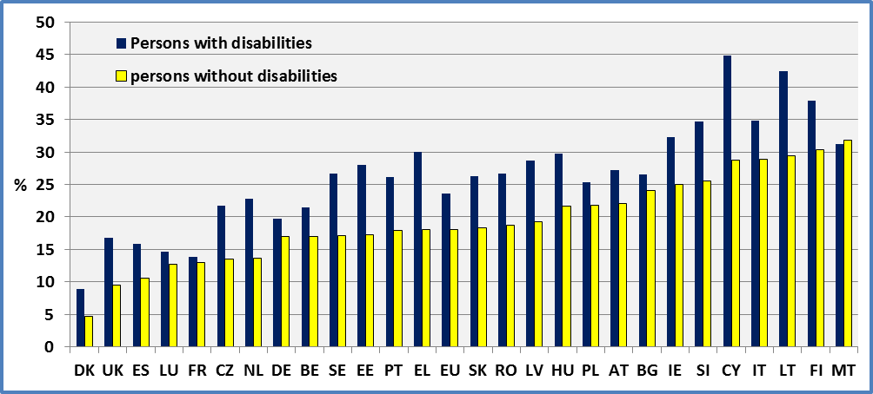

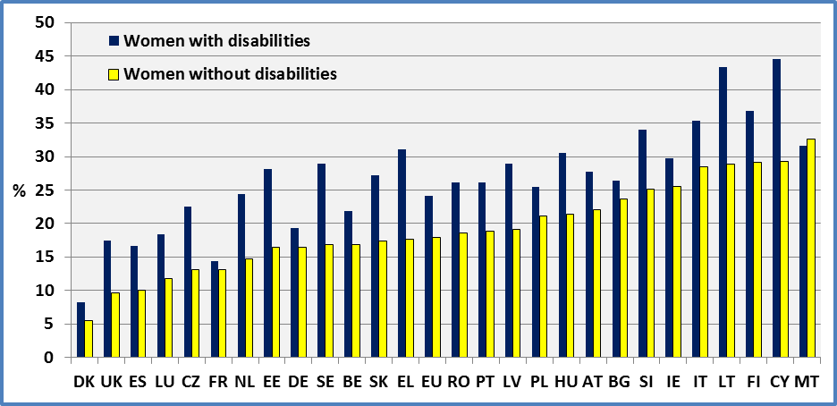

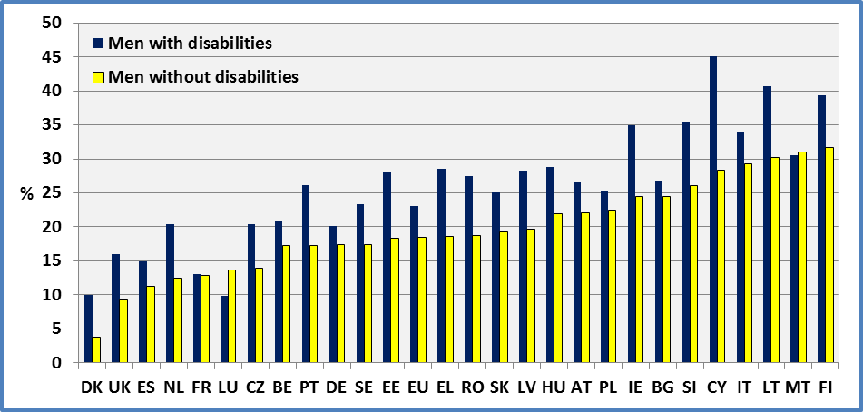
Data source: EU-SILC 2009

Data

Table 31: Percent of persons (aged 16+) in households with difficult access to public transport; 2009.

 | Females + Males |  |  | Females |  |  | Males
 | Disability |  |  | Disability |  |  | Disability
 | Yes | No | Total | Yes | No | Total | Yes | No | Total
AT | 27.2 | 22.1 | 23.5 | 27.7 | 22.0 | 23.7 | 26.5 | 22.1 | 23.3
BE | 21.4 | 17.0 | 18.1 | 21.8 | 16.9 | 18.2 | 20.8 | 17.2 | 18.0
BG | 26.5 | 24.0 | 24.5 | 26.4 | 23.6 | 24.2 | 26.6 | 24.5 | 24.8
CY | 44.8 | 28.8 | 32.9 | 44.5 | 29.3 | 33.6 | 45.1 | 28.3 | 32.1
CZ | 21.7 | 13.5 | 15.5 | 22.5 | 13.1 | 15.6 | 20.4 | 13.9 | 15.3
DE | 19.7 | 17.0 | 17.8 | 19.3 | 16.5 | 17.4 | 20.1 | 17.4 | 18.2
DK | 9.0 | 4.7 | 6.1 | 8.2 | 5.5 | 6.3 | 10.0 | 3.8 | 5.9
EE | 28.1 | 17.2 | 20.3 | 28.1 | 16.4 | 19.9 | 28.1 | 18.3 | 20.7
EL | 30.0 | 18.1 | 20.3 | 31.1 | 17.6 | 20.3 | 28.5 | 18.6 | 20.2
ES | 15.9 | 10.6 | 11.9 | 16.6 | 10.1 | 11.9 | 14.9 | 11.2 | 12.0
FI | 37.8 | 30.4 | 35.4 | 36.8 | 29.1 | 34.2 | 39.3 | 31.7 | 36.6
FR | 13.8 | 13.0 | 13.1 | 14.4 | 13.1 | 13.4 | 13.0 | 12.8 | 12.9
HU | 29.8 | 21.7 | 24.1 | 30.5 | 21.4 | 24.3 | 28.8 | 21.9 | 23.8
IE | 32.2 | 24.9 | 26.4 | 29.7 | 25.5 | 26.4 | 35.0 | 24.4 | 26.4
IT | 34.8 | 28.8 | 30.4 | 35.3 | 28.4 | 30.5 | 33.9 | 29.2 | 30.3
LT | 42.4 | 29.4 | 32.6 | 43.3 | 28.8 | 32.8 | 40.7 | 30.2 | 32.4
LU | 14.6 | 12.8 | 13.1 | 18.4 | 11.8 | 13.3 | 9.9 | 13.7 | 13.0
LV | 28.6 | 19.3 | 22.2 | 28.9 | 19.1 | 22.4 | 28.2 | 19.6 | 22.0
MT | 31.2 | 31.8 | 31.7 | 31.6 | 32.6 | 32.5 | 30.6 | 31.0 | 31.0
NL | 22.8 | 13.6 | 17.3 | 24.4 | 14.7 | 17.8 | 20.4 | 12.5 | 16.7
PL | 25.3 | 21.7 | 22.6 | 25.4 | 21.1 | 22.2 | 25.2 | 22.4 | 23.0
PT | 26.1 | 18.0 | 20.8 | 26.1 | 18.8 | 21.6 | 26.1 | 17.2 | 19.9
RO | 26.7 | 18.7 | 20.3 | 26.1 | 18.6 | 20.4 | 27.5 | 18.7 | 20.2
SE | 26.7 | 17.1 | 20.2 | 28.9 | 16.8 | 19.9 | 23.3 | 17.4 | 20.5
SI | 34.6 | 25.5 | 29.2 | 34.0 | 25.1 | 28.9 | 35.5 | 26.0 | 29.4
SK | 26.3 | 18.4 | 21.2 | 27.2 | 17.4 | 21.2 | 25.0 | 19.3 | 21.1
UK | 16.8 | 9.5 | 11.0 | 17.5 | 9.7 | 11.4 | 16.0 | 9.3 | 10.6
EU | 23.7 | 18.1 | 19.6 | 24.1 | 17.9 | 19.6 | 23.1 | 18.4 | 19.6
Data source: EU-SILC 2008 ; EU-SILC 2009
Table 32: Percent of persons in households with difficult access to public transport; 2009

 | Females + Males
 | Age 16-64 |  |  | Age 65+
 | Disability |  |  | Disability
 | Yes | No | Total | Yes | No | Total
AT | 22.8 | 22.4 | 22.5 | 33.9 | 19.5 | 27.3
BE | 19.4 | 16.8 | 17.3 | 24.6 | 18.5 | 21.2
BG | 25.2 | 23.5 | 23.7 | 27.7 | 27.1 | 27.3
CY | 41.1 | 28.9 | 30.9 | 48.0 | 28.3 | 39.1
CZ | 19.8 | 13.4 | 14.8 | 24.2 | 14.0 | 18.7
DE | 20.2 | 17.6 | 18.2 | 19.1 | 13.1 | 16.5
DK | 8.3 | 4.7 | 6.0 | 10.5 | 4.4 | 6.5
EE | 26.4 | 16.9 | 18.6 | 29.8 | 20.6 | 26.7
EL | 25.4 | 17.3 | 17.9 | 32.1 | 24.1 | 28.7
ES | 14.1 | 10.6 | 11.2 | 18.4 | 11.0 | 14.9
FI | 36.0 | 30.4 | 34.8 | 40.6 | 30.1 | 37.7
FR | 16.2 | 13.2 | 13.7 | 10.1 | 10.9 | 10.5
HU | 24.8 | 21.6 | 22.4 | 36.7 | 21.8 | 31.3
IE | 26.7 | 24.2 | 24.6 | 44.3 | 30.9 | 36.5
IT | 32.8 | 29.6 | 30.1 | 36.3 | 23.8 | 31.2
LT | 38.3 | 28.9 | 30.4 | 46.1 | 33.8 | 41.0
LU | 12.7 | 13.2 | 13.1 | 18.2 | 9.9 | 13.3
LV | 26.9 | 19.0 | 20.8 | 31.0 | 22.6 | 28.0
MT | 32.1 | 32.6 | 32.6 | 30.2 | 25.9 | 27.5
NL | 19.0 | 13.3 | 16.3 | 31.0 | 15.3 | 22.4
PL | 23.9 | 21.7 | 22.1 | 27.3 | 21.9 | 24.9
PT | 24.3 | 18.6 | 20.1 | 28.2 | 13.0 | 23.4
RO | 23.3 | 18.3 | 18.9 | 30.4 | 22.1 | 26.6
SE | 24.6 | 17.2 | 20.0 | 30.1 | 16.7 | 20.8
SI | 32.2 | 26.1 | 28.8 | 38.1 | 22.8 | 30.6
SK | 22.4 | 18.4 | 19.6 | 32.6 | 17.4 | 29.3
UK | 13.8 | 9.3 | 10.0 | 21.5 | 10.7 | 14.7
EU | 21.6 | 18.3 | 19.0 | 26.2 | 16.8 | 21.8
Data source: EU-SILC 2009

Data source
- EUSILC UDB 2008 – version 3 of March 2011
- EUSILC UDB 2009 – version 1 of March 2011
Methodology

The EU-SILC 2009 Module on Material Deprivation includes a question on the ‘Accessibility of public transport’. The possible answers are:

- with great difficulty
- with some difficulty
- easily
- very easily

Eurostat notes that the accessibility of the services is to be assessed in terms of physical and technical access, and opening hours, but not in terms of quality, price and similar aspects. Physical access has to be assessed in terms of distance but also of infrastructure and equipment, for example, which is likely to be of relevance to respondents with a physical impairment.

The respondent should give an answer for the household as a whole. If the respondent does not use a service but other household member(s) do, he or she should assess the accessibility according to their use. Accessibility should be considered at the level of the household, the difficulty should be evaluated for the household as a whole.

Eurostat indicates specifically that if one member of the household has a disability and can hardly access a service (which he needs as an individual) and the household has no resource available to provide support, then access to the service would be considered as difficult for the household.

Public transport refers to use of the bus, metro, tram and similar.

Data for France and Cyprus ought to be interpreted with caution as they involve a very high number of people who declare that these services are not used by the household and who were thus not interviewed further.

The reported estimations refer only to households in which people use public transport.

Notes

The methodology may underestimate the size of the accessibility gap. Indeed, Eurostat notes that if a disabled respondent does not use a transport service at all but other household member(s) do, then accessibility should be assessed according to the other household member(s). In this instance, personal autonomy would not be taken into account.
We have estimated the accessibility indicator by taking into account only persons who answered the questionnaire on household accessibility issues. The results do not change significantly (a difference of less than 1 percentage point). However, in this case, the use of available weights may be questionable.

EU-SILC estimators may underestimate the percentage of people with disabilities considering accessibility to be difficult since persons living in collective households and in institutions are generally excluded from the sample.

ACCESSIBILITY OF POSTAL OR BANKING SERVICES

Relevance to EU policy / Strategy

Accessibility has a high profile in the European Disability Strategy, as one of eight main areas for action. Accessibility is defined as meaning that people with disabilities have access, on an equal basis with others, to the physical environment, transportation, information and communications technologies and systems (ICT), and other facilities and services. This reflects also the commitments on accessibility identified in the UN Convention (in Article 9 and elsewhere).

The Commission considers that accessibility is a precondition for participation in society and in the economy, but the EU still has a long way to go in achieving this. The Commission proposes to develop legislative and other instruments, such as standardisation, to optimise the accessibility of the built environment, transport and ICT. Access to everyday public services (such as banks and post offices) is an example of integration in community life as well as accessibility of the built environment.

One estimation of the accessibility of public services can be derived from the level of ‘difficulty’ that people experience in using postal or banking services. The available indicator considers the household as a whole.

Headline findings

The percentage of people with disabilities living in households with difficult access to postal and banking services amounts to 26% compared to 20% of people without disabilities. If we consider only persons who participated in the household interview, the respective rates are 26% and 19%.

Theindicator is constructed at the level of the household rather than the individual and there is no significant gender difference between households including women and men with disabilities.
The difference between people with and without disabilities increases with age, notably after the age of 40 years. Thus, the respective rates for people aged 65 or more are 29% and 18%, compared to 23% and 20% for those aged 16-64.

There are large differences between Member States. The percentage of households including people with disabilities and reporting difficulty in accessing postal or banking services was less than 15% in the UK and Cyprus but more than 40% in Finland. However, in every Member State there was an accessibility gap between households including people with disabilities and other households.

Figure 47: Percent of persons (aged 16+) in households with difficult access to postal or banking services, 2009

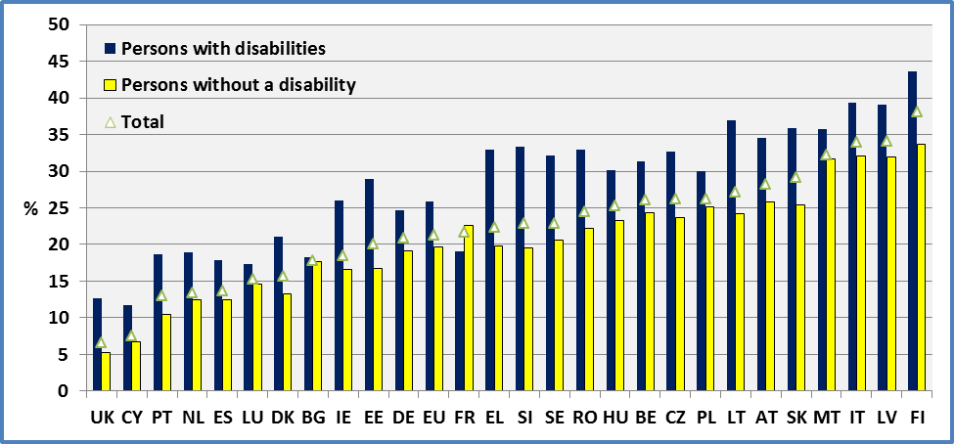

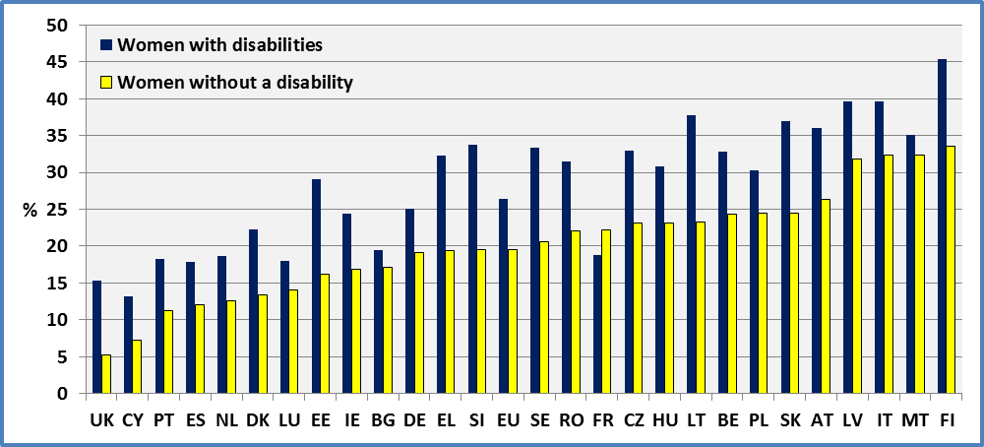
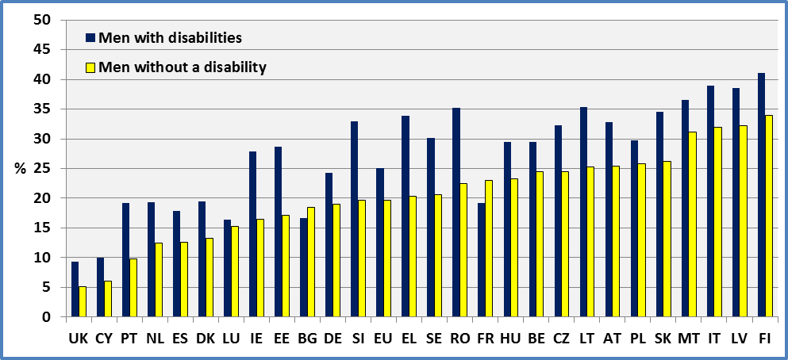Data source : EU-SILC 2009
Data

Table 33: Percent of persons (aged 16+) in households with difficult access to postal or banking services; Age 16, 2009.

 | Females + Males |  |  | Females |  |  | Males
 | Disability |  |  | Disability |  |  | Disability
 | Yes | No | Total | Yes | No | Total | Yes | No | Total
AT | 34.6 | 25.8 | 28.2 | 36.0 | 26.3 | 29.1 | 32.8 | 25.4 | 27.3
BE | 31.4 | 24.3 | 26.0 | 32.8 | 24.3 | 26.5 | 29.5 | 24.4 | 25.5
BG | 18.3 | 17.7 | 17.8 | 19.4 | 17.1 | 17.6 | 16.6 | 18.4 | 18.1
CY | 11.7 | 6.7 | 7.5 | 13.2 | 7.3 | 8.4 | 10.0 | 6.0 | 6.7
CZ | 32.7 | 23.7 | 26.2 | 33.0 | 23.1 | 25.8 | 32.3 | 24.5 | 26.7
DE | 24.7 | 19.1 | 20.8 | 25.1 | 19.1 | 21.0 | 24.3 | 19.0 | 20.7
DK | 21.1 | 13.3 | 15.6 | 22.3 | 13.4 | 16.0 | 19.4 | 13.2 | 15.2
EE | 28.9 | 16.7 | 20.1 | 29.0 | 16.2 | 20.1 | 28.7 | 17.1 | 20.0
EL | 33.0 | 19.8 | 22.3 | 32.3 | 19.4 | 22.1 | 33.9 | 20.3 | 22.5
ES | 17.8 | 12.4 | 13.7 | 17.8 | 12.1 | 13.7 | 17.8 | 12.6 | 13.7
FI | 43.6 | 33.7 | 38.1 | 45.4 | 33.5 | 38.0 | 41.1 | 34.0 | 38.2
FR | 19.0 | 22.6 | 21.7 | 18.8 | 22.2 | 21.3 | 19.2 | 23.0 | 22.2
HU | 30.2 | 23.2 | 25.2 | 30.8 | 23.1 | 25.5 | 29.4 | 23.2 | 25.0
IE | 26.0 | 16.6 | 18.4 | 24.4 | 16.8 | 18.3 | 27.8 | 16.4 | 18.5
IT | 39.4 | 32.1 | 34.0 | 39.6 | 32.3 | 34.5 | 39.0 | 31.9 | 33.6
LT | 36.9 | 24.2 | 27.1 | 37.8 | 23.2 | 27.0 | 35.3 | 25.3 | 27.2
LU | 17.3 | 14.6 | 15.2 | 18.0 | 14.0 | 15.0 | 16.4 | 15.2 | 15.4
LV | 39.1 | 32.0 | 34.1 | 39.6 | 31.8 | 34.3 | 38.5 | 32.2 | 33.8
MT | 35.8 | 31.7 | 32.2 | 35.1 | 32.3 | 32.6 | 36.6 | 31.1 | 31.7
NL | 18.9 | 12.5 | 13.4 | 18.6 | 12.6 | 13.7 | 19.3 | 12.4 | 13.1
PL | 30.0 | 25.1 | 26.2 | 30.3 | 24.4 | 25.8 | 29.7 | 25.8 | 26.6
PT | 18.7 | 10.5 | 13.0 | 18.3 | 11.3 | 13.7 | 19.2 | 9.8 | 12.1
RO | 33.0 | 22.2 | 24.5 | 31.5 | 22.1 | 24.3 | 35.2 | 22.4 | 24.6
SE | 32.2 | 20.6 | 22.9 | 33.3 | 20.6 | 23.3 | 30.2 | 20.6 | 22.4
SI | 33.4 | 19.5 | 22.8 | 33.7 | 19.5 | 22.7 | 32.9 | 19.6 | 22.9
SK | 35.9 | 25.4 | 29.1 | 36.9 | 24.5 | 29.3 | 34.6 | 26.2 | 28.9
UK | 12.6 | 5.2 | 6.6 | 15.3 | 5.3 | 7.4 | 9.3 | 5.1 | 5.8
EU | 25.8 | 19.6 | 21.2 | 26.4 | 19.5 | 21.4 | 25.1 | 19.7 | 20.9
Data source: EU-SILC 2009
Table 34: Percent of persons in households with difficult access to postal or banking services, 2009

 | Females + Males
 | Age 16-64 |  |  | Age 65+
 | Disability |  |  | Disability
 | Yes | No | Total | Yes | No | Total
AT | 28.5 | 25.6 | 26.2 | 43.3 | 27.1 | 36.0
BE | 26.1 | 23.5 | 24.0 | 39.8 | 28.9 | 33.8
BG | 16.9 | 17.9 | 17.8 | 19.5 | 17.0 | 18.1
CY | 11.0 | 6.6 | 7.2 | 12.7 | 7.0 | 9.7
CZ | 31.6 | 23.8 | 25.8 | 34.2 | 23.2 | 28.2
DE | 23.4 | 19.4 | 20.3 | 26.5 | 17.5 | 22.8
DK | 18.9 | 12.8 | 14.8 | 25.8 | 15.3 | 18.9
EE | 26.5 | 16.2 | 18.1 | 31.5 | 20.5 | 27.8
EL | 30.2 | 19.0 | 19.8 | 34.3 | 26.0 | 30.8
ES | 16.6 | 12.5 | 13.2 | 19.4 | 11.4 | 15.7
FI | 43.0 | 34.0 | 37.6 | 44.5 | 32.6 | 40.4
FR | 22.3 | 24.0 | 23.8 | 15.2 | 12.8 | 14.1
HU | 26.1 | 23.1 | 23.8 | 35.9 | 24.1 | 31.6
IE | 21.1 | 15.8 | 16.6 | 36.2 | 23.4 | 29.0
IT | 35.8 | 32.5 | 33.0 | 42.1 | 29.3 | 37.1
LT | 33.7 | 23.5 | 25.1 | 39.9 | 29.6 | 35.2
LU | 14.6 | 14.5 | 14.5 | 22.5 | 15.2 | 18.2
LV | 36.4 | 31.6 | 32.6 | 42.9 | 36.2 | 40.5
MT | 36.8 | 32.6 | 32.9 | 34.8 | 24.8 | 28.5
NL | 16.5 | 12.1 | 12.5 | 23.5 | 15.0 | 17.8
PL | 27.7 | 24.9 | 25.3 | 33.1 | 26.7 | 30.3
PT | 16.3 | 10.8 | 12.0 | 21.6 | 8.3 | 16.5
RO | 30.4 | 21.8 | 23.0 | 36.0 | 25.7 | 31.2
SE | 32.7 | 19.7 | 22.1 | 31.5 | 23.8 | 25.8
SI | 28.4 | 18.4 | 21.0 | 40.4 | 24.5 | 30.3
SK | 31.2 | 25.3 | 26.9 | 43.7 | 27.6 | 40.2
UK | 8.6 | 4.6 | 5.2 | 18.5 | 8.3 | 12.5
EU | 23.4 | 19.8 | 20.4 | 28.7 | 18.4 | 24.0
Data source: EU-SILC 2009

Data source

- EUSILC UDB 2008 – version 3 of March 2011
- EUSILC UDB 2009 – version 1 of March 2011

Methodology

The EU-SILC 2009 Module on Material Deprivation includes a question on the ’Accessibility of postal or banking services‘. The possible answers are:

- with great difficulty
- with some difficulty
- easily
- very easily

Eurostat notes that the accessibility of the services is to be assessed in terms of physical and technical access, and opening hours, but not in terms of quality, price and similar aspects. Physical access has to be assessed in terms of distance but also of infrastructure and equipment, for example, which is likely to be of relevance to respondents with a physical impairment. Also, the services provided at home should also be taken into account, if they are actually used by the household.

The respondent should give an answer for the household as a whole. If the respondent does not use a service but other household member(s) do, he or she should assess the accessibility according to their use. Accessibility should be considered at the level of the household, the difficulty should be evaluated for the household as a whole.

When assessing the accessibility, the physical access and the opening hours are taken into account. For the postal and banking services, technical access could also intervene. Accessibility in terms of phone-banking and PC-banking should also be part of the assessment, if these ways are actually used by the household.

The reported estimations refer to people using postal or banking services.

Notes

Eurostat notes that it is not always the person with disability who assesses the accessibility experienced by the household as a whole. The interviewed person may be any member of the household, disabled or not, although in the latter case would be invited to take into account the accessibility difficulties of other members of the household.

The methodology used may underestimate the difficulties. Indeed, Eurostat notes that if a disabled respondent does not use a transport service at all but other household member(s) can use it for them, then it is not an overall difficulty for the ‘household’ for which accessibility is assessed. In this instance, individual autonomy for people with disabilities would not be taken into account.

We have estimated the accessibility indicator by taking into account only persons who answered the questionnaire on household accessibility issues. The results do not change significantly (a difference of less than 1 percentage point). However, in this case, the use of available weights may be questionable.

EU-SILC estimators may underestimate the percentage of people with disabilities considering accessibility to be difficult, since persons living in collective households and in institutions are generally excluded from the sample.

Summary of findings and recommendations

Demographics

The prevalence of impairment/disability (defined by health-related activity limitation) varies sharply across Member States but remains relatively stable. Between 2008 and 2009 there was no relation between change in national unemployment rates and change of the reported prevalence of impairment-related ‘limitations’.

The prevalence of disability, on this measure, is higher among women mainly due to the gender composition of an ageing population, which may be predicted to increase over time.

The prevalence of impairment/disability increases with age in a similar way for men and women until the age of 40 but begins to dissociate afterwards. The age profile of disability prevalence by age remained unchanged between 2008 and 2009.

Employment

The key Europe 2020 objective requires that 75 % of the EU population aged 20-64 should be employed.

At European level, the employment rate of disabled people is about 27 percentage points lower than that of non-disabled people. There is a significant employment gap between people with and without impairments in all Member States. While the employment rate of people without impairments is higher than 70% in the majority of Member States, for people with impairments it is lower than 50% in the majority of Member States.

Countries with similar employment rates for non-disabled people show big differences for disabled people. This suggests that there is considerable a potential for increasing the employment rate of disabled people. The employment rate of women (both with and without impairments) is relatively low compared to that of men.

When we compare 2009 and 2008, we find that the employment rate of disabled people remained approximately the same in a generally difficult economic environment and labour market.

Unemployment

The EU unemployment rate for disabled people (17.7%) is approximately double the unemployment rate of non-disabled people (9.2%). Following the onset of financial crisis at the end of end 2008 and 2009, there was an increase in the unemployment of both disabled and non-disabled people.

In some countries, the difference between disabled and non-disabled people is relatively small while in others it is very significant. Female unemployment rates are higher compared to male unemployment rates.

The evolution of unemployment across the life cycle follows similar trajectories for people with and without impairments but the unemployment rate for disabled people is higher at all stages of the life cycle.

Activity rate

There is a significant difference in the economic activity of disabled and non-disabled people in all Member States, both for men and women. The activity rate of women is lower than that for men. From a life cycle perspective, the activity rate of disabled people is lower at all ages compared to non-disabled people. The absolute difference (or equality gap) increases with age until the pre-retirement periods.

Countries with similar activity rates for non-disabled people present large differences in the activity rate of disabled people. This calls into question to efficacy of some national policy frameworks and suggests significant potential to increase the economic participation of disabled people through the transfer of experience from one country to another.

At the EU level, there was a small increase of the activity rate of disabled people between 2008 and 2009, despite a difficult environment due to the emerging financial crisis. Increases in the activity rate of non-disabled people are not always accompanied by parallel increases for disabled people, and notably for older disabled workers, which suggest that national activation policies are not always impacting positively on them.

Early leavers from education and training

The Europe 2020 strategy set a target of 10% or less early school leavers by 2020.

At the EU level, there is a difference of 10.9 percentage points between young disabled people (23.3%) and non-disabled young people (12.4%). There disadvantage (or equality gap) is 10 or more percentage points in 15 Member States.

Generally, young women and girls have better achievements (a lower share of early school levers) compared to young men and boys, both for disabled and non-disabled groups.
There is some evidence of a very small improvement of the situation of young disabled people at the EU level between 2008 and 2009 but with significant differences across Member States.

Completion of tertiary or equivalent education

The Europe 2020 strategy set a target for the share of 30-34 years olds having completed tertiary or equivalent education to reach at least 40% in 2020.

Twelve Member States have attained this target for non-disabled people but none for disabled people. At the EU level, the disadvantage (or equality gap) amounts to 14.3 percentage points. The share of persons who have completed tertiary or equivalent education aged 30-34 in 2009 was 21.4% for disabled people and 35.1% for non-disabled people.

Women face an advantage in comparison to men. This is also true for disabled and for non-disbaled women.

There is some evidence of improvement between 2008 and 2009, in the majority of the Member States and at EU level, there national situations vary sharply.

Households with very low work intensity

Work intensity is one component of the Europe 2020 headline indicator ’population at risk of poverty or social exclusion‘ (the EU-SILC User Data Base enables us to estimate the number of persons in jobless households with a Work Intensity of zero).

A large number of disabled people live in jobless households. At the EU level, there is a difference (equality gap) of about 15 percentage points between disabled and non-disabled persons on this measure.

Despite a general worsening of the labour market situation in 2009, following onset of the financial crisis at the end 2008, the situation of disabled persons remained stable at the EU level.

Gender differences are very small with a small advantage for non-disabled men. However, it is important to note that where unit of analysis is the household no account is taken of the gendered distribution of work amongst household members.

Risk of poverty after social transfers

One of the three indicators contributing to the Europe 2020 headline indicator ’population at risk of poverty or social exclusion‘ is the number of People at-risk-of-poverty after social transfers.

At the EU level, 19.9% of disabled persons live in households with a household with a disposable income less than 60% of the national median average, compared to 14.3% for non-disabled persons (after social transfers). In some countries the difference (equality gap) between disabled and non-disabled people is relatively low, but in others relatively it is high, reaching a maximum of 23 percentage points.

Comparing the situation between 2008 and 2009, there was an improvement of the situation of disabled people at the EU level of 1.3 percentage points. At the national level, improvement in the situation of non-disabled is not always associated with improvement of the situation of disabled people.

The situation of women is worse compared to men for both disabled and non-disabled women.

Severe material deprivation

One of the three indicators contributing to the Europe 2020 headline indicator ’population at risk of poverty or social exclusion‘ is the share of population with an enforced lack of at least four out of nine material deprivation items (concerned with economic strain, durables, housing and environment of the dwelling).

About 10.8% of disabled people are severely materially deprived on this measure, compared to 7.1% of non-disabled people. At the national level, this ranges from 1.6% to 60% for disabled people, and from 1% to 41% for non-disabled people, demonstrating a gap in absolute deprivation of living standards.

There was a slight improvement between 2008 and 2009 at the EU level for all groups (of about 1 percentage point) and in the majority of Member States.

From a life cycle perspective, employment appears to be an important factor in reducing material deprivation (deprivation is reduced during working life).

The disability gap is more noticeable for some of the nine deprivation items than forothers. For example, being disabled increases the likelihood of being unable to pay one week’s holidays by 20% in comparison to non-disbaled people (although this item may involve not only financial considerations but also mobility and accessibility issues).

Overall risk of poverty or social exclusion

The Europe 2020 headline indicator ’population at risk of poverty or exclusion‘ combines the three preceding sub-indicators (risk-of-poverty rate after social transfers, severe material deprivation, and people living in households with very low work intensity).

At the European level, 37% of disabled people aged 16-59 are at risk of poverty or social exclusion compared to 21% of non-disabled people in this age group. Even for people with a job there is a disability equality gap, with a risk of 16% for disabled workers , compared to 12% for non-disabled workers.

Between 2008 and 2009 there was a small improvement of the situation for both disabled and non-disabled people at the EU level, but with national differences.

Accessibility of public transport

The proportion of disabled people living in households reporting difficulty in accessing public transport is 22% compared to 18% for non-disabled people. There is a large variation between Member States.
There is no significant difference between women and men on this measure (although it is a household measure not an individual measure).

Amongst persons aged 16-64, the difference is 22% compared to 18%. The respective rates for older people (aged 65 or more) are 26% and 17%. The difference increases with age, notably after the age of 50 years.

These results may underestimate the size of the disability equality gap and the enforced dependency of disabled people on other household members.

Accessibility of postal or banking services

The proportion of disabled people living in households reporting difficult in accessing postal and banking services is 26% compared to 20% of non-disabled people at the EU level but there are big differences between Member States.

There is no significant difference between women and men.

Amongst persons aged 16-64, the difference is 23% compared to 20%. The respective rates for older people (aged 65 or more) are 29% and 18%. The difference increases with age, notably after the age of 40 years.

REFERENCES

EUROPEAN COMMISSION: COMMUNICATION FROM THE COMMISSION TO THE EUROPEAN PARLIAMENT, THE COUNCIL, THE EUROPEAN ECONOMIC AND SOCIAL COMMITTEE AND THE COMMITTEE OF THE REGIONS “European Disability Strategy 2010-2020: A Renewed Commitment to a Barrier-Free Europe”; European Commission Brussels, 15.11.2010 COM(2010) 636 final.

EUROPEAN COMMISSION - EUROSTAT, “DESCRIPTION OF TARGET VARIABLES: Cross-sectional and Longitudinal 2009 operation”; EU-SILC 065 (2009 operation); EUROSTAT, Directorate F: Social Statistics and Information Society Unit F-3: Living conditions and social protection statistics.

EUROPEAN COMMISSION – EUROSTAT: “EU-SILC 065 (2008 operation), DESCRIPTION OF TARGET VARIABLES: Cross-sectional and Longitudinal”; 2008 operation (Version January 2010). Directorate F: Social Statistics and Information Society Unit F-3: Living conditions and social protection statistics;

EUROPEAN COMMISSION – EUROSTAT: EU-SILC UDB 2008 – version 3 of March 2011

EUROPEAN COMMISSION – EUROSTAT: EU-SILC UDB 2009 – version 1 of March 2011

EUROPEAN COMMISSION – EUROSTAT: “YEAR 2009: CROSS-SECTIONAL DATA; DIFFERENCES BETWEEN DATA COLLECTED (as described in the guidelines) AND ANONYMISED USER DATABASE”; EUROPEAN COMMISSION – EUROSTAT, Directorate F: Social Statistics and Information Society, Unit F-3: Living conditions and social protection.

Web pages:

http://ec.europa.eu/justice/discrimination/disabilities/disability-strategy/index_en.htm

http://epp.eurostat.ec.europa.eu/portal/page/portal/europe_2020_indicators/headline_indicators

http://epp.eurostat.ec.europa.eu/portal/page/portal/microdata/

EUROSTAT microdata:
- EUSILC UDB 2008 – version 3 of March 2011
- EUSILC UDB 2009 – version 1 of March 2011

ANNEX

Country abbreviation

AT Austria
BE Belgium
BG Bulgaria
CY Cyprus
CZ Czech Republic
DE Germany
DK Denmark
EE Estonia
EL Greece
ES Spain
FI Finland
FR France
HU Hungary
IE Ireland
IT Italy
LT Lithuania
LU Luxembourg (Grand-Duché)
LV Latvia
MT Malta
NL Netherlands
PL Poland
PT Portugal
RO Romania
SE Sweden
SI Slovenia
SK Slovakia
UK United Kingdom
EU European Union

http://epp.eurostat.ec.europa.eu/portal/page/portal/europe_2020_indicators/headline_indicators.
http://ec.europa.eu/justice/discrimination/disabilities/disability-strategy/index_en.htm European Commission: communication from the commission to the European Parliament, the council, the European economic and social committee and the committee of the regions “European Disability Strategy 2010-2020: A Renewed Commitment to a Barrier-Free Europe”; European Commission Brussels, 15.11.2010 COM(2010) 636 final.
the term ‘persons with disabilities’ is used in the European Disability Strategy and in the UNCRPD but can be interpreted in different ways. From a social model perspective, the available demographic data tends to represent ‘people with impairments’ (those reporting impairments or functional activity limitations) rather than ‘disabled people’ (those experiencing disablement as a consequence of environmental barriers). In this sense, the term ‘people with disabilities’ is used here to refer to ‘people reporting activity limitations’ (a proxy for impairment), while the extent of ‘disability’ is conveyed by the indicator findings of participation and equality outcome gaps outlined later in the report.
COM(2010) 636 final.
COM(2010) 636 final.
Eurostat http://epp.eurostat.ec.europa.eu/portal/page/portal/microdata/
COM(2010) 636 final.
COM(2010) 636 final.
http://epp.eurostat.ec.europa.eu/portal/page/portal/europe_2020_indicators/headline_indicators.
COM(2010) 636 final
Eurostat: http://epp.eurostat.ec.europa.eu/portal/page/portal/sdi/files/QP%20People%20living%20in%20households%20with%20very%20work%20intensity.pdf
The rate might be overestimated for 2009 but remains high when we consider 2008.
The small gender difference reflects the nature of the indicator, as the same household work intensity status is assigned to each member (for example, a couple living together) and does not take into account the distribution of work between women and men within a household.
Extract from ’YEAR 2009: CROSS-SECTIONAL DATA; DIFFERENCES BETWEEN DATA COLLECTED (as described in the guidelines) AND ANONYMISED USER DATABASE‘; EUROPEAN COMMISSION – EUROSTAT, Directorate F: Social Statistics and Information Society, Unit F-3: Living conditions and social protection.
COM(2010) 636 final.
http://epp.eurostat.ec.europa.eu/portal/page/portal/europe_2020_indicators/headline_indicators
http://epp.eurostat.ec.europa.eu/portal/page/portal/sdi/files/at-risk-of-poverty-rate.pdf
For a full description see: EUROPEAN COMMISSION – EUROSTAT: Directorate F: Social Statistics and Information Society Unit F-3: Living conditions and social protection statistics; “EU-SILC 065 (2008 operation), DESCRIPTION OF TARGET VARIABLES: Cross-sectional and Longitudinal”; 2008 operation (Version January 2010).
COM(2010) 636 final
http://epp.eurostat.ec.europa.eu/portal/page/portal/europe_2020_indicators/headline_indicators
http://epp.eurostat.ec.europa.eu/portal/page/portal/sdi/files/QP%20Severely%20materially%20deprived%20persons.pdf
COM(2010) 636 final
http://epp.eurostat.ec.europa.eu/portal/page/portal/europe_2020_indicators/headline_indicators
http://epp.eurostat.ec.europa.eu/portal/page/portal/sdi/files/QP%20Population%20at%20risk%20of%20poverty%20or%20exclusion.pdf
EUROPEAN COMMISSION, EUROSTAT, “DESCRIPTION OF TARGET VARIABLES: Cross-sectional and Longitudinal 2009 operation”; EU-SILC 065 (2009 operation); EUROSTAT, Directorate F: Social Statistics and Information Society Unit F-3: Living conditions and social protection statistics.
EUROPEAN COMMISSION, EUROSTAT, “DESCRIPTION OF TARGET VARIABLES: Cross-sectional and Longitudinal 2009 operation”; EU-SILC 065 (2009 operation); EUROSTAT, Directorate F: Social Statistics and Information Society Unit F-3: Living conditions and social protection statistics.

